**Candidate Name: Aidan Taylor**

**Candidate Number:** *<Your Candidate Number Here>*

**Centre Name:** *<Your Centre Name Here>*

**Centre Number:** *<Your Centre Number Here>*

**Project Title: 2D Battle Platformer Game**

# 

# A Level Computer Science Programming Project

Coding styles:

|  |  |
| --- | --- |
| **TOP BAND TECHNIQUES:** | **Page Number** |
| Annotation used to describe code effectively | Throughout code, e.g. 60-65 |
| Meaningful identifier names | Throughout code, e.g. 92-98 |
| File paths parameterised |  |
| Consistent style throughout | Throughout code |
| Appropriate indentation | Throughout code, e.g. 87, 90 |
| Modularisation of code (subroutines) | Throughout, e.g. 96-103 |
| Good use of local variables | Throughout, e.g. 81-85 |
| Minimal use of global variables | None |
| Managed casting of types | Throughout, e.g. 60 |
| Well-designed user interface | Throughout, e.g. 88-90 |
| Good exception handling | Throughout, e.g. 61-62 |
| Cohesive subroutines where code does just one thing | Throughout, e.g. 64-69 |
| Modules (with collections of subroutines) | Throughout, organised into files |
| Subroutines with common purpose grouped | Throughout, e.g. 103-105 |
| Module code interacts with other parts of the program through its interface only | Files get constants from the constants.py file, e.g. 60 and 91 |
| Modules have subroutines with appropriate interfaces | Used to update buttons, e.g. 83 (.ChangeColour()) |

Technical skills:

|  |  |  |
| --- | --- | --- |
| **TOP BAND TECHNIQUES:** | **How They are implemented** | **Page Number** |
| List operations | Storing objects, accessing level data from a file. | Throughout, e.g. 65-70 |
| Stack | For implementing an undo function in the level editor. | Created 125, used 81-87 |
| Files organised for direct access | Files store level data and will be organised by level numbers. | 139-141 |
| Complex Mathematical/ scientific model | Forces acting on player, movement mechanics and collisions. | Throughout, e.g. 99 and 107-108 |
| Complex user defined algorithms | For changing keybinds, checking if player is on the ground. | Throughout, e.g. 60-61, 99-100 |
| Complex object-oriented model | Players, platforms and other objects created with classes, inheritance and more. | 91-124 |
| Dynamic generation of objects | To create arrows. | 117-119 |
| Complex client server model with request and response objects | Will connect 2 clients together with a server and send objects and encrypted data between them. | 70-76 and 128-132 |
| **MIDDLE BAND TECHNIQUES:** | | |
| Simple user defined algorithms | Movement of player, cooldown checks, updating players and more | Throughout, e.g. 102-105, 111-113 |
| Dictionaries | Linking keybinds to codes for online transmission | 65, 71, 95 |
| Reading and writing from files | Level loading | Throughout, e.g. 79 |
| **RESTRICTED BAND TECHNIQUES:** | | |
| Appropriate choice of simple data types | Use of Booleans, integers, floats and strings throughout. | Throughout, e.g. 93-96 |
| Single mathematical calculations | Various movement-based features. | Throughout, e.g. 61-62, 66-67 |

Contents

1 A Level Computer Science Programming Project 1

1.1 Dictionary 7

2 Analysis 8

2.1 Project proposal 8

2.1.1 Introduction: 8

2.1.2 The Problem: 9

2.1.3 Importance: 9

2.1.4 The User: 9

2.2 Research 10

2.2.1 Interview: 10

2.2.2 What I have learnt from interview 11

2.2.3 Options available on the market now: 13

2.2.3.1 Brawlhalla: 13

Overview: 13

Best features in Brawlhalla: 13

Fighting mechanics and how they work in Brawlhalla: 14

Knockback calculation: 15

Other features: 16

2.2.3.2 Super Smash Bros: 17

Game modes: 17

2.3 Useful Theory and Source Documents 18

2.4 Project Objectives 21

2.5 Stack prototype for use in level editor 51

2.6 Server Prototype which can send and receive strings 42

2.7 Modelling 23

2.7.1 Player Animations Flowchart 23

2.7.2 Level Creation Flowchart 23

2.8 Input Process Storage Output 25

2.8.1 For main menu 25

2.8.2 For playing game 25

2.8.3 For Online Play using server 26

2.8.4 Settings Menu 26

2.8.5 For creating a level 26

2.8.6 For loading a level 26

2.8.7 For dealing/taking damage and determining knockback 26

2.8.8 Player Collisions with Platform and Passing Through with Down Key 27

3 Documented Design 27

3.1 Interface Design 27

3.1.1 Main Menu Screen 27

3.1.2 Level Editor Screen 28

3.1.3 Options Menu 30

3.2 Overall System Design 31

3.2.1 Top-Down Design Diagram 31

3.2.1.1 Main 31

3.2.1.2 Server 32

3.2.2 Input Process Storage Output Tables 33

3.2.2.1 For main menu 33

3.2.2.2 For creating a level 33

3.2.2.3 For loading a level 34

3.2.2.4 Determining knockback 57

3.2.2.5 Player passing through platforms 35

3.2.2.6 For online play using a Server 35

3.3 Using Pygame 36

3.3.1 Introduction 36

3.3.2 Processing player inputs 37

3.3.3 Creating Screen and Background 37

3.3.4 Adding Shapes and Images to the Screen 38

3.3.5 Game Visuals 38

3.3.5.1 Player Images 38

Introduction to player images 38

How will the player be animated? 39

3.3.5.2 Hitbox 40

What is a hitbox? 40

Player and platform hitboxes 40

3.3.6 Creating Working Buttons 41

3.3.7 Collisions 41

3.4 Using Socket 41

3.4.1 Creating a Server 41

3.4.2 Communicating Between Client and Server 42

3.5 Data Dictionary 44

3.6 Classes 46

3.6.1 Class Diagram 46

3.6.2 Key Attributes 47

3.6.2.1 Player 47

3.6.2.2 Platform 48

3.6.2.3 Network 49

3.6.2.4 Arrow 49

3.7 Key Subroutines 49

3.7.1 Play 49

3.7.2 PlayOnline 50

3.7.3 Redrawing Window 50

3.7.4 Edit Level 50

3.7.4.1 Undo Function **Error! Bookmark not defined.**

3.7.5 Save Level 52

3.7.6 Loading Levels and Processing Objects 53

3.7.7 Update Subroutines 54

3.7.8 Saving Animation Images 55

3.7.9 Change Keybinds 55

3.7.10 Cooldown Checking 56

3.7.11 Move 56

3.7.12 Change Button Colour 57

4 Technical Solution 58

4.1 Main Python File – “main.py” 59

4.2 Player Python File – “player.py” 91

4.3 Platform Python File - "plat.py” 122

4.4 Button Python File – “button.py” 123

4.5 Constants Python File - "constants.py” 124

4.6 Stack Python File – “stack.py” 125

4.7 Network Python File - "network.py” 128

4.8 Server Python File - "server.py” 129

4.9 Other Files 133

4.9.1 Archer 133

4.9.1.1 Animations 133

Idle.png 133

Run.png 133

Jump.png 134

Light Attack.png 134

Heavy Attack.png 134

4.9.2 Knight 135

4.9.2.1 Animations 135

Idle.png 135

Run.png 135

Jump.png 136

Light Attack.png 136

Heavy Attack.png 136

4.9.3 Arrow 137

4.9.3.1 Arrow.png 137

4.9.4 Menu 138

4.9.4.1 Background.png 138

4.9.4.2 Level Editor Rect.png 139

4.9.4.3 Options Rect.png 139

4.9.4.4 Play Rect.png 139

4.9.4.5 Quit Rect.png 139

4.9.5 Text Files 139

4.9.5.1 Player1Keybinds.txt 139

4.9.5.2 Player2Keybinds.txt 140

4.9.5.3 Level1.txt 140

5 Testing 142

5.1 Test table 142

5.2 Improvements 149

6 Evaluation 150

6.1 My overall evaluation 150

6.2 Evaluation by objective 151

## Dictionary

**Keybind** – A key on the keyboard or button on the mouse selected to perform a certain action on the screen, e.g. the move left keybind is ‘a’ (a is the key to make the character move left).

**Hitbox** – A shape or region around a character or object which handles detection and responses to collisions and hits with other entities in the game. They are essential for making gameplay interactions responsive.

**Gravity** – The force any two objects with mass apply on each other, which depends on their distance apart and their mass. This mostly refers to the earth applying a downwards force to the player.

**Normal contact force** – The force exerted by a surface on an object in contact with it, which acts perpendicular to the surface. This will be used to allow players to stand on platforms.

**Friction** – The resistive force to movement when an object is moving on a surface. The magnitude of this force depends on the mass of the object, gravitational field strength and roughness of the surface. The direction always opposes direction of travel.

**Collision** – Where two objects in the game interact upon contact, causing actions to the objects as stopping movement or taking damage.

**Skill curve** – How difficult a game is to learn and gain skill at.

**Knockback** – A game mechanic where a character or object is pushed backward upon collision with enemy attack.

**Player inputs** – Actions sent by a player through buttons on a keyboard, mouse, or controller to interact with the game.

**Processing** – Analysing or reading data to use in code to get a desired outcome.

**Projectiles** – Objects in a game that are launched or thrown where the only force after they are shot acting on them is gravity.

**Abstraction** – Filtering out unnecessary details to create a general model of a problem.

**Tuple** – An ordered collection of elements, typically of different data types.

**Surface** – A portion of the screen that stores pixel data and can be drawn onto the display window or other surfaces.

**Parameters** – Variables or values which are passed into a function or method to vary its output.

**Array** – A data structure that stores a collection of elements, usually the same data type.

**Attribute** – Characteristic of an object in object-oriented programming which stores data of that object, represented by variables within a class.

**Melee** – Close range attacks using weapons such as fists or swords.

**Socket** – Anendpoint for sending or receiving data.

**User interface (UI)** – Any aspects of the code which the user can operate and interact with.

**Composition** – An object-oriented programming technique where one class contains objects of other classes.

**Inheritance** – An object-oriented programming technique where a class inherits properties and methods from another class.

**Dependency** – Where one component or module relies on another to function.

**Subroutine** – Code that does a task and can be called from other parts of a program, does not return a value.

**Function** – Code that does a task and can be called from other parts of a program, returns a value.

**Iteration** – Repeating a set of instructions multiple times until a certain condition is met.

**Blit** – A Pygame function used to draw images on the screen.

**Pseudocode** – A simplified, informal way of writing algorithms and code.

# Analysis

## Project proposal

### Introduction:

Many people around the world have loved the ease of access and simplicity associated with 2D games for decades, with one of the most popular types of these games being 1 vs 1 battle games. From the old street fighter arcade game to Super Smash Bros (introduced in 1999 by Nintendo) and more recently Brawlhalla (in 2014 by Blue Mammoth Games) genres like this have always been popular. For my project, I plan to put my own spin on this type of game. This will be very beneficial for those who are enjoyers of 2D platformers and want a new challenge, or beginners to give them a simple route into gaming.

### The Problem:

Many people who are not avid video game players struggle to get into gaming, whether that’s because they don’t know which games to play, or they find existing ones too difficult and restricting. But the fact is, they do not have a fun and accessible game to enjoy with others, and therefore don’t choose to play video games in their free time. This is supported by the following survey (<https://www.statista.com/statistics/300513/gaming-by-demographic-group-uk/>), presenting how after 24, the percentage of gamers in the UK follows a steep negative trajectory, with a huge drop of 13 percent from the 16-24 age group to the 25-34 age group. I believe they want a game that is simple, fun and easy to run, because this allows it to be accessible for all the mentioned age groups. Features that would help this would be fast loading times, easy and adjustable controls and customisable level creation. This type of game is known as a casual game, preferred by the majority of gamers (as the statistics show below from explodingtopics.com illustrate).

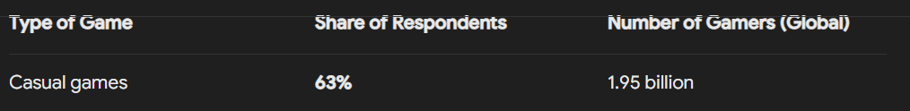

### Importance:

Games like these are very effective at helping people to bond, but most new or popular games at the moment are complicated and inaccessible for many gamers who don’t have lots of free time and just want to have some fun for a short period of time. The importance of simple and enjoyable games has been lost recently and I would like to bring it back. According to an Express VPN survey, 79 percent of gamers play retro games and the biggest reason they played was for fun, which 38 percent noted as their primary reason. The most popular game of these was Super Mario Bros, so using features from this game, such as its easily understandable user interface system, will be very important in creating a successful game. (https://www.expressvpn.com/blog/who-spends-the-most-time-gaming/#:~:text=Retro%20releases%20are%20also%20considered,gamers%20than%20their%20younger%20counterparts.)

### The User:

I intend to aim this project at as many people as possible to make it profitable. The main user groups I aim to reach are:

* Users who enjoy retro games – because many complex 3D games are being released but there are not many 2D games for those who enjoy retro gaming,
* Users who do not have as much time for gaming – because as games are becoming more complicated and leaving out those without time to learn them,
* Users who use video games to bond with families or friends in the same location – because online play across the internet can be confusing and intimidating but only playing over a local network is more accessible for many people
* New gamers trying to learn from scratch who need a game with fewer buttons and clearer instructions to start on.

This can be accomplished by making the game as efficient and minimalistic as possible whilst still having accurate calculations and being visually appealing. Features such as a simple but high resolution background and buttons that match with the theme of the game which have clear and obvious functions displayed to the user. Another way, is through optimising the game correctly to run exceptionally on any device the user has. The objectives could also be met by using simplified physics calculations which are fairly accurate to real world physics but do not require massive amounts of computing power.

## Research

### Interview:

In this interview I intend to find out, first hand, what some of the users who enjoy these types of games would like from this project.

What is your name?

Jacob

Ozz

Ian

Clare

What do you do in your free time?

Play with computers, certain video games and coding, especially web development.

Designing and computer engineering, video games, game development and enjoys seeing games which he can take inspiration from.

Maths, gaming, programming challenges, piano, rock climbing, swimming.

Gym, guitar, Lego, gaming, TikTok.

Do you play video games, and which are your favourite?

Roblox, Minecraft, GTA, Among us and Flappy Bird.

Super Smash Bros, Mortal Combat, Street Fighter, Slap Happy Rhythm Busters and Tekken.

Hollow Knight, Team Fortress 2 and Dying Light 1 and 2.

Fortnite, Star Wars Battle Front 2, Forza Horizon 4, Super Mario Bros.

What are your favourite features of any 2D games you have played previously?

The tasks around the map in among us, and the ease of use of Flappy Bird because of its simple and accessible keybinds (buttons used to do certain actions in the game, e.g. space to jump).

Movement systems are much more precise and snappy because of the lower degrees of freedom than in 3D, much more straightforward to navigate as a player in the 2D space. Movement systems are how the player controls and manoeuvres the game world. They are the basis of nearly every game.

Movement in Hollow Knight, when you attack downwards you bounce upwards. In celeste, dashing mechanics such as getting lots of speed from dashing. Other creative and unique mechanics.

Power ups, simple movement, graphics of Clash of Clans and Mario.

Have you ever played any fighter games and what were your favourite features?

Guns for an added element for more interesting fights because they add range and more dodging mechanics.

The use of rhythm in attack patterns in some games adds an extra element of skill.

In team fortress 2 shooting at the floor propels you upwards. Doom eternal you can kill enemies to get ammo back and setting them on fire gives you armour back.

Different characters with different abilities with different fighting styles, good fighting graphics.

Was there anything you wish had been included in this game or features from other games you have seen which would benefit the game?

Faster loading times.

Having standard features but done very well which is not done in many games and makes them much more enjoyable to play.

Grappling hooks to be able to swing off objects.

More split screen games for local play, customisable characters.

### What I have learnt from interview

The main features that were popular from other games to consider including in my project and features that potential clients wish had been included are:

* 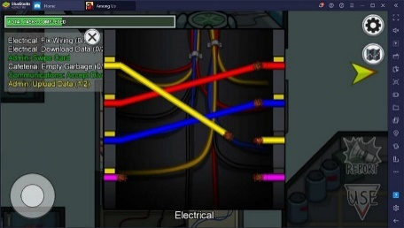Simple and accessible keybinds such as in Flappy Bird and other games, this will allow a wide range of users to easily play and not make the skill curve) too steep.
* The use of tasks in games, such as Among Us which allow everyone in the game to always have several things to do, keeping games unpredictable and fun.
* Snappy movement, which is simple and responsive, means I need to program the game, as efficiently as possible, so that the game takes minimal time to load and run. 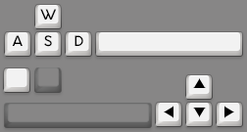Making the movement responsive and fast on any computer no matter the specifications.
* Keeping it in 2D and not moving to 3D seems like the best decision for my game. Potential clients prefer the ease of navigation in the 2D space making fights more focussed on dodging and landing hits than complicated 3D movement.
* Involving fun but simple mechanics that add to the fight, such as dashing which could have a cooldown and adds speed to the player, making landing hits more difficult. Different attack directions could have different bonuses, such as rebounding upwards after a downwards attack as it may be more difficult to land.

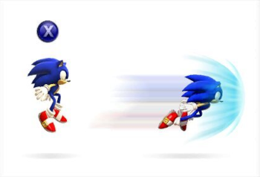

* Including ranged weapons for an extra dimension of fighting with more interesting dodging and ways of landing hits on the opponent.
* Simple ways of adding more skill to the fights could be adding attack rhythms as these are easy for newer players to learn but will make people play the game for longer. This could be done by adding a second key for an alternative attack.
* Making the program compact and easy to run (by applying efficient coding techniques) because many people are deterred from games by long loading times.
* Grappling hooks could be a fun feature to include but may give the user too many keybinds and mechanics to learn if dashing and other features were included.
* Different characters with unique abilities for fun and different battles, potentially customisable.
* Split-screen play for local multiplayer.

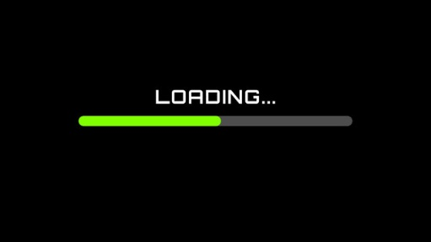

### Options available on the market now:

#### Brawlhalla:

[Play Brawlhalla For Free Now! — Brawlhalla](https://www.brawlhalla.com/play)

##### **Overview**:

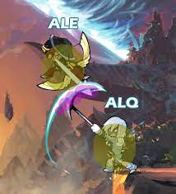Brawlhalla is the more modern game which I intend to include more features from, due to the fact that it is more efficiently programmed for 2-dimensional gameplay. It is very easy to play online, placing it above the older games, along with having great graphics and physics handling. It has many different characters with different abilities, which I will consider for my project, because I believe it will be a feature that makes the game much more enjoyable for users, as suggested by the survey I conducted. The second feature which I believe makes this game especially good, is the battle and collision physics. This is because the player inputs are processed and displayed quickly and efficiently to minimise delay and make the game more realistic and playable for users. These collisions are also very realistic due to the complex physics calculations used, and knockback is a very significant part of the game because it can be won by knocking the other player off the map. The developers kept health high and knockback strong but used features such as double jumping so that skilled players can get back onto the map, leading to long and fun battles. However, for my project, their competitive game mode does not meet the criteria for my clients. In Brawlhalla, spending lots of time practicing is required before you can start to win any games in this gamemode, rendering it an inaccessible game for new players.

##### **Best** **features** **in** **Brawlhalla**:

One of my favourite features in Brawlhalla, which lines up with prospective clients’ thoughts, is the dashing and double jump mechanics. Dashing works by adding a horizontal velocity to the player and making the player unable to take damage for a short period of time. This allows players to more easily dodge attacks and get back on to the platform. There are some different aspects that make the dodge/dash mechanic work: assigning a keybind to dash, creating a cooldown for when you can dash again and making sure the player cannot take damage whilst they are dashing. Double jumping works by allowing the player to choose to jump again in the air before touching the ground, adding vertical velocity, which allows the player to dodge more attacks successfully and can be saved for emergencies when they cannot dodge an attack in any other way. It can also be used if the player has fallen off the platform to get back on again. The way it can be implemented is using a counter to keep a track of how many jumps each player has left, subtracting one when the player jumps and setting the counter back to 2 when the player lands.

##### Fighting mechanics and how they work in Brawlhalla:

Brawlhalla lists what the dodge mechanic does on its website (image below). It allows players to dodge attacks, move around and control movement more precisely and efficiently, tricking your opponent and to change direction quickly.

There are also many different ways of attacking and attack types dealing variable amounts of damage which contribute toward how much knockback the player takes. The image below and right shows all the different attacks in Brawlhalla and how to perform them. There are 2 attack keys, left and right click, which perform a light and heavy attack respectively. These attacks then change depending on whether the player is in the air, on the ground, moving a certain direction or attacking downwards or upwards. This results in different damage, velocity changes and knockback taken by the opponent.

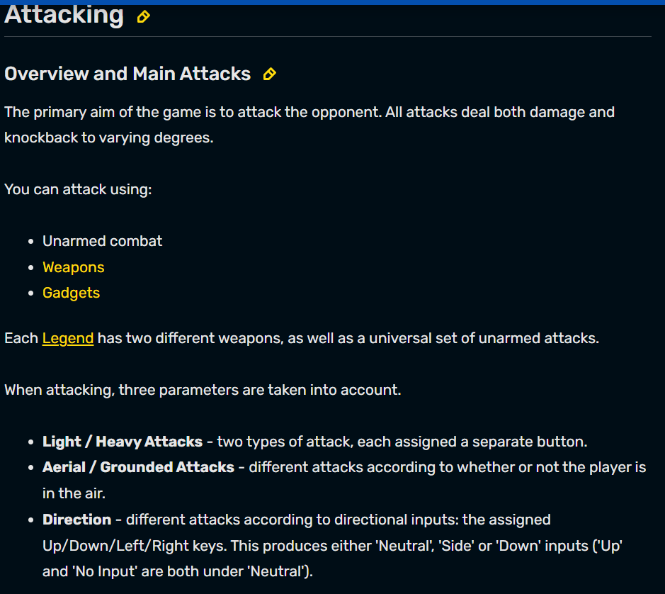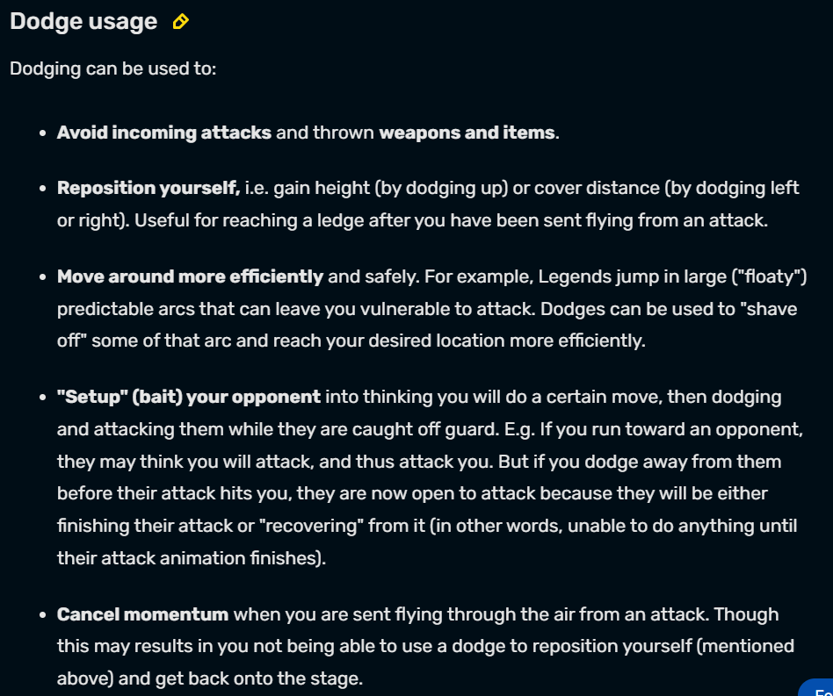

##### Damage dealing and taking:

The way damage is calculated in Brawlhalla is shown below. Damage taken by each player is added up and as the player’s damage taken increases, so does the player’s knockback taken upon being hit. The damage a player takes on a hit depends on their character’s defence (a resistance to damage) and the strength of the attack; this is shown in the table below. The image below and to the right show the damage of different weapons, which are multiplied by their speed (the attacks they can perform in a certain amount of time).

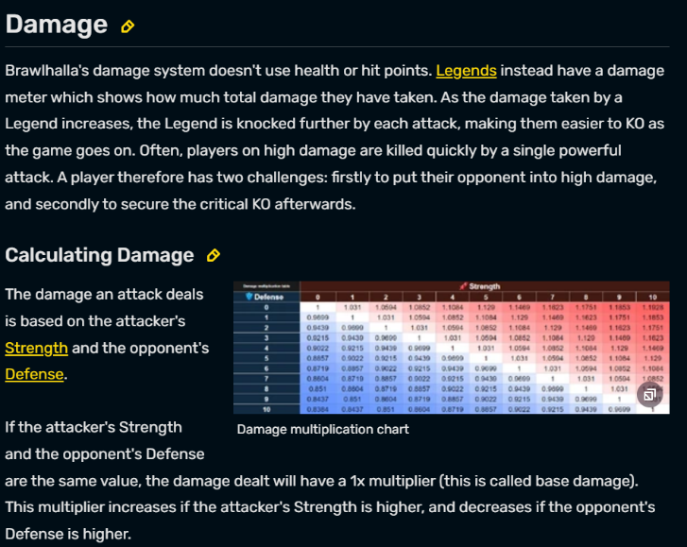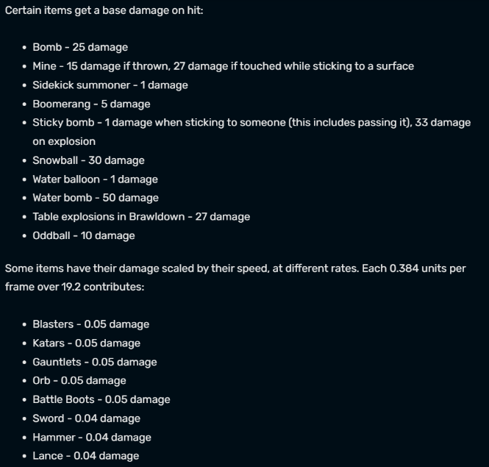

##### Knockback calculation:

The way knockback is calculated is shown below. The image on the right displays how the knockback multiplier is calculated, as the colour gets darker the knockback multiplier increases, as seen in the additional notes for each colour. The actual knockback taken in the end is calculated using the information on the right. The fixed force is the force applied always by every weapon, but some do more damage than others. Variable force is any other factors which affect force that are not constant, such as the knockback multiplier, damage done by the attack, and the strength stat of the character performing the attack.

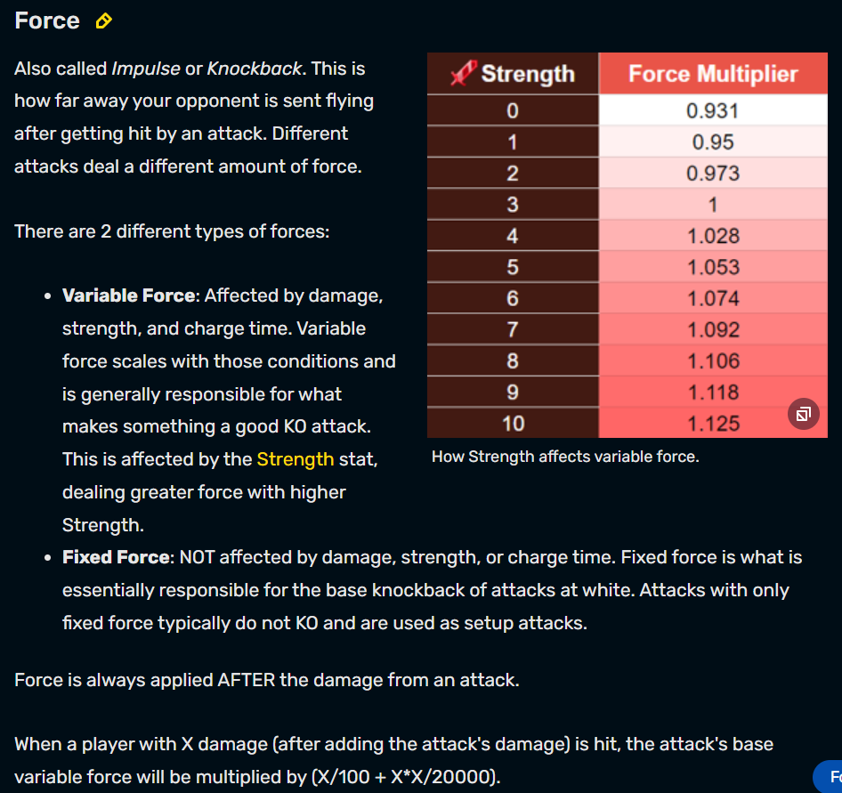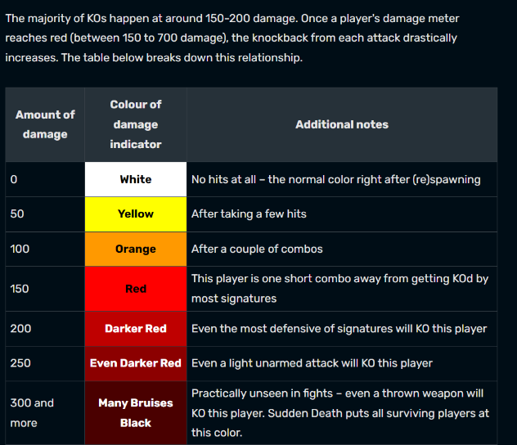

##### Other features:

I could include a way of disarming other players if I have collectable weapons. The way this is done in Brawlhalla is, if the player experiences enough force and damage, using the calculations from above, then the player’s weapon will be lost. This could have been a good addition to the game but due to time constraints may not be possible because I believe other features, such as dashing and double jumping, will add more to the game. The image down and right shows how attack priority is ordered in Brawlhalla. This is useful because if both attacks happen simultaneously, then the attack that is more significant in their ordering will be carried out instead of the smaller and less important attack. However, I decided an alternative approach to this should be used in this project where both attacks can happen at the same time because this will change the gameplay from Brawlhalla to make players more careful when they have taken lots of damage.

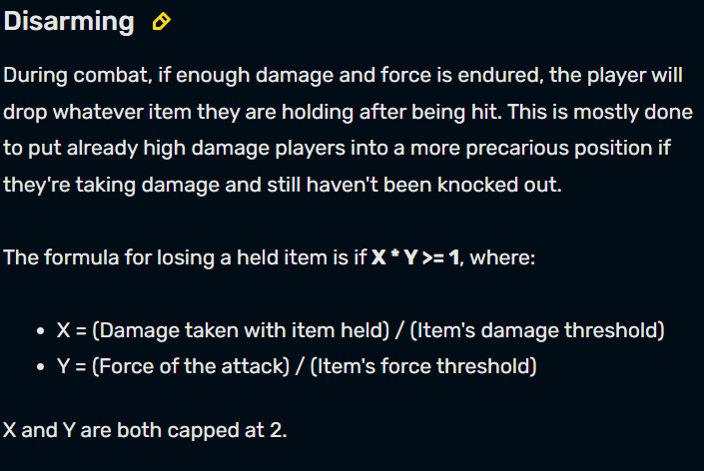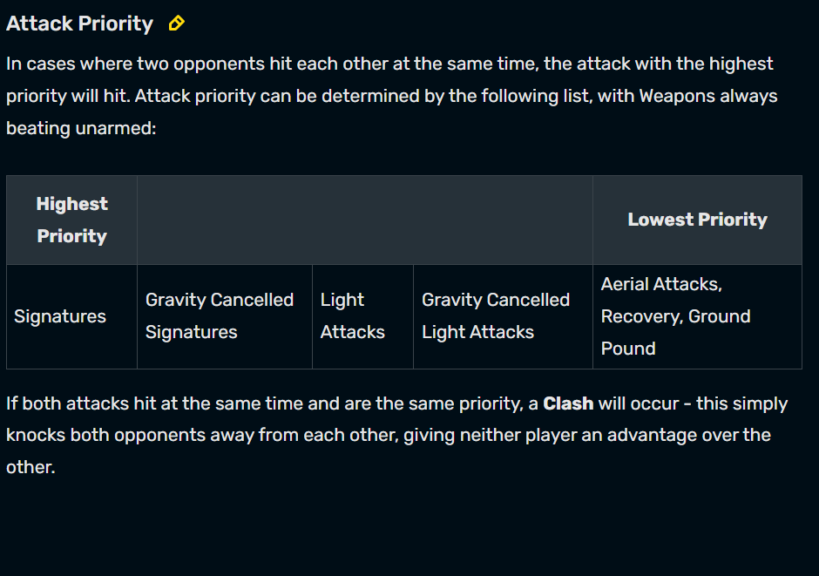

#### Super Smash Bros:

[Super Smash Bros. Ultimate for the Nintendo Switch system | Official Site](https://www.smashbros.com/en_US/index.html)

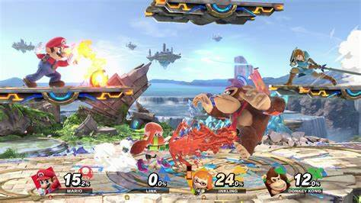

##### Game modes:

Super Smash Bros has many different modes which add variety to the game and allow the users to find and play their favourites and show them to their friends. Some of these game modes are listed below with short descriptions. Some of the modes that I think I could use aspects of in my game could be slow-mo, lightning and tiny melee. These could be their own separate modes or could be power ups included in the game like those in Super Mario Bros. However, these modes could also be confusing for players with less experience in games so may not fit my project specifications because this would result in many extra and confusing buttons for players to understand.

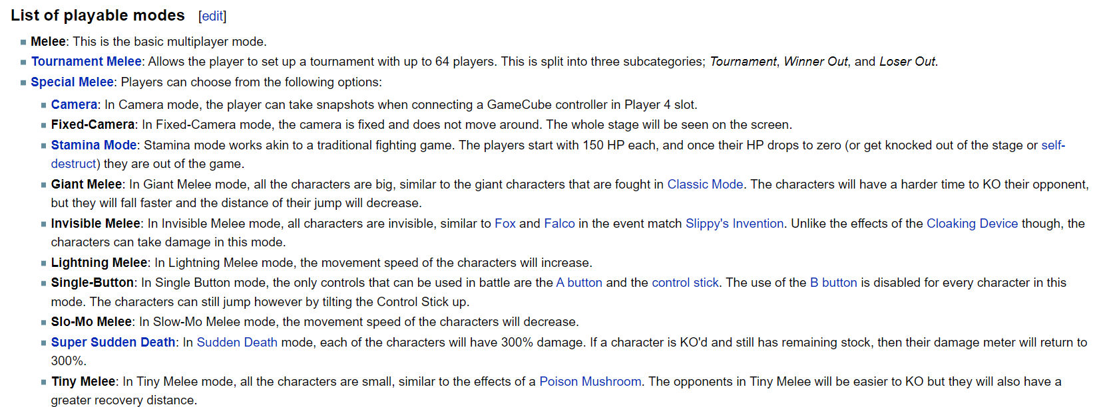

## Useful Theory and Source Documents

<https://builtin.com/data-science/python-socket>

This website shows how to set up a simple socket server in python which allows inputs from several clients to be received simultaneously. A socket is an end of a 2-way communication link between a client and a server. This allows information from the client to be sent to the socket and then be processed by the server and displayed to both player’s screens at the same time. I intend to do this over a Wi-Fi network to allow people in the same house to play together easily and host their own servers at any time. This is very convenient and using this tutorial along with my own knowledge should create responsive and fast client and server communication.

<https://www.techwithtim.net/tutorials/python-online-game-tutorial/connecting-multiple-clients>

This tutorial shows how to simply connect several clients to a python socket server. I intend to use this as a base but instead of passing pieces of information from client to server I will pass objects because this is the most efficient and fast way. Objects are created using a class as their structure and will contain all the necessary information the other client, which is receiving the data, will need to reconstruct the player onto their screen.

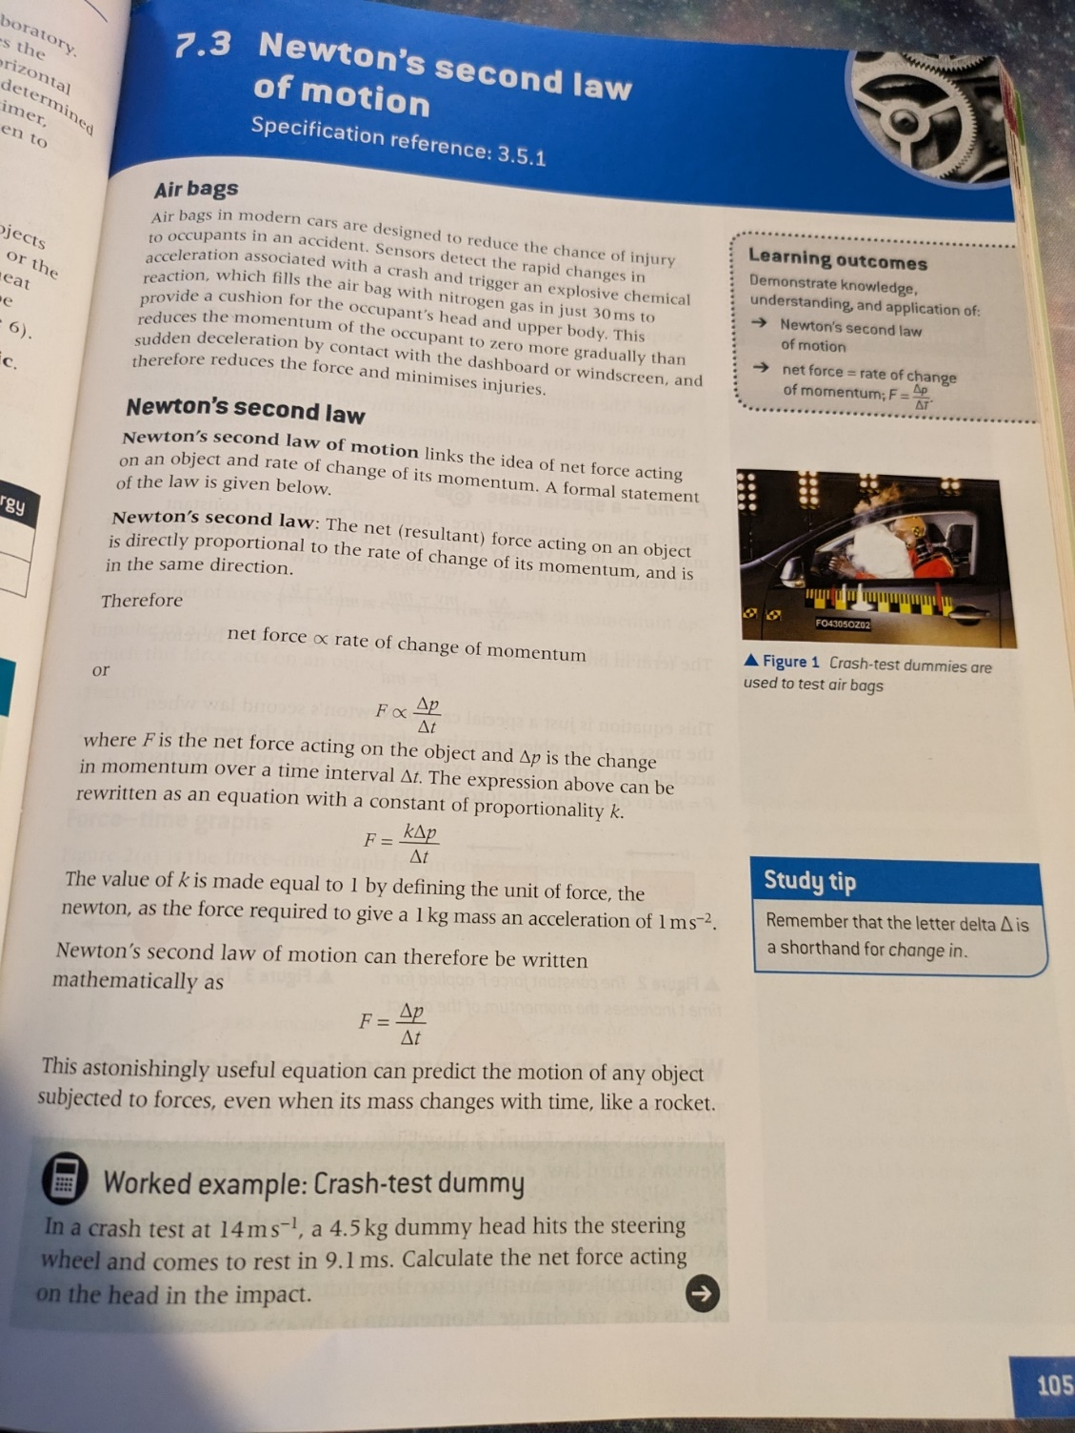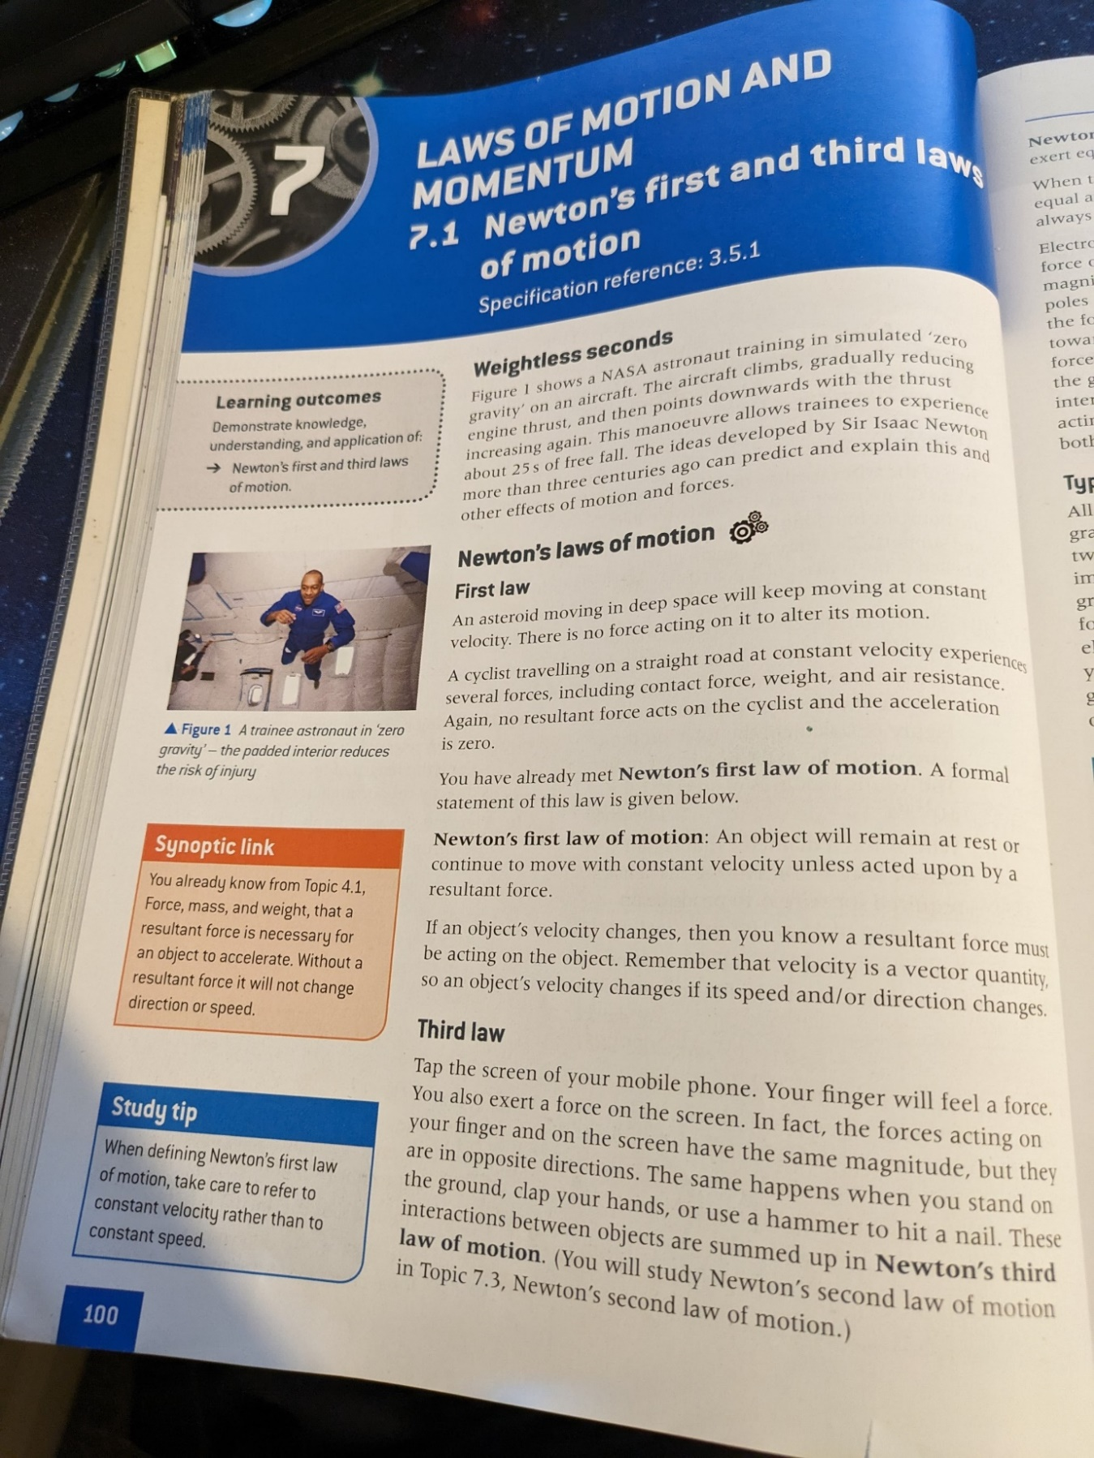

Newton’s first law states that unless an overall resultant force is acting on an object, it will keep moving at a constant velocity. This will be useful for my program because I will follow this rule to make sure the player’s resultant force remains at 0 until a user inputs a key. Once a key is inputted, Newton’s second law will be used to calculate the acceleration that should be applied to the player.

Newton’s second law is used to calculate the acceleration of an object based on force applied to it and its mass. This will be used in my project for any movement, such as jumping because the force applied downwards is what makes the player jump; the acceleration will be calculated using the force to change the player’s velocity. This equation is used in Pygame’s collision calculations alongside impulse and momentum calculations which I will be using in my project.

Newton’s third law states that, for every action (force) in nature there is an equal and opposite reaction. This will be used in my project during player’s collisions with platforms because the player must receive a normal reaction force from the platform to keep its gravity from pulling them down through the platform.

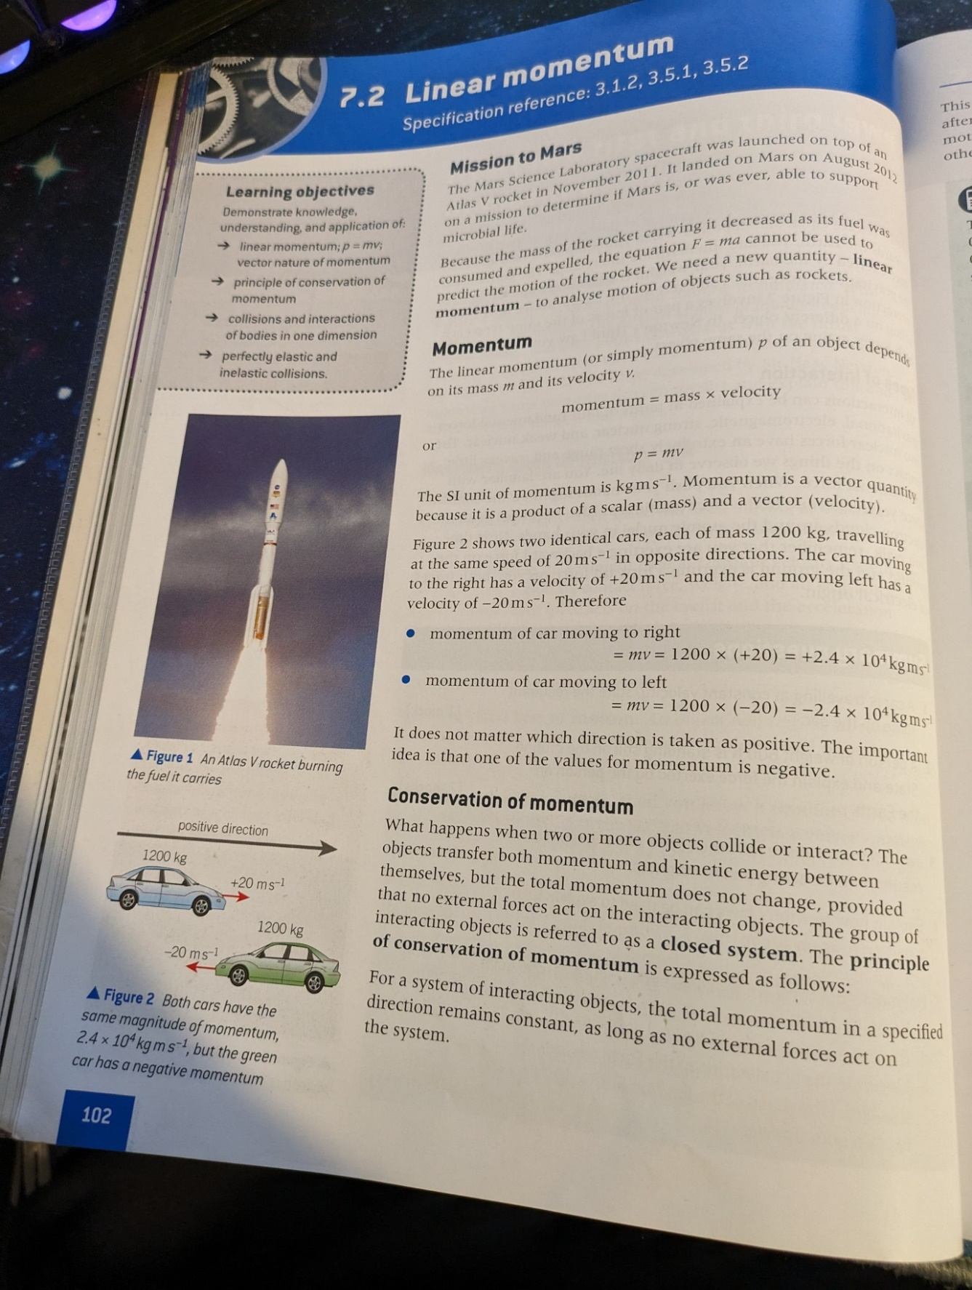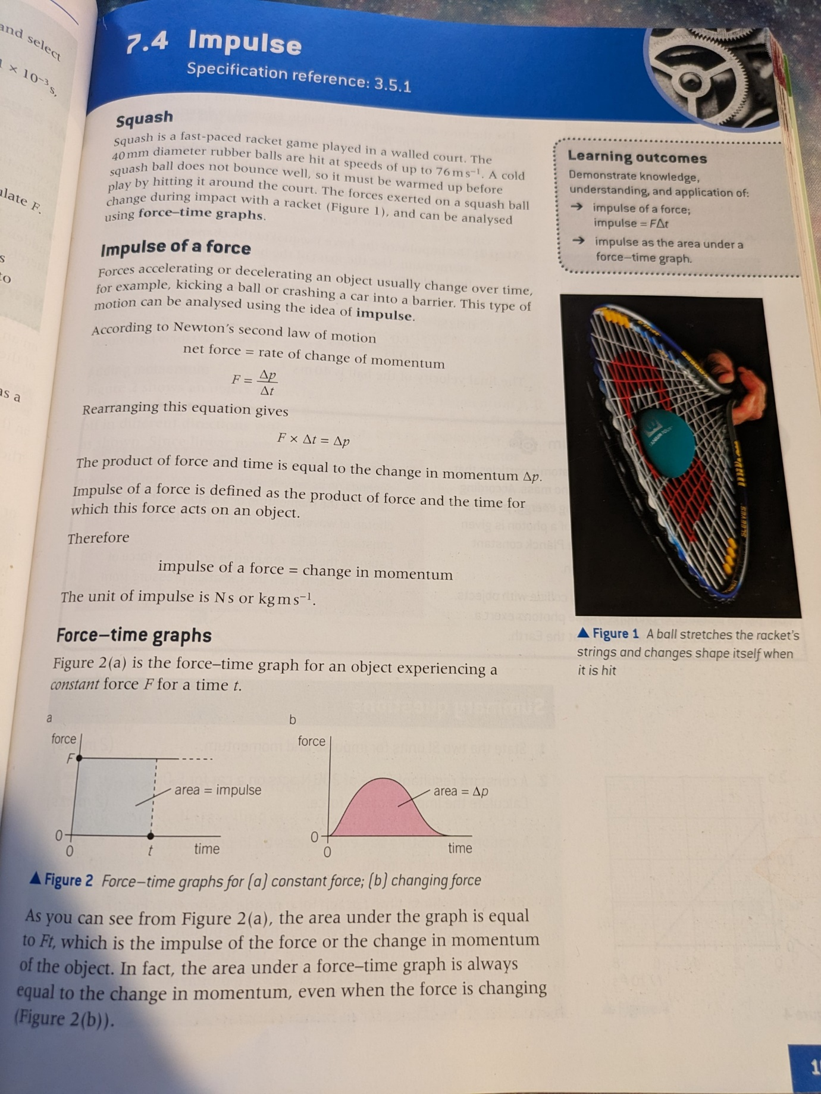Momentum is equal to mass multiplied by velocity and is mainly used in collision calculations due to the law of conservation of momentum. This law states that momentum before the collision is equal to momentum after the collision, which can be used to calculate the result of what happens after 2 objects hit each other by comparing their momentum before and after the collisions. Once the momentum after the collision is known, this can be devided by the mass to find out how much velocity the objects will have after the collision.

The left source document presents how to calculate impulse. Impulse is the change in momentum on an object (momentum explained above), which will help to calculate the result that the force will have on the motion of the player over time in my project, such as after jumping.

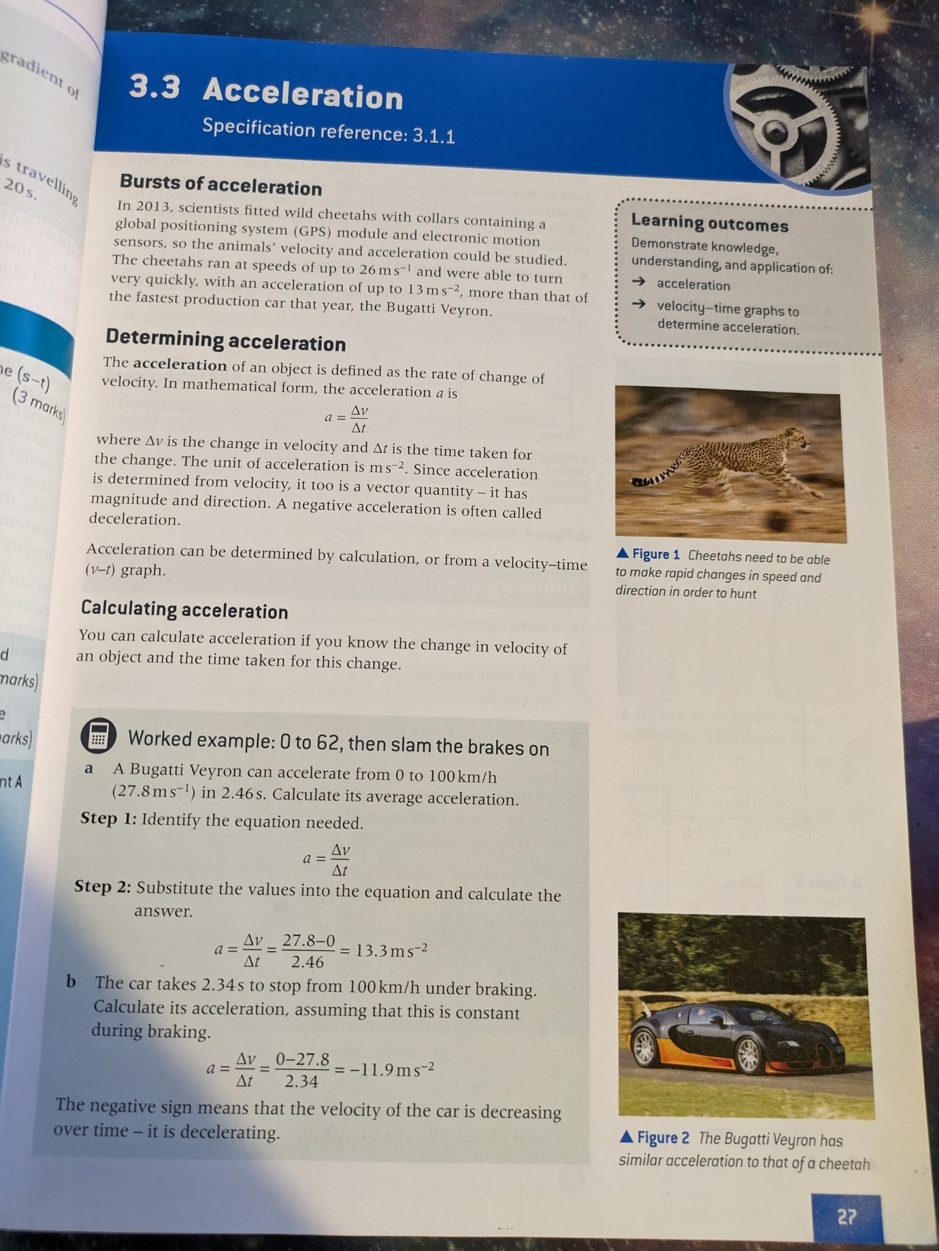

The left source document shows how to calculate aceleration. Acceleration is used in many important equations, known as suvat equations in 2D motion. such as in projectiles and others. For example the effect of gravity on an object is the acceleration it applies downwards to the object. Therefore, I will use acceleration when the player is falling and any movement of projectiles, such as arrowsor bullets, in my project.

## Project Objectives

From my research I have concluded that these are:

1. A 2D game due to its simplicity and accessibility.
2. An option for the user to select which level to play when play is selected.
3. Colourful maps with working platforms that the player can stand on.
4. Moveable players by user inputs.
5. Player attacks that can damage other players.
6. Two or more unique characters with different abilities/weapons.
7. The player should be able to jump and double jump to make gameplay more interesting.
8. The player’s number of jumps should be reset to 2 when the player lands on a platform.
9. The player should be able to dash.
10. Dashing should make the player temporarily immune to taking damage.
11. The player should be able to pass through platforms, except the big central one, by pressing the down keybind.
12. The player should be able to pass through all platforms by jumping from underneath them except from the big one.
13. Any projectiles shot by the player should be removed from the scene if they collide with a player or go off the screen.
14. A point should be added to the player’s score every time the other player goes off the bottom of the screen.
15. A way for the user to make their own maps to play.
16. An undo button in the map editor mode using a stack data structure.
17. An option for the user to select which level to save their data in.
18. Storage of map data in files.
19. Function(s) to load map data from files.
20. The ability for the user to change their keybinds in a settings mode.
21. The program should store keybind data in files so that changed keybinds stay changed after program is reloaded.
22. Fully animated characters that look good.
23. Physics based calculations for finding the results of applying friction and gravity.
24. Realistic, fast and responsive fighting using knockback with a multiplier depending on damage taken.
25. Several attacks for more interesting fights involving different damage and cooldowns.
26. An offline mode for local play on the same device.
27. An online mode that will run through a python socket server for play over a local network, which will pass objects between a client and server.
28. Allow several clients to connect simultaneously using threading.
29. Working buttons that perform an action when pressed.
30. A quit button to exit the program.
31. An interactive menu that will take the player to different parts of the game.
32. An efficient program which allows for fast loading times of below 20 seconds and responsive gameplay with less than 20 milliseconds between beginning and end of a game loop.
33. A program which can handle lots of data and still run quickly.

## Modelling

### Player Animations Flowchart

Animations are the changing of an image over time to make the user believe that the image is moving. These animations greatly increase the user enjoyment of any game because it makes the character seem more real to the player. Downloading a video to my project would take a very long time in the loading process of the game which is against my objectives (as it would increase level loading times). Therefore, a much better option would be to load several images or split up one image with several frames on it and play them one after another to make the image appear to be moving to the user. This will be discussed further in documented design.

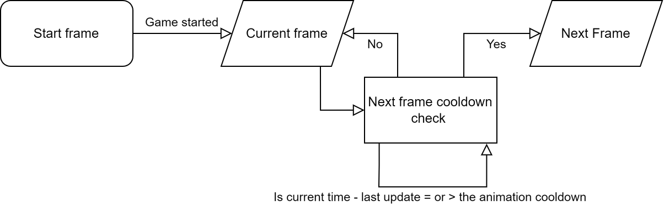

### Level Creation Flowchart

This flowchart represents what happens with every action that the user can take in the Level Editor mode using the stack. This will be discussed further in documented design.

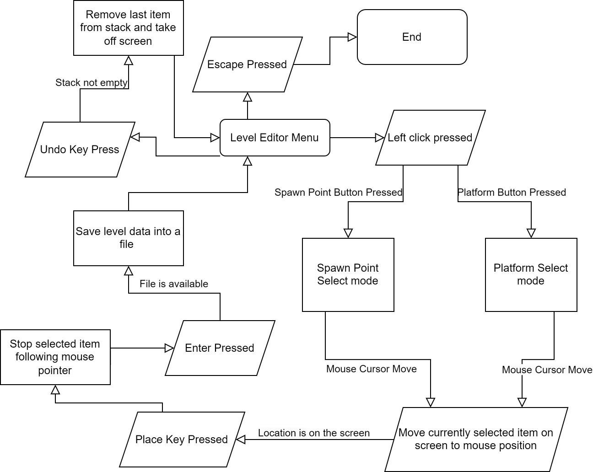

### Undo function using a stack

The level editor mode should have a way of undoing the last level element the user placed on the scene so that they do not have to restart level creation every time they make a mistake. This can be done using a stack. A stack is a last in first out (LIFO) data structure, which means the last element that is put on top of the stack is the first thing you will get back if you remove an element from the stack. This works very well for an undo function because the program needs the last thing put on the stack to be removed if the user presses the undo button. For example, in this project if the user places a platform and then decides they do not want it there afterwards, they can press the undo button, and the platform will be removed. A diagram illustrating how a stack works is shown below.

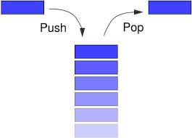

## Input Process Storage Output

These tables outline how aspects of the game will work and any parts that need to be explained in more detail will be refined in the documented design.

### For main menu

|  |  |
| --- | --- |
| Input | Mouse coordinates on the screen, left click press |
| Process | Depending on position of button press:   * Go to level selection screen. * Go to level creation screen. * Go to settings menu screen. * Exit program |
| Storage | Mouse coordinates. |
| Output | Buttons changing colour, screen changing to other modes. |

### For playing game

|  |  |
| --- | --- |
| Input | Mouse and keyboard presses |
| Process | Depending on decided binds and settings for different actions:   * Player moves, attacks, jumps or dashes based on which button player presses. * Escape button – bring up settings menu. |
| Storage | Update variables, especially Boolean attributes of the player about which actions are currently being carried out. |
| Output | Output the player, background, platforms and enemy to the screen. |

### For Online Play using server

|  |  |
| --- | --- |
| Input | Attributes of the player from the client |
| Process | Update which client is currently sending data, send all received data to other client. |
| Storage | Update variables for the player in server script. |
| Output | Other clients screen will have the current client’s player’s position and other attributes updated. |

### Settings Menu

|  |  |
| --- | --- |
| Input | Mouse coordinates and presses, keyboard presses |
| Process | Keybinds should be able to be changed for each player. |
| Storage | Update variables and save keybind data to keybinds file. |
| Output |  |

### For creating a level

|  |  |
| --- | --- |
| Input | Mouse coordinates on the screen, button and keyboard/mouse presses |
| Process | Depending on decided binds and settings for different actions:   * Place selected item * Save data into a file |
| Storage | Update variables and save item data to a file. |
| Output | The level can be selected to play and displayed on the screen. |

### For loading a level

|  |  |
| --- | --- |
| Input | Level number |
| Process | File with appropriate level number is selected and data from file is read and imported into program. |
| Storage | Level number, file data |
| Output | Level contents on screen |

### For dealing/taking damage and determining knockback

|  |  |
| --- | --- |
| Input | Damage taken. |
| Process | Use a formula which takes in damage and outputs knockback. This formula should make knockback increase with every hit but by a decreasing amount. Add knockback to the player’s velocity. |
| Storage | Store result of formula in a variable. And update x velocity attribute. |
| Output | Player moves across the screen. |

### Player Collisions with Platform and Passing Through with Down Key

|  |  |
| --- | --- |
| Input | Player hitbox, platform hitbox and whether the platform can be passed through. |
| Process | Check if hitboxes are colliding, if they are normal contact force should be applied. Check if down is being pressed, then check if the platform can be passed through and if so, move player through the platform. |
| Storage | Change Boolean attribute of player about whether they are on the platform and passing through the platform to true. |
| Output | Player stays on platform and if down pressed, passes through platform. |
|  |  |

# Documented Design

## Interface Design

### Main Menu Screen

There should be buttons for each of the different modes because this will allow the user to have choice over which mode they would like to play, and buttons are a simple way for them to control this. There should also be a simple looking background. This is to make the game look professional because it will improve the user’s perception of the game. The background should match the aesthetics with the buttons, which can be done by matching the colour scheme and theme. This will appeal to my clients as lots of colours and buttons confuses people.

The background and buttons will both be png images which can be saved in appropriate files and loaded into Pygame. The buttons should be able to have text put on them (so the player understands the function) by allowing buttons to be created with an image background as an attribute. They should be .png images for several reasons:

* Lossless compression is used so the image will not lose its quality.
* png images are widely supported.
* They can be made transparent or partially transparent which will be useful for removing player image backgrounds.

The images below are options for the background in the Main Menu and possibly other screens.

To make the buttons easier to see, they should be given background images for the text to go on. This background image is shown below and could be resized. The text should be a strong colour such as black and change colour to show that the cursor is over it to improve the useability of the program.



### Level Editor Screen

The level editor screen should be a still snapshot of the play screen without the players displayed so that the user can see how their level will look. There should be buttons at the bottom of the screen to add a platform or spawn point for each player, which should have images that can be moved to represent the platforms and spawn points so that the user can place them where they want. This will make the game more fun because the users can make their own levels using their creativity to show to their friends and family. This method of creating an edit screen is better than others (such as too many buttons which overcomplicate level creation) because my game should be simple and accessible as stated in the design specification. Below are some examples of existing games, which allow users to create and design levels for them to play.

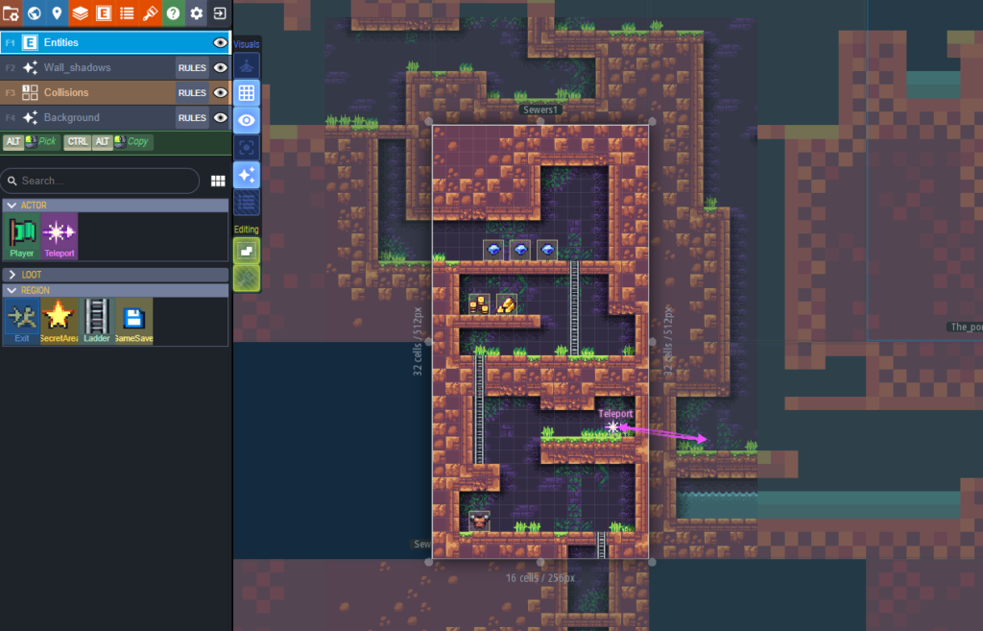

This level editor is good because it displays the game screen just as how it would look in the game, but with an added menu out of the way with buttons for editing. It has clearly sorted objects that make useability extremely easy. This would appeal to my users because it is very clear how to make your level, how your level will look when you play it and the buttons for everything are very well explained for everyone to understand.

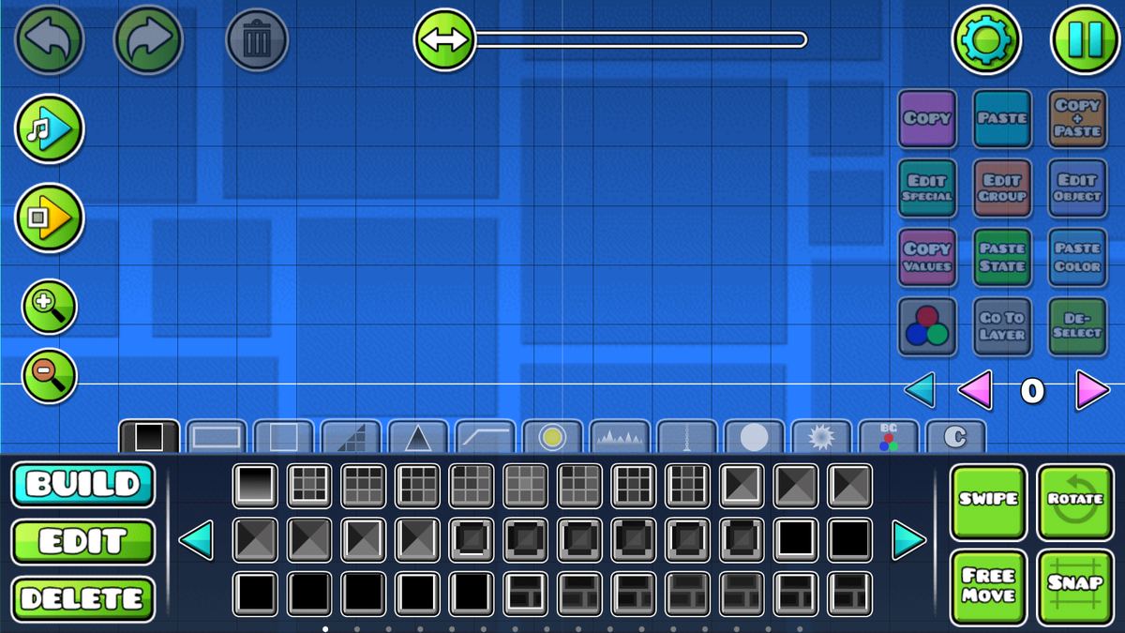

This level editor also has all the items that can be placed sorted very well and has lots of choice so players can create unique levels. This is very appealing to experienced gamers who want high levels of customisability however, it may make creating levels very daunting or confusing to new players. Therefore, my level editor should have less options but have similar buttons to this game with images on them to show the user what they are.

### Options Menu

This menu should be simple and easy for users to change important settings such as keybinds and exiting the game. The background and button images should be the same across the different game menus to connect the game and give it a cohesive and aesthetic theme. Games without a cohesive theme often look rushed and confusing for users which is why cohesion is highly important for this project. The keybinds for each player should be able to be changed to allow personalisation because this would accommodate lots of players who do not like the default keybinds, along with allowing users to set their own challenges for each other of using different keybinds. This menu should pause the game and stop it running for local play to allow the user to change keybinds without the other player attacking them. How they will be changed will be discussed further in the design section.

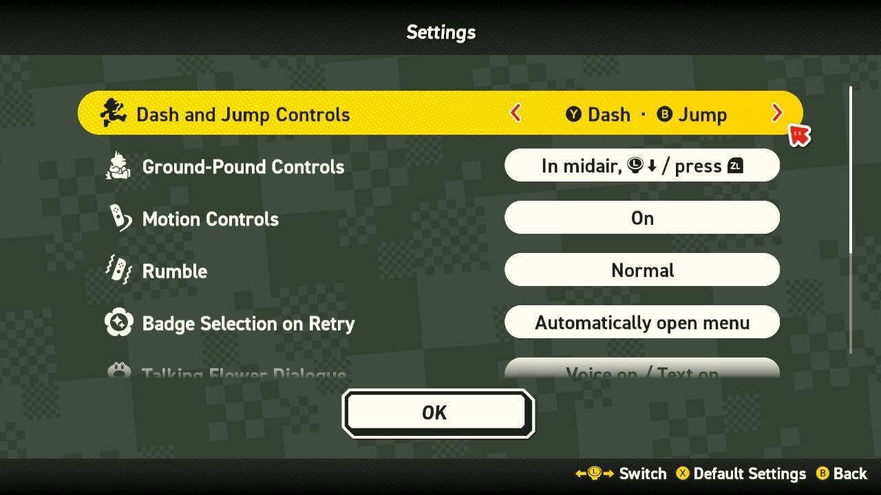

The settings menu above is good because the text is an appropriate size to be able to read easily and there are simple options to allow keybinds and controls to be changed. This could be implemented into my project so that users can easily read instructions on the screen and not strain their eyes.

## Overall System Design

### Top-Down Design Diagram

#### Main

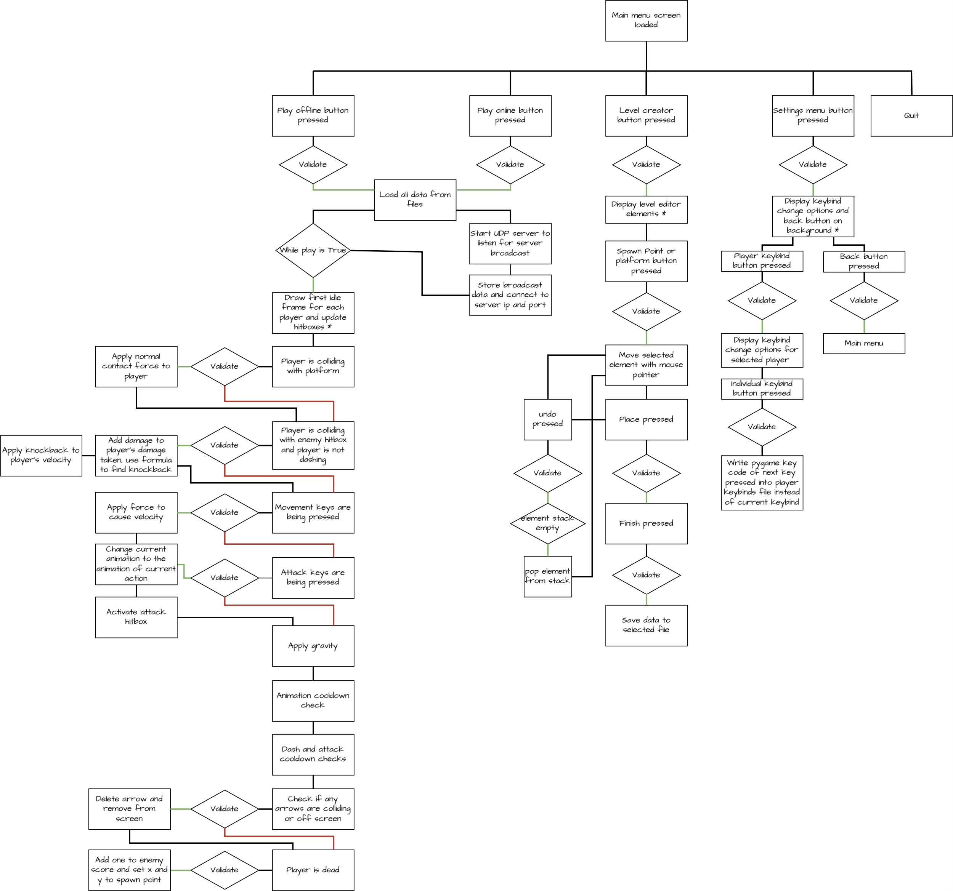Below is an overview of the system from the main page.

#### Server

Below is an overview of the system from the server.

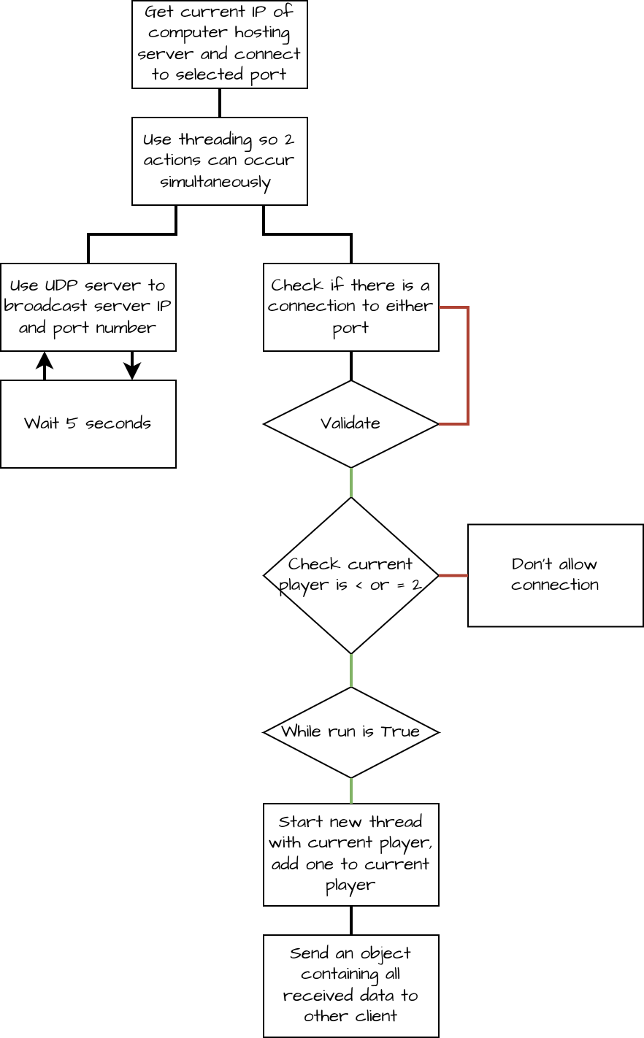

### 

### Input Process Storage Output Tables

#### For main menu

|  |  |
| --- | --- |
| Input | Detected with Pygame mousedown and keydown event listeners:   * Mouse coordinates on the screen (x, y)   Whether left click is pressed, the event listeners use code 0 for left click. |
| Process | Depending on the detected x and y coordinates of the mouse as left click is detected by Pygame mousedown event listener:   * Run LevelSelect() function. * Run CreateLevel() function. * Run Settings() function. * Exit program |
| Storage | Mouse coordinates in a mouse position array variable. |
| Output | Buttons changing colour, screen changing to other modes. |

#### For creating a level

|  |  |
| --- | --- |
| Input | Detected with Pygame mousedown and keydown event listeners:   * Mouse coordinates on the screen (x, y) * Which button is pressed – a property of the event listeners such as 0 as left click on the mouse |
| Process | Depending on decided binds and settings for different actions:   * Select platform placing mode, set mode variable = “plat”. Platform sized Pygame rect object will follow mouse pointer until place is pressed. * Select spawn point placing modes (for each player) set mode variable = “SP”. Small square Pygame rect object will follow mouse pointer until place is pressed. * Place selected item – stop changing x and y coordinates and allow modes to be selected again. * Save data into a file – stop any object currently selected from moving and deletes any unplaced objects. * Escape key pressed – call MainMenu() function. |
| Storage | As an item is placed, item coordinates and other attributes should be saved into their appropriate object and added to the list of the objects variable. Process list once enter is pressed and save data into a file. |
| Output | The level can be selected to play and displayed on the screen, as a consequence of the LoadLevel() and ProcessObject() functions. |

#### For loading a level

|  |  |
| --- | --- |
| Input | Level number as an integer |
| Process | * Open the file in read mode. * Store the data in the file in an array with each line as a different element. * Iterate through each element and transfer the data into the attributes of its appropriate object. * Return the created objects in an array back to the main function. |
| Storage | Level objects in an array. |
| Output | Returns list of objects back to the main function so that they can be drawn on the machine. |

|  |  |
| --- | --- |
| Input | Attacked player’s damage taken |
| Process | * Add damage taken to total damage taken * Input total damage taken to knockback calculation formula * Apply result as a force to the player’s velocity in the same direction they were attacked from |
| Storage | Knockback as a float |
| Output | Player image moving across the screen |

#### Player passing through platforms

|  |  |
| --- | --- |
| Input | Key presses detected with Pygame mousedown and keydown event listeners. |
| Process | * Check if currently bound down key is being pressed. * Check if player’s current platform can be passed through * Remove normal contact force applied on the player until the player has fully passed through the platform. |
| Storage | N/A |
| Output | Player image moving on the screen |

#### For online play using a Server

|  |  |
| --- | --- |
| Input | To the server:   * Data from each client, sent in an object containing all necessary data.   To each client:   * The server IP and port number broadcasted from the server by UDP server. * Data from the server about the other client in an object. |
| Process | * The server should start, using its current IP address and a selected port. It should then connect to a predetermined port number on the local network and broadcast the IP address and port number it is going to use to host the game server. * The client should then connect to the same predetermined port and save the received data in 2 string variables, one for IP and one for port * The client should then use these variables to connect to the game server. * Next, the client should create a new object containing all the important information about the player that is active on that client and transmit it to the server. * The server should then process this data and send it to the other client. * The other client should then transfer the data from the transmitted object to the player that is not controlled by that client. |
| Storage | Data from both clients should be stored and used to update player objects. Server should store data from both clients in case an error occurs so the server can still return data to the client that hasn’t got the error. |
| Output | Other client’s player image moving on the screen. |

## Using Pygame

### Introduction

Pygame is a set of Python modules for making games or creating visuals such as graphs with python. It includes computer graphics, sound libraries and input handling. Pygame abstracts many low-level operations to do these actions. Pygame is the best library to use for this because of its:

* Graphics: Pygame allows you to draw sprites, shapes, images, and text easily.
* Audio: Built-in support for sound effects and music.
* Input Handling: Handles user inputs like keyboard, mouse, and joystick.
* Collision Detection: Easy collision handling for sprites and objects.
* Cross-Platform support for Windows, macOS and Linux
* Large number of tutorials and users
* Lack of dependencies, it is self-contained and doesn’t rely on heavy external engines or libraries.

### Processing player inputs

Pygame handles player inputs by using an **event-driven system** that records keyboard presses, mouse movements, clicks, and joystick events on a controller. It creates a queue for all player actions to be stored. Each frame, Pygame checks this queue, allowing the program to detect and respond to any new events. It uses the pygame.event.get() function to get all the events from the queue which can then be used to check if a specific action is in the queue. This allows the program to keep constantly up to date with all actions occurring and for ease of checking whether an action has occurred quickly and efficiently. All of the above will be used for detecting key inputs in my game to help it run smoothly on any device the client may have.

The 2 key press events are KEYDOWN or MOUSEBUTTONDOWN– triggered when a key is pressed down – and KEYUP or MOUSEBUTTONUP – triggered when a key is released. In my game the KEYDOWN and MOUSEBUTTONDOWN events should be used to check if the attack or jump keys are being pressed, because these actions should only be performed once and not use continuous key presses. This is because if the player presses a key, the event handler will detect it as several presses but these actions have cooldowns and cannot occur multiple times so it would waste resources to constantly use the cooldown checking functions if the user is not intending to press the key multiple times. A secondary problem with using continuous key pressing detection is that the player would use both jumps and perform a double jump every time the user only pressed jump once because the program would interpret the slight hold down of the key as two presses.

However, I do intend on using continuous key presses for some actions. Continuous key presses use the pygame.key.get_pressed() function to check if a specific action is in the queue, which should be used in my project for movement keys to check if a key is being held down.

Pygame also allows for checking the position of the mouse using pygame.mouse.get_pos() and to check if the mouse is moved with MOUSEMOTION. Finding the coordinates of the mouse will be very useful for the menus which will be discussed in the screen and background, and buttons sections.

### Creating Screen and Background

To create the main game window, Pygame has a pygame.display.set_mode() function. This function takes a tuple of the screen’s width and height in pixels and returns a surface object. There are other options for the pygame.display.set_mode() function, such as making the window resizable, fixing it to the screen size or making a window borderless. This surface can then have any files or shapes drawn on it and these will appear to the user after the pygame.display.update() function has been used to update the screen. This will be used in my project to create the surface that everything in the game will be drawn on to, this should be defined at the start of the program.

The background is an image or colour which is drawn on to the main game window surface object. For this project, the image chosen in interface design should be loaded into the project and stored in a variable at the start of the running process; it should be drawn onto the surface, which should then be updated.

### Adding Shapes and Images to the Screen

Pygame has built-in functions for drawing simple 2D shapes like rectangles, circles, lines, and polygons directly on the screen surface. Each of these functions take 3 parameters, the first is the surface the shape is being drawn on to, the second is the colour of the shape – usually using rgb but it accepts hexadecimal and other formats as well – and the third is the position and size of the shape or a hitbox containing this information.

Pygame also has functions for loading and drawing images, this is done with the pygame.image.load() function which takes only one parameter – the path to the image as a string. This can then be drawn on the screen using the surface.blit() function taking the image being blitted and the coordinates as parameters. Blitting is the process of copying an image onto another surface. This image can then be rotated, flipped or have its size adjusted using built in Pygame functions.

For this project, the main uses from these functions should be:

* Loading .png images and drawing them on the screen.
* Creating hitboxes using Pygame’s built in rectangle shape and using this to detect collisions for attacks and with platforms.
* The flip function to flip the image when the player changes direction.

How exactly these features will be implemented will be discussed further in game visuals.

### Game Visuals

The characters will be constructed by the program with 2 main parts: the player image frame and the player hitbox. The player image frame will be displayed on top of the hitbox and should be changed to make the image appear to be moving because the image is the visual part of the player which is animated. The hitbox should handle all collisions with other objects because it will be created as a Pygame Rect object, allowing it to use Pygame’s collision detection system to allow collisions to be detected quickly and accurately. The hitbox should be updated every frame to make sure it is in the same position as the player image as this is what its shape is supposed to represent.

#### Player Images

Introduction to player images

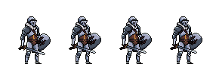

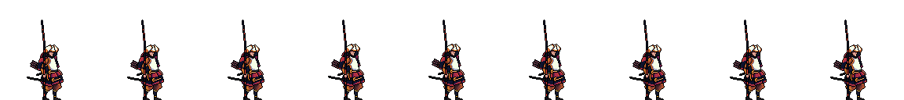

Above are images of player models with animations from a website referenced in the reference section. Using these models would allow me to manually animate the player whilst making it look realistic. The top player is a knight character and should have only close ranged attacks. This will cause this player to have to move lots in order to dodge the ranged attacks of other players and get closer to deal damage. The bottom player is an archer which will have a low damaging close range attack and a long ranged higher damaging attack, allowing the player to sit back to deal longer ranged damage.

##### How will the player be animated?

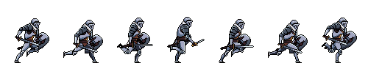The player frames for each animation are taken from a .png image containing all the frames for each animation. A .png image should be used because it can be made transparent to remove the background. For example, the run frame for the knight character (shown below) needs to be split into each individual frame by dividing the number of frames in the image by the width of the image in pixels.

At the beginning of the game running process, the program should load all of the .png images from files and split them into their individual frames which will be stored in array attributes to each player. This will help the program to run more quickly, because the images will be loaded before the main game loop begins. There should also be an array attribute to the player with all the current frame in the animation that are in use for each animation. The way that the frame number will increase will be using a cooldown check. The program will check, each run through, if the current time the program has been running for subtract the time at the last time the program changed frame is greater than or equal to the cooldown, and if so, the frame number should increase by one.

#### Hitbox

##### What is a hitbox?

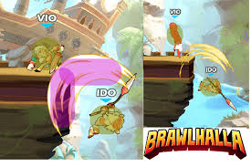Hitboxes are used in the majority of games for handling collisions. They are a vital part of making a game realistic and should be used for every object in my game. In many games the player has a main hitbox which fits around the image of the player and a hitbox on the player’s weapon to check for collisions with other players whilst the player is attacking. For example, Brawlhalla (shown below) uses a shape, which game engines call a ‘capsule’; a capsule is a rectangle with curved edges. Brawlhalla uses many capsules of several sizes to cover the full area of the attack animation and can use the space where the capsules overlap as a section which deals higher damage.

##### Player and platform hitboxes

Based on this research I have decided the best way of doing this for my game is to use rectangular hitboxes because these are easily supported on Pygame and are fairly accurate to where the attack animations occur. This is the most similar shape to the capsule used in brawlhalla and suits the attack animations I have chosen for my game very well. For close melee attacks, a rectangular hitbox in front of the player should be used. But, for any ranged attacks, the hitbox will need to follow the projectile that has been fired, such as an arrow or bullet because this is what will deal the damage.

A separate head hitbox would allow me to find out if the player is hitting their head and therefore stop their motion, so they don’t go through the platform. Additionally, this will allow the code to check if the platform can be passed through and if so, ignore the collision until the head hitbox has cleared the bottom of the platform to make the player pass through it seemlessly. The foot hitbox allows the system to differentiate between the players foot and the overall hitbox colliding with a platform. This is useful because the player should have forces applied in different directions depending on if the side of the hitbox or the bottom of the player hitbox collides with the platform. This will also allow for the player to move down through a platform with a keybind on the keyboard. This adds more movement possibilities into the game, making each game unique, unpredictable and therefore fun.

To update player and attack hitboxes, there should be an Update() function which updates all the coordinates and sizes of the hitboxes of all elements on the screen that can move and should return this as an array so the hitboxes can be redrawn in the correct places in the Draw() function.

The platforms will not move so the hitbox can be set from the original coordinates and will not need updating. A simple rectangular hitbox will fit them perfectly because they will be created using the rectangular Pygame object.

### Creating Working Buttons

The buttons will have a class because they will all follow the same basic structure with either an image, background, or no background with text, and the same functions for updating their position and checking if they are being pressed. The construction of the class will be discussed further in the classes section of documented design.

Pygame can be implemented to create a rectangle Pygame shape, which will hold the data for the position of the text so that it can be drawn in the correct place. Pygame can also be used to track the mouse pointer position so that if it is hovering over a button, the text will change colour to indicate to the player that they have hovered over it. This is useful to show what a player is selecting very clearly and makes the game look more professional, improving its perception by clients.

### Collisions

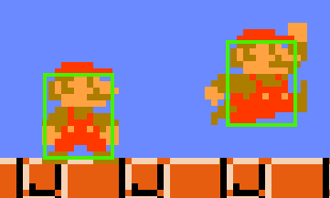In Pygame, collision detection usually involves checking if two objects overlap in space. Pygame provides multiple ways to perform collision detection, depending on the shape of your objects and the accuracy you need. However, because the player images I have chosen are close to rectangular, collision detection using rectangular hitboxes should be used as shown in the image on the right.

Pygame supports this directly through the Rect class. Each object in Pygame can have a Rect object, which represents the bounds of the sprite. Using the function colliderect, Pygame checks if the 2 Rect objects are overlapping and returns True if they are.

## Using Socket

Socket is a python library and provides low-level networking capabilities. Some examples of what you can do with it are:

* Creating a server that can accept incoming connections.
* Establishing a client and allowing it to connect to the server.
* Send and receive data over a network using TCP and UDP protocols.
* Manage multiple sockets.

### Creating a Server

To create a server, first a socket needs to be established. This is done using the socket function, this takes 2 parameters: the address family (IPv4 should be used in this project) and second parameter specifies the type of connection (UDP and TCP) should be used in this project. TCP should be used for the main server because it provides reliable and error-checked communication, ensuring that game data like player actions are consistently delivered without data loss. UDP should be used for broadcasting because it is fast, lightweight, and supports sending messages to multiple clients simultaneously without needing error checking.

Next, the socket needs to be bound to a port and IP address. A port is a virtual point on a computer for network connections, which acts as a channel for data exchange between a device and other systems over the internet or a local network. Ports are identified by numbers and help organize and manage different types of network traffic. An IP address is a unique number to each device on a network to identify it and enable communication. A program can either bind to a specific IP address or use 0.0.0.0 or an empty string mean the program is listening to find an IP later in the code. 0.0.0.0 will be used in my project for the server to bind to before it finds its current IP address.

After binding, the server should start listening (checking) for connections. This is done with the listen method which takes one parameter, the maximum number of connections that it can have. My project should have a maximum of 2 connections because it is a 2 player game.

If a connection is detected by the listen method, the accept function is used to allow the connection and it returns a new socket object and the client’s address.

### Communicating Between Client and Server

To receive and send data, two types methods are needed:

* The send method, which has 2 variations, the send and sendall methods. Both methods return data to the client – send will send data whenever it can but may not send all data in one go, whereas sendall will keep trying to send all the data until it can send all of it in one go. Any data that is sent must be sent with the .encode() method which turns the data into bytes which can be sent across a socket server. These methods will be used in both the client and server code because they will both need to send lots of data in different ways, whilst making sure it is secure using the .encode() method.
* The recv method reads data from the client, it takes one parameter – the max number of bits of information it can receive so that it cannot get overloaded. The .decode() method is required to transfer the bytes back into data that can be understood by the program. These methods will be used in both the client and server code because both will need to receive and process data so that it can be used.

Once communication is finished, both the client and server sockets should be closed to free up resources using the .close() method, which takes no parameters.

#### Python server prototype which can send and receive strings

import socket

This section of the code checks which client is sending the information and then sets up the reply accordingly so that the client receives the correct information.

from _thread import *

This creates a socket which is what data from the clients are sent to

import sys

server = "YOUR LOCAL IPV4"

port = 5555

s = socket.socket(socket.AF_INET, socket.SOCK_STREAM)

This binds the socket to the port address you choose at the top; this is a virtual port which is a virtual location where the server is hosted that other devices on the network can connect to.

try:

s.bind((server, port))

except socket.error as e:

str(e)

s.listen(2)

print("Waiting for a connection, Server Started")

def read_pos(str):

str = str.split(",")

return int(str[0]), int(str[1])

Threading is the process of running several processes at the same time, this is to allow both clients to send and receive data to the server simultaneously, instead of having to wait. This line sends the client an encoded string containing the players coordinates, they must be encoded to prevent interception from hackers in case the information is important.

def make_pos(tup):

return str(tup[0]) + "," + str(tup[1])

pos = [(0,0),(100,100)]

def threaded_client(conn, player):

conn.send(str.encode(make_pos(pos[player])))

reply = ""

while True:

try:

data = read_pos(conn.recv(2048).decode())

This line receives the data sent by the client and decodes it to send to the other client

pos[player] = data

if not data:

print("Disconnected")

break

else:

if player == 1:

Finds the client which the server is sending the data to (the opposite of the client who sent the data).

reply = pos[0]

else:

reply = pos[1]

print("Received: ", data)

print("Sending : ", reply)

Encodes and sends the data to the client.

conn.sendall(str.encode(make_pos(reply)))

except:

break

print("Lost connection")

Closes this thread of communication with the client if the while loop is broken.

conn.close()

currentPlayer = 0

while True:

conn, addr = s.accept()

print("Connected to:", addr)

start_new_thread(threaded_client, (conn, currentPlayer))

currentPlayer += 1

## Data Dictionary

The key variables are listed below with their type, initial value and description of their function.

|  |  |  |  |
| --- | --- | --- | --- |
| Data Item | Type | Initial Value | Information |
| objList | Array | Empty | Stores all the objects for items in the game such as players and platforms for use in the program. |
| arrowList | Array | Empty | Stores all currently active arrow objects. |
| mode | String | Empty | Stores the current selected item in the level editor menu. |
| MousePos (or similar) | Tuple | (0,0) | Stores mouse coordinates on the screen whilst in each game-mode or screen that requires it. |
| image | pygame.Surface | Empty | Stores the current loaded image before it is added as an attribute to its player object. |
| buttonSelected | Reference | None | Stores the current button object that has been selected by the player to change their keybinds. |
| currentTime | Float | 0 | The current time since the program started, used to compare to last updates for cooldown checking. |
| passThroughCount and collideCount | Integer | 0 | Store the number of platforms the player is colliding with and passing through at a time. |
| Booleans storing current events | | | |
| run | Boolean | True | Keeps the game loop running until the player presses exit and it causes the game loop to finish. |
| isDead | Boolean | False | Stores if either player is dead or not. |
| Variables for use with online server | | | |
| currentPlayer | Integer | Empty | Stores the current player that is active on current client to send to the server. |
| otherPlayer | Integer | Empty | Stores the other player that is not active on current client to send to server. |
| serverIP | String | ‘0.0.0.0’ | Stores the IP address of server to connect to. |
| serverPort | Integer | Empty | Stores port number of the server to connect to. |
| players | Array | Empty | Stores the 2 player objects and their updates every time the client and server exchange information. |
| reply | Reference | Empty | Stores the information the server will send back to the client. |
| data | Reference | Empty | Stores the data received by the client to the server. |

## Classes

### Class Diagram

In this project, the screen/UI is partially relied on by every class except the stack class because the visuals are the only way the user can take in the game’s information. The relationship between the screen and the player is composite because if the screen is deleted the players will also be deleted from the user’s perspective. The knight and archer are both players, so they inherit from the player class. The arrow class can only exist if the archer class exists and if it is deleted so is the arrow, therefore the relationship between archer and arrow is composite. The player also has a relationship with the platform. This is shown in the diagram with 2 conditions: 0..1 next to the platform shows that a player may be associated with 0 or 1 platform at one time; the 0..* next to the player shows that the platform may be associated with 0 or more players at one time.

The relationship between screen/UI and the player is a dependency (weak association) because the player depends on the server for some actions such as loading or saving data, but one player is managed by the server and the other only sends data and is not managed by the server. The relationship between the online object and the server is composite because the online object’s only function is to hold information to send to the server, so it cannot exist without the server. The network class also has a composition relationship with the server because its functions are to send data to the server, therefore it cannot exist without the server.

### Key Attributes

#### Player

|  |  |  |  |
| --- | --- | --- | --- |
| Attribute | Type | Initial Value | Information |
| x, y | Floats | Spawn point of player (from level file) | Stores the current position of the player in the x and y directions. |
| width, height | Integers | Input when object is created | Stores player’s width and height. |
| keybinds | Dictionary | Empty | Loads player’s keybinds from a file and stores them. |
| vel_x, vel_y | Floats | 0 | Stores the current velocity the player is travelling at. |
| numJumps | Integer | 2 (or number of intended jumps to start with) | Stores the current number of jumps the player has, will decrease by one when the player jumps and return to 0 when touching floor. |
| direction | Integer | 1 or -1 depending on if player 1 or 2 | Stores the direction the player is facing, 1 for left, -1 for right. Because player could be moving in one direction but still facing another. |
| damageTaken | Integer | 0 | Stores the total damage taken by the player since last death or join. |
| Score | Integer | 0 | Stores the total number of times player has knocked the other player off. |
| Collisionboxes | Reference | Rect objects containing starting width, height, x and y coordinates. | Used to check for collisions with objects and keep a track of the player’s size and location for redrawing the scene. |
| currentPlat | Reference | None | Stores, if any, the platform the player is currently colliding with |
| lastUpdates | Integer | 0 | Stores the last update to check against current time for cooldown checks on any actions with cooldowns. |
| isPerformingAction | Boolean | False | Stores whether the player is currently performing each specific action. |
| canPerformAction | Boolean | True | Stores whether the player can perform each specific action, it is changed after a successful cooldown check and after player performs action. |
| frames and flippedFrames for each action | Array | Empty | Stores Pygame images of each frame in the animation for each action. |
| currentAnim | Reference | Idle animation image | Stores current animation that is being displayed. |
| currentAnimNumbers | Array | [0,0,0,0,0,0,0,0,0,0] | Stores frame number each animation is on. |
| currentAnimIndex | Integer | 0 | Stores current index in the array above. |
| Dictionaries | Dictionary | Full of each animation | Map animations to their text or index equivalent. |
| Knight and Archer Subclasses | | | |
| imageDisplacement | Array | [-1, -16] for Knight and [-25, -50] for Archer | Stores the amount the image needs to be moved to fit correctly into the hitbox. |
| images | Reference | Reference to relevant .png file | Loads and stores .png image of each animation at the start of the running process. |
| lightAttackCooldown and heavyAttackCooldown | Integer | 1200 and 3000 for Knight and 1400 and 5000 for Archer | Stores the number of milliseconds before the player can do each attack again. |
| canCreateArrow | Boolean | True | Keeps a track of if player has an arrow active or not, and therefore if the player can shoot bow again – only for Archer. |
| isFiringArrow | Boolean | False | Keeps a track of if the player is in the firing arrow animation – only for Archer. |

#### Platform

|  |  |  |  |
| --- | --- | --- | --- |
| Attribute | Type | Initial Value | Information |
| x, y | Floats | Data from file | Stores the current position of the platform in the x and y directions. |
| width, height | Integers | Input when object is created | Stores platform’s width and height. |
| colour | Tuple | Data from file | Stores the colour of the platform in the rgb format. |
| passThrough | Boolean | Data from file | Stores whether the platform can be passed through by the player. |

#### Network

|  |  |  |  |
| --- | --- | --- | --- |
| Attribute | Type | Initial Value | Information |
| Port | Integer | 5555 | A chosen port number which is likely to be unique that will be broadcasted on the UDP server. |
| Server | Reference | Input when object is created | Stores the server object. |

#### Arrow

|  |  |  |  |
| --- | --- | --- | --- |
| Attribute | Type | Initial Value | Information |
| x, y | Floats | Input when object is created | Stores the current position of the arrow in the x and y directions. |
| width, height | Integers | Input when object is created | Stores platform’s width and height. |
| direction | Integer | Input when object is created | Stores the direction the arrow is travelling. |
| firedBy | Reference | Input when object is created | Stores the player the arrow was fired by. |
| hasHit | Boolean | False | Stores whether arrow has hit an enemy. |
| mass | float | 0.1 | Stores the mass of the arrow. |

## Key Subroutines

Below are examples of some of the key subroutines that should be included in this project.

### Play

The play function is the function that runs the main game loop. The main important structure of this subroutine will be: a section at the start for establishing local variables and loading anything that only needs to be loaded once, and a ‘while’ loop containing checks and actions that need to be carried out every frame for the game to run. Most games of this type follow a similar structure, highlighting how versatile and efficient it is to allow the creation of so many different games.

There are several variables that need to be established and smaller subroutines that need to be loaded at the beginning:

* The arrow variable should be set to None, isDead should be set to False.
* LoadLevel() subroutine should be used to transfer the data in the file into useable data in the form of objects to be displayed on the screen.
* Keybinds for each player should be loaded from the player keybinds file and saved as an attribute to the player.

The next section is the while loop, which is for actions that need to be repeated:

* Move function – will be discussed later.
* Check all player collisions: head hitbox with platforms, body hitbox with platforms or weapons and foot hitbox with platforms.
* Apply gravity
* Use Pygame events manager to check if any of the keys to activate events with cooldowns are being pressed
* Check if either player is dead
* Move and apply gravity to the arrow
* Redraw the window

### PlayOnline

This subroutine is the same as the Play() but is constructed so that only one player can be moved and controlled. The other player’s movements are controlled by the other client: only data received from the server is used to move the player, which is not controlled by the current client.

To do this over any network, a complex client server model is required. The first part is to create a UDP server for the client to receive the port number and IP address of the server so that this setup can work on any network and the user does not need to edit the code directly. However, the user cannot enter the main game loop until a connection to the main server is established. This means that the client must keep attempting to receive a broadcast from the server until it gets information that works, then the loading and game loop above will be run.

### Redrawing Window

For the user to play the game, the screen needs to be constantly updated with all the objects in the correct locations several times per second. This is done by making an efficient game loop and running the redraw window function every frame.

This function consists of an iterative statement at the start which runs the Draw() function for every object in the scene, which will draw that individual object on the screen in its updated position. It then finds the current animation that each player is on and tries to blit that onto the screen, or blits the last frame on the screen if not. It will then draw the updated scores onto the screen and finally update the screen. This function really brings the game to life, allowing users to see the results of every key they are pressing, drawn in front of them.

### Edit Level

The EditLevel() function should be an alternative while loop to the play game loop, so that the user can keep editing for as long as they would like until they have submitted their level to be saved into a file. I plan to construct this function so that the user can visually see the level they are creating as they create it because this will let them more easily see what they are creating, as well as with giving them new and innovative ideas along the way on how to improve their level.

The beginning of the function should be establishing variables and screen elements, this will include:

* Defining button objects.
* Defining the unmovable central platform.
* Establishing boolean variables about which items the user has selected and the mode variable which holds a string representing the current item the user has selected.
* Defining the stack.

The next section is the while loop. This will run repeatedly as long as the user is editing a level, it should include:

* Create the mouse pointer and set its coordinates to current coordinates.
* Drawing a background and spawn point mode, platform mode and back buttons on the screen.
* Using Pygame’s events manager to check if left click is being pressed and if the current mouse position is on one of the buttons. Then changing the current mode to the relevant mode and causing the correct object to be created and follow the mouse pointer. It should also check if the user is currently in a mode and then save the object placed onto the stack and stop the object following the mouse pointer.
* If the user is detected by Pygame’s events manager to have pressed the enter key then the program should ask the user to pick a level number to save data into and then run the save level functions discussed below.

## Python stack prototype for use in level editor

class Stack:

  def __init__(self, maxSize):

This section describes what is in the stack. The data is an array that contains all the values in the stack, the top is the index of the item at the top of the stack and the max size of the stack is how large the stack can be before the push function will no longer work.

    self.data = []

    self.top = -1

    self.mode = []

    self.maxSize = maxSize

  def GetData(self):

    return self.data

The setData function sets the data in the index position inputted to the value of data inputted, replacing any data already stored there. The addData function adds the inputted data onto the end of list as long as the list isn’t full

  def SetData(self, index, data):

    (self.data)[index] = data

  def AddData(self, data, mode):

    self.data.append(data)

    self.mode.append(mode)

  def GetTop(self):

    return self.top

These are getters and setters, these simply just get the value of an attribute of the object or set a value of an attribute to another value.

  def SetTop(self, top):

    self.top = top

  def SetSize(self, size):

    self.maxSize += size

  def IsEmpty(self):

isFull and isEmpty simply check if the list has reached its max size or if the list has nothing in it to avoid errors when adding and removing items.

    return len(self.data) <= 0

  def IsFull(self):

    if len(self.data) >= self.maxSize:

      return True

def Push(self, newData, newMode):

This is the Push function which is the way you add data to a stack. The function first checks to see if the stack is full because otherwise it cannot have any more data added. If not full, then the new data item is added using the addData function and the top of the list is set one higher.

if self.IsFull():

      print("Error, stack full")

    else:

      self.AddData(newData, newMode)

      self.SetTop(len(self.data)-1)

  def Pop(self):

    currentNode = self.GetTop()

    if self.IsEmpty():

The pop function is how data is removed from a stack, data can only be taken from the top one at a time because a stack is a last in first out data structure. First the program checks if the list is empty and if so, outputs an error. If not, then the piece of data with the index at the top of the list is set to none and the top is set to the index below. The peek function just lets the user see the top item of the stack.

        print("ERROR")

        return "error, stack empty"

    else:

      self.data.Pop(currentNode)

      self.mode.Pop(currentNode)

      self.SetTop(int(self.getTop())-1)

  def Peek(self):

    return self.GetData()[self.GetTop()]

### Save Level

After level editing, the level data should be saved into an appropriate file as the user selects to allow the user to remember where they have stored their level and play it whenever they choose. This can be done by allowing the user to select a level number to save their level data into so they can find it when selecting a level to play. This is used in many games with level editors and I think it would be a great addition to mine.

The way level data is stored will follow a specific format so that levels can easily be read and transferred into useable data. This format will be as strings, each corresponding to attributes to their specific object, except the first string which will be the type of object. These strings will be separated by full stops so that the .split() built in python function to split the line into separate strings in a list.

### Loading Levels and Processing Objects

Each level is stored in its own file, with one line for each object in the scene. Level files should be named by “Level” followed by a number. The level is loaded by opening the level file of the number the player selects, and inputting this level number into the LoadLevel() function.

The LoadLevel function works with the ProccessObject() function to fully transfer all file data for a level into objects which can be used by the main game loop. The pseudocode below shows how the code for LevelEditor and ProcessObject will run.

FUNCTION LoadLevel(LevelNumber: INTEGER): RETURNS ARRAY OF Player and Platform

DECLARE Arrays: objList ← []

objtypeList ← []

playerSPList ← []

OPEN "Level"+String(LevelNumber)+".txt" FOR READ

DECLARE Array: Lines = Level.readlines() #this reads the file and puts each line into its own element of the array

        FOR i ← 0 TO len(Lines):

            Line ← str(Lines[i]).split(".") #Creates a new line variable for each line in the file and splits into a list every time there is a comma.

            clean ← Line[len(Line)-1].strip() #Removes extra, unnecessary characters from the end of line.

            APPEND Line[0] TO objtypeList #First element in Line will be the type of object.

            newObj, SP ← ProcessObject(clean) #Inputs each part of the Line into the ProcessObject function which will be discussed later.

            APPEND SP TO playerSPList

            APPEND newObj TO objList

    RETURN objList and playerSPList

FUNCTION ProcessObject(attributeList: ARRAY OF STRINGS):

name ← None

MATCH attributeList[0] TO: #compares first element of attributeList to the strings below

‘Knight’:

name ← Knight OBJECT (attributeList[1 TO 7]) #creates new object

SP ← (attributeList[1], attributeList[2] #creates player’s spawn point

‘Archer’:

name ← Archer OBJECT (attributeList[1 TO 7])

SP ← (attributeList[1], attributeList[2]

‘Platform’:

name ← Platform OBJECT (attributeList[1 TO 7])

SP ← None

### Update Subroutines

Update subroutines are individual for each object and contained within their class. Their purpose is to update attributes to the object that need to be drawn on the screen, these include:

* Position, in x and y directions
* Velocity in the x and y directions
* The object’s collision box

The update subroutines should be called just before the RedrawWindow() function, so that the most up-to-date information will appear on the screen for the user. The hitbox needs to be updated regularly because the program is constantly checking for collisions between objects’ hitboxes, and it can only use the last updated version of the hitbox. Therefore, for the game to run as well as possible, the hitboxes should be updated frequently so that hits are only counted when they should be. This would greatly improve the gaming experience for the user because it will make the program more realistic. Below shows pseudocode for my design of the player’s update method:

CLASS Player:

    FUNCTION Update(self, arrowList: ARRAY OF Arrow):

        self.collisionbox ← pygame.Rect(self.x, self.y, self.width, self.height)

        self.footCollisionbox ← pygame.Rect(self.x, self.y+value, self.width, value)

        self.headCollisionbox ← pygame.Rect(self.x, self.y+value, self.width, value)

        IF self.isHeavyAttacking = True and self.isFiringArrow:

            self.attackCollisionBox ← pygame.Rect(arrowList[0], arrowList[0].y, 64, 16)

        ELSE IF self.isAttacking = True:

            self.attackCollisionBox ← pygame.Rect(#contains values equal to the size and location of the attack hitbox of the player)

        ELSE:

            self.attackCollisionBox ← None

#value represents variable or integer which will be calculated later

### Saving Animation Images

Animation images should be saved as attributes to the player they belong to. This is because the animations are different for every player type. The animations will be loaded from one .png image containing many frames; this image should be split up, with each frame as an element in a list. The Pseudocode below shows how an image will be loaded:

    FUNCTION GetImage(self, frameNum: INTEGER, orientation: STRING, sheet: REFERENCE, width: INTEGER, height: INTEGER, scale: INTEGER, colour: TUPLE):

        Image ← pygame.Surface((width, height)).convert_alpha()

        image.blit(sheet, (-5,0), (frameNum*width,0, width, height)) #this formula will separate the image out into its individual frames

        IF orientation = "l":

            image ← pygame.transform.flip(image, True, False) #this will flip the image

        image ← pygame.transform.scale(image, (width*scale, height*scale)) #transforms the image to its correct size for the screen

        image.set_colorkey(colour) #removes the image background

        RETURN image

### Change Keybinds

This function should be a method inside the player class because the keybinds will be an attribute to the player class. This allows each player’s keybinds to be changed individually. The function will run if the player selects the change keybinds button from the settings menu. The function should:

* Iterate through the keybinds dictionary of the player using the built-in enumerate function in python. Inside the for loop there should be: a button object for each keybind, text for the button, and a Rect to track its position.
* Update mouse pointer position
* Buttons should be updated and checked for interactions from the player.
* If an interaction occurs, the program should store the next input from the player and change the currently selected keybind in the file to the key that was pressed.

### Cooldown Checking

The player has several actions that should only be performed once, before the user has to wait before they can perform them again to stop players jumping, dashing and attacking an unlimited amount of times. This would be bad because the game could be easily be won by just holding down the attack keybind, adding cooldowns increases the difficulty by making users time their attacks and dashes. The way that these cooldowns will be checked is using cooldown checking subroutines.

For movement, the program will use pygame.key.get_pressed() to check for continuous key presses, but for keys that are only meant to be pressed once, the Pygame events manager with KEYDOWN and MOUSEBUTTONDOWN functions should be used. After these detect the key being pressed and the other criteria in the comparison to be correct, they will run the actions inside the if statement.

Adding a cooldown allows for the program to make some actions to take longer before they can be performed again, such as if a particular attack is especially powerful or does lots of damage. It should have a longer cooldown to make the game fair.

Cooldown checks are done using the Pygame tick system to find the time at a given moment since the program started running. This allows for a variable to store the last time the action took place and every time the action is attempted, the program should compare the current time with the last time the action occurred. If the difference is greater than the cooldown then the action should become available to be performed, but otherwise if should remain unable to be performed. In this project, the animation cooldowns should be stored as attributes to each player so that they can be adjusted and accessed for individual players.

### Move

This should be a method of the player class. It should control all player actions that are not part of the Pygame events manager. All handling of the Pygame events manager should be done in one area for each game loop.

The method should consist of:

* Checking if the left or right keybinds are being pressed and if the player is not heavy attacking, increase the velocity by acceleration until max velocity is reached. If the player is heavy attacking, the max velocity should be slower because it is harder to move faster when performing a long attack.
* Checking if down is being pressed so that the player can go through any platform that can be passed through that the player is on.
* Check if velocity is greater than or less than 0, setting the current direction and animating the player. If jump is true then the run animation should be overruled to play the jump one instead.
* Apply friction to the player for more realistic deceleration.
* Run the attack animation if the player is attacking, this should overrule all other animations.
* Check if the player has been attacked and apply knockback to the player if so.
* Add the current velocity to the player’s x and y position.

### Change Button Colour

This function is to change the colour of the text on a button if it is being hovered over by a user’s cursor. This is to improve the UI of the game and so the player knows when they are selecting a button. For this to happen, the attribute corresponding to text colour for the button needs to change. Below shows pseudocode for how this could be done:

FUNCTION ChangeColour(self, position: TUPLE OF FLOATS):

      IF position[0] BETWEEN (self.rect.left, self.rect.right) AND position[1] BETWEEN(self.rect.top, self.rect.bottom): #checks if the cursor is inside the button’s area.

          self.text ← self.font.render(self.text_input, True, self.hovering_colour) #changes the text colour to the new colour.

      ELSE:

          self.text ← self.font.render(self.text_input, True, self.base_colour) #keeps text colour the same.

### Determining knockback

Knockback should increase with the damage that the player takes. However, a linear (damage taken and knockback increase at the same rate) relationship would cause the player to move far too quickly across the screen after being hit only a few times, or the player to barely move on the first few hits. Therefore, the formula must increase but by a smaller and smaller value each time the player is hit. To achieve a relationship like this, the formula must be K + DF where K is an integer, D is damage taken and F is a fraction between 0 and 1. Below shows a graph of a possible formula that fits the above criteria, the y axis represents the knockback, and the x axis represents the total damage taken.

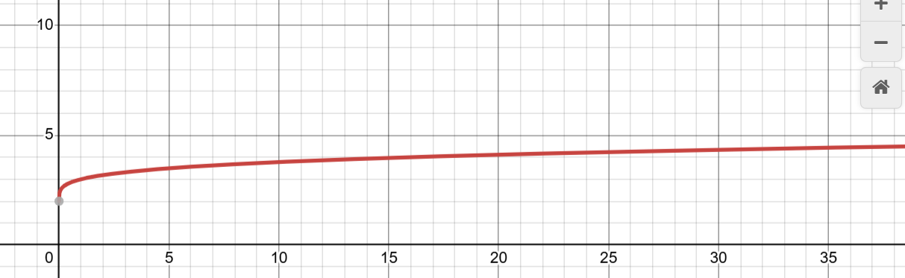

# Technical Solution

Below shows all of the code for this project, the green text with hashtags at the start are my comments, explaining how each part of the code works. Each file of the code has its own heading as shown below with the file type and file name.

|  |  |
| --- | --- |
| File name and number | Beginning page number |
| 4.1 Main Python File – “main.py” | 85 |
| 4.2 Player Python File – “player.py” | 90 |
| 4.3 Platform Python File – "plat.py” | 121 |
| 4.4 Button Python File – “button.py” | 122 |
| 4.5 Constants Python File - "constants.py” | 124 |
| 4.6 Stack Python File – “stack.py” | 125 |
| 4.7 Network Python File – “network.py” | 127 |
| 4.8 Server Python File - "server.py” | 129 |
| 4.9 Other Files (.png, .txt) | 132 |

## Main Python File – “main.py”

from re import X

import pygame, sys

import os

import math as m

import time

import socket

from pygame.locals import QUIT

from player import Player, OnlineObject, Knight, Archer, Arrow

from button import Button

from plat import Plat

from stack import Stack

import constants as c

from network import Network

import random

#Creates the window which everything is drawn onto

win = pygame.display.set_mode((c.width, c.height),pygame.RESIZABLE)

width = c.width

height = c.height

#Initialises Pygame and captions the window

pygame.init()

pygame.display.set_caption("Client")

#A function to change text into usable objects

def ProcessObject(attributeList):

    name = None

    SP = None

    #This match function is used to compare the first item on each line of the file to find out what type of object

needs to be created

    #The rest of the data is then inputted as attributes and the spawn point (SP) is set if the object is a player

    match attributeList[0]:

        case 'Knight':

            name = Knight(int(attributeList[1]), int(attributeList[2]), int(attributeList[3]),

int(attributeList[4]), (int(attributeList[5]), int(attributeList[6]), int(attributeList[7])))

            SP = (int(attributeList[1]),int(attributeList[2]))

        case 'Archer':

            name = Archer(int(attributeList[1]), int(attributeList[2]), int(attributeList[3]),

int(attributeList[4]), (int(attributeList[5]), int(attributeList[6]), int(attributeList[7])))

            SP = (int(attributeList[1]),int(attributeList[2]))

        case 'Platform':

            name = Plat(int(attributeList[1]), int(attributeList[2]), int(attributeList[3]), int(attributeList[4]),

(int(attributeList[5]), int(attributeList[6]), int(attributeList[7])), attributeList[8])

    return name, SP

def LoadLevel(LevelNumber):

    objList = []

    playerSPList = []

    #Opens the text file relating to the selected level

    with open ("Level"+LevelNumber+".txt", "r") as Level:

        #Reads the file data and stores each line as an item in the array Lines

        Lines = Level.readlines()

        #Iterates through each item in Lines and runs ProcessObject() on it to transfer text into objects

        for i in range(len(Lines)):

            Line = str(Lines[i]).split(".")

            newObj, SP = ProcessObject(Line)

            #Adds new objects and data to the correct Array

            playerSPList.append(SP)

            objList.append(newObj)

    return objList, playerSPList

#Used to draw everything onto the screen each frame

def RedrawWindow(playerList, platList, arrowList):

    #Background needs to be redrawn so that the old images are no longer on the screen, the background covers them

up

    win.fill("Light Blue")

    #Draws all the platforms on the screen

    for i in range(len(platList)):

        platList[i].Draw(win)

    #Draws any existing arrows onto the screen

    for arrow in arrowList:

        arrow.Draw(win)

    #Draws the current frame for each player on the screen

    for i in range(len(playerList)):

        try:

            #Finds the current frame

            frame = playerList[i].currentAnim[playerList[i].currentFrame]

            #Finds the position to draw it on the screen

            position = (playerList[i].x+playerList[i].imageDisplacement[0],

playerList[i].y+playerList[i].imageDisplacement[1])

            #Draws it

            win.blit(frame, position)

        #If there is an issue finding the frame, such as game lag

        except:

            #Resets the player's current frame because most likely the frame number has become to high

            playerList[i].currentFrame = 0

            #Finds the current frame

            frame = playerList[i].currentAnim[playerList[i].currentFrame]

            #Finds the position to draw it on the screen

            position = (playerList[i].x+playerList[i].imageDisplacement[0],

playerList[i].y+playerList[i].imageDisplacement[1])

            #Draws it

            win.blit(frame, position)

    #Recreates the scores for each player incase they have changed

    scoreText1 = GetFont(75).render(str(playerList[0].score), True, "Blue")

    scoreRect1 = scoreText1.get_rect(topleft=(300, 50))

    scoreText2 = GetFont(75).render(str(playerList[1].score), True, "Red")

    scoreRect2 = scoreText2.get_rect(topleft=(800, 50))

    #Redraws the scores for each player

    win.blit(scoreText1, scoreRect1)

    win.blit(scoreText2, scoreRect2)

    #Updates the screen

    pygame.display.update()

#Run when the player opens the settings menu

def SettingsMenu(playerList):

    #run is used to stop the while loop if it is set to False

    run = True

    #Creates all of the text and buttons that appear on the screen

    Text1 = pygame.font.Font(None, 100).render("Settings", True, "White")

    Rect1 = Text1.get_rect(midleft=(550, 100))

    p1Button = Button(pygame.image.load("Menu/Play Rect.png"), (300, 400), "Player 1 Keybinds", GetFont(50),

"Green", "White")

    p2Button = Button(pygame.image.load("Menu/Play Rect.png"), (1100, 400), "Player 2 Keybinds", GetFont(50),

"Green", "White")

    quitButton = Button(pygame.image.load("Menu/Play Rect.png"), (700, 700), "Quit", GetFont(50), "Green", "White")

    while run == True:

        #Keeps a track of the position of the mouse pointer on the screen

        MousePos = pygame.mouse.get_pos()

        #Draws the text and buttons onto the screen

        win.blit(c.BG, (0, 0))

        win.blit(Text1, Rect1)

        for button in [p1Button, p2Button, quitButton]:

            button.Update(win)

            button.ChangeColour(MousePos)

        #Uses Pygame's event handler

        for event in pygame.event.get():

            #Checks if left click is pressed

            if event.type == pygame.MOUSEBUTTONDOWN:

                #If it is over any of the buttons, it opens the appropriate part of the settings menu

                if p1Button.CheckInput(MousePos):

                    playerList[0].ChangeKeybinds(win, 1)

                elif p2Button.CheckInput(MousePos):

                    playerList[1].ChangeKeybinds(win, 2)

                #Goes back to main menu

                elif quitButton.CheckInput(MousePos):

                    MainMenu()

            if event.type == pygame.KEYDOWN and event.key == pygame.K_ESCAPE:

                    run = False

        #Updates the screen

        pygame.display.update()

#A function used to get the player's keybinds from a file

def GetKeybinds(numLines, player):

    keybindList = []

    #Opens file in read mode

    with open ("Player"+str(player)+"Keybinds.txt", "r") as Keybinds:

        #Stores each line in the file as an item in the array Lines

        Lines = Keybinds.readlines()

        #Iterates through Lines and adds each line to keybindList which will be returned to the Play() gameloop

        for i in range(numLines):

            keybindList.append(int(Lines[i]))

    return keybindList

#Main function for the offline gamemode

def Play(levelNum):

    #Define variables which are used in the gameloop

    clock = pygame.time.Clock()

    arrowList = []

    arrow = None

    run = True

    playerList = []

    platList = []

    #Uses LoadLevel() to turn file data into an array of objects and an array of player spawn points

    objList, playerSPList = LoadLevel(str(levelNum))

    #Iterate through objList and add platforms to platList

    for i in range(len(objList)-2):

        platList.append(objList[i+2])

    #Iterates through players

    for i in range(2):

        #Loads players animations

        objList[i].LoadAnims()

        #Adds players to playerList

        playerList.append(objList[i])

        #Gets keybinds and inputs them to their appropriate place in the dictionary

        keybindList = GetKeybinds(7, i+1)

        playerList[i].Keybinds = {

            "left":keybindList[0],

            "right":keybindList[1],

            "up":keybindList[2],

            "down":keybindList[3],

            "attackLight":keybindList[4],

            "attackHeavy":keybindList[5],

            "dash":keybindList[6]

            }

    #Gameloop

    while run:

        #Sets clock speed to allow the while loop to run 60 times per second (this is so that players do not move

faster or slower depending on computing power)

        clock.tick(60)

        #Runs Move() function for each player

        arrow = playerList[0].Move(playerList[1], arrowList)

        arrow = playerList[1].Move(playerList[0], arrowList)

        #Checks if player is dead

        for i in range(2):

            isDead = playerList[i].DeathCheck()

            if i == 0:

                deadPlayer = 0

                alivePlayer = 1

            elif i == 1:

                deadPlayer = 1

                alivePlayer = 0

            #If so, it resets the dead player to their spawn point and adds score to the other player

            if isDead:

                playerList[alivePlayer].score += 1

                playerList[deadPlayer].x = playerSPList[deadPlayer][0]

                playerList[deadPlayer].y = playerSPList[deadPlayer][1]

                playerList[deadPlayer].vel_x = 0

                playerList[deadPlayer].vel_y = 0

                isDead = False

                playerList[deadPlayer].damageTaken = 0

            #Runs Gravity(), cooldown and collision checks on each player

            playerList[i].Gravity()

            playerList[i].IsDashingCooldownCheck()

            playerList[i].DashCooldownCheck()

            playerList[i].CanAttackCheck()

            playerList[i].OnGroundCheck(platList)

            playerList[i].HitHead(platList)

        #Uses Pygame event handler to check for actions because the actions below should only be performed once

before a cooldown is required

        for event in pygame.event.get():

            #Jump check for each player

            if event.type == pygame.KEYDOWN and event.key == playerList[0].Keybinds["up"] and playerList[0].numJumps >= 1:

                playerList[0].vel_y = -16

                if playerList[0].vel_x != 0:

                    playerList[0].vel_x += (playerList[0].vel_x)/2

                playerList[0].numJumps -= 1

                playerList[0].isJumping = True

                if not playerList[0].isJumping:

                    playerList[0].currentFrame = 0

            if event.type == pygame.KEYDOWN and event.key == playerList[1].Keybinds["up"]  and

playerList[1].numJumps >= 1:

                playerList[1].vel_y = -16

                if playerList[1].vel_x != 0:

                    playerList[1].vel_x += (playerList[1].vel_x)/2

                playerList[1].numJumps -= 1

                playerList[1].isJumping = True

                if not playerList[1].isJumping:

                    playerList[1].currentFrame = 0

            #Dash check for each player

            if event.type == pygame.KEYDOWN and event.key == playerList[0].Keybinds["dash"]:

            playerList[0].DashCooldownCheck()

                if playerList[0].canDash == True:

                    playerList[0].vel_x = 18*playerList[0].currentDir

                    playerList[0].isDashing = True

                    playerList[0].canDash = False

            if event.type == pygame.KEYDOWN and event.key == playerList[1].Keybinds["dash"]:

                playerList[1].DashCooldownCheck()

                if playerList[1].canDash == True:

                    playerList[1].vel_x = 18*playerList[1].currentDir

                    playerList[1].isDashing = True

                    playerList[1].canDash = False

            #Light attack check for each player

            if event.type == pygame.KEYDOWN and event.key == playerList[0].Keybinds["attackLight"] and

playerList[0].isLightAttacking == False and playerList[0].isHeavyAttacking == False and

playerList[0].canLightAttack == True:

                playerList[0].isLightAttacking = True

                playerList[0].canLightAttack = False

                if not playerList[0].isJumping:

                    playerList[0].currentFrame = 0

                playerList[1].isAttacked = False

            if event.type == pygame.KEYDOWN and event.key == playerList[1].Keybinds["attackLight"] and

playerList[1].isLightAttacking == False and playerList[1].isHeavyAttacking == False and

playerList[1].canLightAttack == True:

                playerList[1].isLightAttacking = True

                playerList[1].canLightAttack = False

                if not playerList[1].isJumping:

                    playerList[1].currentFrame = 0

                playerList[0].isAttacked = False

            #Heavy attack check for each player

            if event.type == pygame.KEYDOWN and event.key == playerList[0].Keybinds["attackHeavy"] and

playerList[0].isLightAttacking == False and playerList[0].isHeavyAttacking == False and

playerList[0].canHeavyAttack == True:

                playerList[0].isHeavyAttacking = True

                playerList[0].canHeavyAttack = False

                if not playerList[0].isJumping:

                    playerList[0].currentFrame = 0

                playerList[1].isAttacked = False

            if event.type == pygame.KEYDOWN and event.key == playerList[1].Keybinds["attackHeavy"]  and

playerList[1].isLightAttacking == False and playerList[1].isHeavyAttacking == False and

playerList[1].canHeavyAttack == True:

                playerList[1].isHeavyAttacking = True

                playerList[1].canHeavyAttack = False

                if not playerList[1].isJumping:

                    playerList[1].currentFrame = 0

                playerList[0].isAttacked = False

            #Check to see if settings menu has been opened

            if event.type == pygame.KEYDOWN and event.key == pygame.K_ESCAPE:

                SettingsMenu(playerList)

        #Runs RedrawWindow() to redraw the screen

        RedrawWindow(playerList, platList, arrowList)

        #Iterates through each arrow in the arrowList

        for i in range(len(arrowList)):

            #Tries to check if the arrow is off the screen or has collided with an enemy player

            try:

                if (arrowList[i].x >= c.width + arrowList[i].width or arrowList[i].x < 0-(arrowList[i].width) or

arrowList[i].y > c.height or arrowList[i].y < 0) or (arrowList[i].hasHit):

                    arrowList[i].firedBy.isFiringArrow = False

                    del arrowList[i]

            except:

                continue

        #Applies gravity and movement to each arrow in arrowList

        for arrow in arrowList:

            arrow.Gravity()

            arrow.Move(arrowList)

#Main function for the online gamemode

def PlayOnline(levelNum):

    #Define variables which are used in the gameloop

    clock = pygame.time.Clock()

    arrowList = []

    arrow = None

    run = True

    playerList = []

    platList = []

    #Uses LoadLevel() to turn file data into an array of objects and an array of player spawn points

    objList, playerSPList = LoadLevel(str(levelNum))

    #Iterate through objList and add platforms to platList

    for i in range(len(objList)-2):

        platList.append(objList[i+2])

    #Iterates through players

    for i in range(2):

        #Loads players animations

        objList[i].LoadAnims()

        #Adds players to playerList

        playerList.append(objList[i])

        #Gets keybinds and inputs them to their appropriate place in the dictionary

        keybindList = GetKeybinds(7, i+1)

        playerList[i].Keybinds = {

            "left":keybindList[0],

            "right":keybindList[1],

            "up":keybindList[2],

            "down":keybindList[3],

            "attackLight":keybindList[4],

            "attackHeavy":keybindList[5],

            "dash":keybindList[6]

            }

    #Creates a new socket to use

    udp_socket = socket.socket(socket.AF_INET, socket.SOCK_DGRAM)

    udp_socket.setsockopt(socket.SOL_SOCKET, socket.SO_BROADCAST, 1)

    #Binds the socket to the same port that the server is broadcasting its IP address and port of game server on

    try:

        udp_socket.bind(('', 37020))

    except:

        #There can be two clients that join so there is a second udp socket incase both clients try to join at the same time

        try:

            udp_socket.bind(('', 37021))

        #If binding to both ports fails (there is already a client connected), client returns to main menu

        except:

            MainMenu()

    #Saves data received from server broadcasts

    data, addr = udp_socket.recvfrom(1024)

    #Decodes data so that it is transmitted safely

    serverInfo = data.decode()

    serverIP, serverPort = serverInfo.split(':')

    serverPort = int(serverPort)

    n = Network(serverIP)

    #Defines the default data to be sent, this will be changed later

    data = OnlineObject(300, 300, 0, 0, 1, False, False, False, False, False, False, False, [0,0,0,0,0,0,0,0,0,0],

0)

    #Gameloop

    while run:

        #Sets clock speed to allow the while loop to run 60 times per second (this is so that players do not move

faster or slower depending on computing power)

        clock.tick(60)

        #Sets the current player and otherPlayer, this allows the program to know which player the user can control

and which player's data to send to the server

        if data.player == 0:

            data.player = 1

            player = data.player

            otherPlayer = 0

        elif data.player == 1:

            data.player = 0

            player = data.player

            otherPlayer = 1

        #Uses the makObject function to make an OnlineObject to send to hold the data that is sent to the server

using the .send() function

        data = n.Send(playerList[player].MakeObject(player, playerList[otherPlayer]))

        #Tries to update the other player in the current scene

        try:

            arrow = data.UpdateObject(playerList[otherPlayer], arrowList, playerList[player])

        #For the except statement to occur, there must have been an error with receiving data such as the other

client leaving

        except:

            MainMenu()

        #Moves the active player on this client

        arrow = playerList[player].Move(playerList[otherPlayer], arrowList)

        #Checks if the other player has been attacked

        playerList[otherPlayer].CheckAttacked(playerList[player], arrowList)

        #Checks if the active player is dead

        isDead = playerList[player].DeathCheck()

        #If true then the other player has score added and the dead player has coordinates reset

        if isDead:

            playerList[otherPlayer].score += 1

            playerList[player].x = playerSPList[player][0]

            playerList[player].y = playerSPList[player][1]

            playerList[player].vel_x = 0

            playerList[player].vel_y = 0

            playerList[player].damageTaken = 0

            isDead = False

        #Runs Gravity(), cooldown and collision checks on each player

        for i in range(2):

            playerList[i].Gravity()

            playerList[i].IsDashingCooldownCheck()

            playerList[i].DashCooldownCheck()

            playerList[i].CanAttackCheck()

            playerList[i].OnGroundCheck(platList)

            playerList[i].HitHead(platList)

        #Uses Pygame event handler to check for actions because the actions below should only be performed once

before a cooldown is required

        for event in pygame.event.get():

            #Jump check for active player

            if event.type == pygame.KEYDOWN and event.key == playerList[player].Keybinds["up"] and

playerList[player].numJumps >= 1:

                playerList[player].vel_y = -16

                if playerList[player].vel_x != 0:

                    playerList[player].vel_x += (playerList[player].vel_x)/2

                playerList[player].numJumps -= 1

                playerList[player].isJumping = True

                playerList[player].currentFrame = 0

            #Dash check for each player

            if event.type == pygame.KEYDOWN and event.key == playerList[player].Keybinds["dash"]:

                playerList[player].DashCooldownCheck()

                if playerList[player].canDash == True:

                    playerList[player].vel_x = 16*playerList[player].currentDir

                    playerList[player].isDashing = True

                    playerList[player].canDash = False

            #Light attack check for active player

            if event.type == pygame.KEYDOWN and event.key == playerList[player].Keybinds["attackLight"] and

playerList[player].isLightAttacking == False and playerList[player].isHeavyAttacking == False and

playerList[player].canLightAttack == True:

                playerList[player].isLightAttacking = True

                playerList[player].canLightAttack = False

                playerList[otherPlayer].isAttacked = False

                if not playerList[player].isJumping:

                    playerList[player].currentFrame = 0

            #Heavy attack check for active player

            if event.type == pygame.KEYDOWN and event.key == playerList[player].Keybinds["attackHeavy"] and

playerList[player].isLightAttacking == False and playerList[player].isHeavyAttacking == False and

playerList[player].canHeavyAttack == True:

                playerList[player].isHeavyAttacking = True

                playerList[player].canHeavyAttack = False

                playerList[otherPlayer].isAttacked = False

                if not playerList[player].isJumping:

                    playerList[player].currentFrame = 0

            #Takes user to settings menu if escape key is pressed

            if event.type == pygame.KEYDOWN and event.key == pygame.K_ESCAPE:

                SettingsMenu(playerList)

        #Runs RedrawWindow()

        RedrawWindow(playerList, platList, arrowList)

        #Iterates through each arrow in the arrowList

        for i in range(len(arrowList)):

            #Tries to check if the arrow is off the screen or has collided with an enemy player

            if (arrowList[i].x >= c.width + arrowList[i].width or arrowList[i].x < 0-(arrowList[i].width) or

arrowList[i].y > c.height or arrowList[i].y < 0) or (arrowList[i].hasHit):

                arrowList[i].firedBy.isFiringArrow = False

                del arrowList[i]

        #Applies gravity and movement to each arrow in arrowList

        for arrow in arrowList:

            arrow.Gravity()

            arrow.Move(arrowList)

def LevelSelect(numList, mode):

    #Initialising variables used to draw text and create buttons to be drawn on the screen

    levelList = []

    halfLen = len(numList)//2

    Text1 = GetFont(75).render("Select one of the saved levels to play:", True, "White")

    Rect1 = Text1.get_rect(topleft=(75, 150))

    #count used to find out how many levels there are

    count = 1

    count2 = 1

    #Iterates through the first half of the levels and creates buttons for them, this will be the top row on the

screen

    for i in range(len(numList)-halfLen):

        levelList.append(Button(None, (100*(count), 300), str(numList[i]), GetFont(75), "Yellow", "Light Blue"))

        count += 1

    #Iterates through the second half of the levels and creates buttons for them, this will be the bottom row on the

screen

    for i in range(halfLen):

        levelList.append(Button(None, (100*(count2), 450), str(numList[i+(len(numList)-halfLen)]), GetFont(75),

"Yellow", "Light Blue"))

        count2 += 1

    #Loop which runs when in the level selector

    while True:

        #Draws background and text onto the screen

        win.blit(c.BG, (0, 0))

        win.blit(Text1, Rect1)

        #Keeps a track of the position of the mouse pointer on the screen

        MousePos = pygame.mouse.get_pos()

        #Iterates through all the buttons representing each level

        for i in range(len(levelList)):

            #Runs the ChangeColour() and Update() functions on each button

            levelList[i].ChangeColour(MousePos)

            levelList[i].Update(win)

            #Using Pygame's event handler

            for event in pygame.event.get():

                #Iterates through each of the buttons and checks if it has been pressed by the user

                for i in range(len(levelList)):

                    if event.type == pygame.MOUSEBUTTONDOWN and levelList[i].CheckInput(MousePos):

                        #Runs the correct gameloop depending on if the user has selected online or offline and

inputs the level number into this function

                        if mode == "offline":

                            Play(numList[i])

                        elif mode == "online":

                            PlayOnline(numList[i])

        #Updates the screen

        pygame.display.update()

#Uses built in Pygame function to get the requested font size

def GetFont(size):

    return pygame.font.Font(None, size)

#Function used to save the user's created level to a file

def WriteToFile(Stack, LevelNumber):

    #Checks if the file already exists with data inside and if so, overwrites the old data with new data

    if os.path.exists("Level"+LevelNumber+".txt"):

        os.remove("Level"+LevelNumber+".txt")

    #Sets the default spawn points incase the user hasnt set any

    SPPosList = ["300.200","800.200"]

    #Iterates through Stack

    for i in range(Stack.GetTop()+1):

        #If the type of data in this position in the stack is a spawn point, the program sets the corresponding

element in the SPPosList to the value

        if Stack.mode[i] == "SP1":

            SPPosList[0] = ""

            for j in range(2):

                SPPosList[0] += str(Stack.data[i][j])

                if j != 1:

                    SPPosList[0]+= "."

        if Stack.mode[i] == "SP2":

            SPPosList[1] = ""

            for j in range(2):

                SPPosList[1] += str(Stack.data[i][j])

                if j != 1:

                    SPPosList[1]+= "."

    #Opens the level corresponding with the user's selection

    with open("Level"+LevelNumber+".txt", "a") as Level:

        #Writes the default level data into the file

        Level.write("Knight."+str(SPPosList[0])+".57.60.0.0.255 \n")

        Level.write("Archer."+str(SPPosList[1])+".57.60.0.0.0 \n")

        Level.write("Platform.300.600.700.25.0.255.0.False \n")

    #Iterates through all elements in Stack

    for i in range(Stack.GetTop()+1):

        #Opens the level corresponding with the user's selection

        with open("Level"+LevelNumber+".txt", "a") as Level:

            curLine = Stack.GetData()[i]

            #If the element in Stack is a platform, its data is written into the file

            if Stack.mode[i] == "PLAT":

                for j in range(9):

                    try:

                        Level.write(str(curLine[j]))

                    except:

                        Level.write("None")

                    if j != 8:

                        Level.write(".")

                #Writes a new line

                Level.write("\n")

def AddLevelChoice(LevelElements):

    #Creates all the text that appears on the screen and their Pygame rect objects

    levelList = []

    Text1 = GetFont(75).render("Save the Level you have just created, either:", True, "White")

    Rect1 = Text1.get_rect(topleft=(75, 150))

    Text2 = GetFont(75).render("Replace an existing level save:", True, "White")

    Rect2 = Text1.get_rect(topleft=(75, 250))

    Text3 = GetFont(75).render("Or save your data into a new, empty level:", True, "White")

    Rect3 = Text3.get_rect(topleft=(75, 450))

    #Counts used to keep a track of the number of levels with data in

    count = 1

    count2 = 1

    #Iterates through all possible levels that could have data saved in them

    for i in range(20):

        #Creates the buttons for all levels which already have data

        if os.path.isfile("Level"+str(i+1)+".txt"):

            levelList.append(Button(None, (100*(count), 400), str(i+1), GetFont(75), "Yellow", "Light Blue"))

            count += 1

        #Creates the buttons for all levels which do not have data

        else:

            levelList.append(Button(None, (100*(count2), 600), str(i+1), GetFont(75), "Yellow", "Light Blue"))

            count2 += 1

    #Loops whilst the user is in this menu

    while True:

        #Draws background and text onto screen

        win.blit(c.BG, (0, 0))

        win.blit(Text1, Rect1)

        win.blit(Text2, Rect2)

        win.blit(Text3, Rect3)

        #Keeps track of mouse pointer's position on the screen

        MousePos = pygame.mouse.get_pos()

        #Iterates through all the buttons representing each level

        for i in range(len(levelList)):

            #Runs the ChangeColour() and Update() functions on each button

            levelList[i].ChangeColour(MousePos)

            levelList[i].Update(win)

            #Using Pygame's event handler

            for event in pygame.event.get():

                #Iterates through each of the buttons and checks if it has been pressed by the user

                for i in range(len(levelList)):

                    if event.type == pygame.MOUSEBUTTONDOWN and levelList[i].CheckInput(MousePos):

                        #If it has it runs WriteToFile() on the data and takes user to the main menu

                        WriteToFile(LevelElements, str(i+1))

                        MainMenu()

        pygame.display.update()

def LevelEditor():

    #Initialises the variables that will be used to edit the levels

    numClicks = 1

    mode = None

    LevelElements = Stack(15)

    platSelected = False

    platCount = 1

    platList = []

    SPcount = [0,0]

    SP1Selected = False

    SP2Selected = False

    #Creates the big platform at the bottom because this must be in every level and adds it to platList

    bigPlat = Plat(300, 600, 700, 25, (0, 255, 0), True)

    platList.append(bigPlat)

    #Loads the images behind buttons, these are the same images used in the menu and help the user see the buttons

more easily

    buttonImage = pygame.image.load("Menu/Play Rect.png")

    #These images are then scaled to the correct size for the screen

    buttonImageScaled = pygame.transform.scale(buttonImage, (buttonImage.get_size()[0]*0.85,

buttonImage.get_size()[1]*0.75))

    buttonImage2 = pygame.image.load("Menu/Level Editor Rect.png")

    buttonImage2Scaled = pygame.transform.scale(buttonImage2, (buttonImage2.get_size()[0]*0.78,

buttonImage2.get_size()[1]*0.75))

    #Creates all the buttons and text for the screen

    LEBack = Button(None, (1230, 70), "BACK", GetFont(75), "Black", "Green")

    PlatformButton = Button(buttonImageScaled, (1180, 700), "PLATFORM", GetFont(75), "Black", "Green")

    spawnPointButtonP1 = Button(buttonImage2Scaled, (270, 700), "SPAWN POINT P1", GetFont(75), "Black", "Green")

    spawnPointButtonP2 = Button(buttonImage2Scaled, (760, 700), "SPAWN POINT P2", GetFont(75), "Black", "Green")

    Instr1Text = GetFont(25).render("LEFT CLICK to select an option", True, "Black")

    Instr1Rect = Instr1Text.get_rect(topleft=(60, 35))

    Instr2Text = GetFont(25).render("SPACE to choose where to place", True, "Black")

    Instr2Rect = Instr2Text.get_rect(topleft=(60, 55))

    Instr3Text = GetFont(25).render("ENTER once youve finished", True, "Black")

    Instr3Rect = Instr3Text.get_rect(topleft=(60, 75))

    #Main loop that repeats whilst the user is in this mode

    while True:

        #Keeps a track of the mouse pointer's current position

        EditMousePos = pygame.mouse.get_pos()

        #Fills the background with light blue and draws all the text onto the screen

        win.fill("Light Blue")

        win.blit(Instr1Text, Instr1Rect)

        win.blit(Instr2Text, Instr2Rect)

        win.blit(Instr3Text, Instr3Rect)

        #Runs ChangeColour() and Update() on each button on the screen

        for button in [LEBack, PlatformButton, spawnPointButtonP1, spawnPointButtonP2]:

            button.ChangeColour(EditMousePos)

            button.Update(win)

        #Using Pygame's events manager

        for event in pygame.event.get():

            #If the user selects the platform button and the user's numClicks is greater than or equal to 1 (does

not have anything selected)

            if event.type == pygame.MOUSEBUTTONDOWN and PlatformButton.CheckInput(EditMousePos) and

pygame.mouse.get_pressed()[0] and numClicks >= 1 and LevelElements.IsFull != True:

                #numClicks is set to 0 because the user has an item selected

                numClicks = 0

                #The mode (what the user has selected) is set to PLAT and a platform is created so that the user can

see where they are putting the platform

                mode = "PLAT"

                plat = Plat(EditMousePos[0], EditMousePos[1], 200, 15, (0, 255, 0), True)

                platList.append(plat)

                #platCount keeps a track of how many platforms are on the screen and platSelected is set to True

                platCount += 1

                platSelected = True

            #If the user selects spawn point 1 button, they have not got anything else selected and there is not

already a spawn point 1

            elif event.type == pygame.MOUSEBUTTONDOWN and spawnPointButtonP1.CheckInput(EditMousePos) and

pygame.mouse.get_pressed()[0] and numClicks >= 1 and SPcount[0] == 0:

                #numClicks is reset to 0, showing the user has something selected

                numClicks = 0

                #The mode is set to SP1 meaning the user has the spawn point 1 button selected

                mode = "SP1"

                #and the spawn point count is increased by one to make sure multiple spawn points are not created

for one character

                SPcount[0] += 1

                SP1Selected = True

                #A rect object is created to represent the spawn point

                SP1 = pygame.Rect(EditMousePos[0], EditMousePos[1], 20, 20)

            #If the user selects spawn point 1 button, they have not got anything else selected and there is not

already a spawn point

            elif event.type == pygame.MOUSEBUTTONDOWN and spawnPointButtonP2.CheckInput(EditMousePos) and

pygame.mouse.get_pressed()[0] and numClicks >= 1 and SPcount[1] == 0:

                #numClicks is reset to 0, showing the user has something selected

                numClicks = 0

                #The mode is set to SP2 meaning the user has the spawn point 2 button selected

                mode = "SP2"

                #and the spawn point count is increased by one to make sure multiple spawn points are not created

for one character

                SPcount[1] += 1

                SP2Selected = True

                #A rect object is created to represent the spawn point

                SP2 = pygame.Rect(EditMousePos[0], EditMousePos[1], 20, 20)

            #If space is pressed and the current mode is PLAT, the platform should be placed

            if event.type == pygame.KEYDOWN and event.key == pygame.K_SPACE and numClicks == 0 and mode == "PLAT":

                #The platform is no longer selected

                platSelected = False

                #The platform does not follow the mouse pointer anymore and is locked in place

                curPlatPos = EditMousePos

                #An object for the platform is created and pushed onto the stack

                obj = ["Platform", curPlatPos[0], curPlatPos[1], 200, 15, 0, 255, 0, True]

                LevelElements.Push(obj, mode)

                #numCLicks is reset to 1 so the user can select something else

                numClicks = 1

            #If space is pressed and the current mode is SP1, the spawn point should be placed

            if event.type == pygame.KEYDOWN and event.key == pygame.K_SPACE and numClicks == 0 and mode == "SP1":

                #The spawn point is no longer selected

                SP1Selected = False

                #The spawn point does not follow the mouse pointer anymore and is locked in place

                curSpawnPos = EditMousePos

                #A tuple is created for the spawn point and pushed onto the stack

                LevelElements.Push(curSpawnPos, mode)

                #numCLicks is reset to 1 so the user can select something else

                numClicks = 1

            #If space is pressed and the current mode is SP2, the spawn point should be placed

            elif event.type == pygame.KEYDOWN and event.key == pygame.K_SPACE and numClicks == 0 and mode == "SP2":

                #The spawn point is no longer selected

                SP2Selected = False

                #The spawn point does not follow the mouse pointer anymore and is locked in place

                curSpawnPos = EditMousePos

                #A tuple is created for the spawn point and pushed onto the stack

                LevelElements.Push(curSpawnPos, mode)

                #numCLicks is reset to 1 so the user can select something else

                numClicks = 1

            #If r is pressed and the stack is not empty then the last action should be undone

            if event.type == pygame.KEYDOWN and event.key == pygame.K_r and LevelElements.GetTop() >= 0:

                #If the element ontop of the stack is a platform the last item in platList is deleted and 1 is

subtracted from platCount

                if LevelElements.mode[LevelElements.GetTop()] == "PLAT":

                    del platList[platCount-1]

                    platCount -= 1

                #If the element ontop of the stack is a spawn point 1, SP1 is set to None and there are no spawn

point 1s now

                elif LevelElements.mode[LevelElements.GetTop()] == "SP1":

                    SP1 = None

                    SPcount[0] = 0

                #If the element ontop of the stack is a spawn point 2, SP2 is set to None and there are no spawn

point 2s now

                elif LevelElements.mode[LevelElements.GetTop()] == "SP2":

                    SP2 = None

                    SPcount[1] = 0

                #The element ontop of the stack is popper off

                LevelElements.Pop()

            #If escape is pressed the user is taken to the main menu

            if event.type == pygame.MOUSEBUTTONDOWN and LEBack.CheckInput(EditMousePos) or event.type ==

pygame.KEYDOWN and event.key == pygame.K_ESCAPE:

                MainMenu()

            #If the return key is pressed, AddLevelChoice() is run

            if event.type == pygame.KEYDOWN and event.key == pygame.K_RETURN:

                AddLevelChoice(LevelElements)

        #Whilst the user has a platform selected, the platform will follow the user's mouse pointer

        if platSelected == True:

            plat.x = EditMousePos[0]

            plat.y = EditMousePos[1]

            plat.Update()

        #Every platform in platList is drawn onto the screen

        for plat in platList:

            plat.Draw(win)

        #Whilst the user has a spawn point selected, the spawn point will follow the user's mouse pointer

        if SPcount[0] == 1:

            if SP1Selected == True:

                SP1 = pygame.Rect(EditMousePos[0], EditMousePos[1], 20, 20)

            #It is then drawn on the screen

            pygame.draw.rect(win, (255, 0, 0), SP1)

        #Whilst the user has a spawn point selected, the spawn point will follow the user's mouse pointer

        if SPcount[1] == 1:

            if SP2Selected == True:

                SP2 = pygame.Rect(EditMousePos[0], EditMousePos[1], 20, 20)

            #It is then drawn on the screen

            pygame.draw.rect(win, (0, 0, 255), SP2)

        #The screen is then updated

        pygame.display.update()

def MainMenu():

    pygame.display.set_caption("Menu")

    #The buttons to take the user to each part of the game and title text are then created

    PlayButton = Button(pygame.image.load("Menu/Play Rect.png"), (640, 250), "PLAY LOCAL", GetFont(75), "green",

"White")

    PlayOnlineButton = Button(pygame.image.load("Menu/Level Editor Rect.png"), (640, 375), "PLAY ONLINE",

GetFont(75), "green", "White")

    LevelEditButton = Button(pygame.image.load("Menu/Level Editor Rect.png"), (640, 500), "EDIT LEVEL", GetFont(75),

"green", "White")

    OptionsButton = Button(pygame.image.load("Menu/Options Rect.png"), (640, 625), "OPTIONS", GetFont(75), "green",

"White")

    QuitButton = Button(pygame.image.load("Menu/Quit Rect.png"), (640, 750), "QUIT", GetFont(75), "green", "White")

    MenuText = GetFont(100).render("MAIN MENU", True, "#b68f40")

    MenuRect = MenuText.get_rect(center=(640, 100))

    numList = []

    #Loop that tuns whilst the user is in the main menu

    while True:

        #Keeps track of the current position of the user's mouse pointer

        MenuMousePos = pygame.mouse.get_pos()

        #Draws the text and background onto the screen

        win.blit(c.BG, (0, 0))

        win.blit(MenuText, MenuRect)

        #Runs ChangeColour() and Update() on each button in the scene

        for button in [PlayButton, PlayOnlineButton, LevelEditButton, OptionsButton, QuitButton]:

            button.ChangeColour(MenuMousePos)

            button.Update(win)

        #Using Pygame's event handler

        for event in pygame.event.get():

            #If the user presses quit, the program is closed

            if event.type == pygame.QUIT:

                pygame.quit()

                sys.exit()

            #If the user presses left click

            if event.type == pygame.MOUSEBUTTONDOWN and pygame.mouse.get_pressed()[0]:

                #If the button selected is the play button, the program checks that a level exists and then runs

LevelSelect()

                if PlayButton.CheckInput(MenuMousePos):

                    for i in range(20):

                        if os.path.isfile("Level"+str(i+1)+".txt"):

                            numList.append(i+1)

                    LevelSelect(numList, "offline")

                #If the button selected is the play online button, the program checks that a level exists and then

runs LevelSelect()

                if PlayOnlineButton.CheckInput(MenuMousePos):

                    for i in range(20):

                        if os.path.isfile("Level"+str(i+1)+".txt"):

                            numList.append(i+1)

                    LevelSelect(numList, "online")

                #If the button selected is the options button, the program opens the settings menu

                if OptionsButton.CheckInput(MenuMousePos):

                    SettingsMenu(None)

                #If the button selected is the level editor button, the program opens the level editor menu

                if LevelEditButton.CheckInput(MenuMousePos):

                    LevelEditor()

                #If the quit button is pressed, the program closes

                if QuitButton.CheckInput(MenuMousePos):

                    pygame.quit()

                    sys.exit()

        #The screen is updated

        pygame.display.update()

#The MainMenu() is run first to start the program

MainMenu()

## Player Python File – “player.py”

import pygame

import constants as c

from button import Button

#The arrow class, used to create arrows when a player from the Archer class shoots them

class Arrow():

    def __init__(self, x, y, vel_x, vel_y, direction, firedBy):

        #Attributes

        #x (horizontal) and y (vertical) track poisition of the arrow

        self.x = x

        self.y = y

        #vel_x (horizontal) and vel_y (vertical) track the current velocity (speed and direction) in each of their

planes

        self.vel_x = vel_x

        self.vel_y = vel_y

        #width and height store the size of the arrow so that it can be drawn correctly onto the screen

        self.width = 64

        self.height = 16

        #mass stores the mass of the arrow for use in applying gravity

        self.mass = 0.2

        #hasHit stores whether the arrow has hit an enemy so that it can deal damage and be removed from the screen

        self.hasHit = False

        #The collisionbox is a pygame rect object to use in collision detection

        self.collisionbox = pygame.Rect(x, y+24, 64, 16)

        #firedBy stores the player object of which player fired the arrow

        self.firedBy = firedBy

        #image stores the .png file of the image to be drawn on the screen for the arrow and flippedImage is to use

if the arrow is facing the other direction

        self.image = pygame.image.load("Arrow/Arrow.png").convert_alpha()

        self.flippedImage = pygame.transform.flip(self.image, True, False)

    def Update(self):

        #Updates the hitbox so that it can correctly detect collisions

        self.collisionbox = pygame.Rect(self.x, self.y+24, 64, 16)

    def Draw(self, win):

        #Draws the arrow's image onto the screen and finds which way to make it face based on the arrow's velocity

        if self.vel_x > 0:

            win.blit(self.image, (self.x, self.y))

        elif self.vel_x < 0:

            win.blit(self.flippedImage, (self.x, self.y))

    def Move(self, arrowList):

        #Adds the velocity in each direction to the position so that the player moves

        self.x += self.vel_x

        self.y += self.vel_y

        self.Update()

    def Gravity(self):

        #applied gravity to the arrow so that it falls as arrows do in reality

        self.vel_y += c.GRAVITY*self.mass

class Player():

    def __init__(self, x, y, width, height, colour):

        #Attributes

        #x (horizontal) and y (vertical) track position of the player

        self.x = x

        self.y = y

        #width and height store the size of the player so that it can be drawn correctly onto the screen

        self.width = width

        self.height = height

        #vel_x (horizontal) and vel_y (vertical) track the current velocity (speed and direction) in each of their

planes

        self.vel_x = 0

        self.vel_y = 0

        #mass stores the mass of the player for use in applying gravity

        self.mass = 1

        #numJumps stores the current amount of times the player can jump

        self.numJumps = 2

        #currentDir stores the direction the player is facing; this is used in applying velocity to enemy players

when they are hit

        self.currentDir = 1

        #damageTaken stores the total damage dealt by the other player to the current player since the last time

this player was knocked off

        self.damageTaken = 0

        #Stores the total number of times this player has knocked the other player off

        self.score = 0

        #colour determines the team the player is on and the colour of the hitbox if it is drawn

        self.colour = colour

        #keybinds will be a dictionary that links names of the actions (as strings) with the Pygame keycode of the

current keybind

        self.Keybinds = None

        #These are collisionboxes to detect collisions with different objects in the game in different scenarios

        #collisionbox encompases the whole player and is used for checking if the player is being hit

        self.collisionbox = pygame.Rect(x, y, width, height)

        #footCollisionbox is used for standing on platforms and passing through platforms

        self.footCollisionbox = pygame.Rect(x, y+(height-5), width, 5)

        #headCollisionbox is used for checking if player is hitting head on a platform

        self.headCollisionbox = pygame.Rect(x, y-5, width, 5)

        #Stores the current platform object the player is on if there is one

        self.currentPlat = None

        #These lastUpdates store the last time (in ms) that the player performed an action to compare with the

current time to see if the player can perform the action again

        self.animLastUpdate = pygame.time.get_ticks()

        self.dashLastUpdate = pygame.time.get_ticks()

        self.isDashingLastUpdate = pygame.time.get_ticks()

        self.lightAttackLastUpdate = pygame.time.get_ticks()

        self.heavyAttackLastUpdate = pygame.time.get_ticks()

        #Boolean variables which keep a track of if the player is currently performing certain actions

        self.isAnimating = False

        self.isLightAttacking = False

        self.isHeavyAttacking = False

        self.isHoldingHeavyKey = False

        self.isAttacked = False

        self.canLightAttack = True

        self.canHeavyAttack = True

        self.isGrounded = False

        self.isPassingThrough = False

        self.isDashing = False

        self.canDash = True

        self.isJumping = False

        #These arrays store all of the .png images split up into their individual frames, each as its own element in

its array

        self.idleFrames = []

        self.flippedIdleFrames = []

        self.runFrames = []

        self.flippedRunFrames = []

        self.lightAttackFrames = []

        self.heavyAttackFrames = []

        self.flippedLightAttackFrames = []

        self.flippedHeavyAttackFrames = []

        self.jumpFrames = []

        self.flippedJumpFrames = []

        #Stores the current frame that should be drawn on the screen

        self.currentFrame = 0

        #Stores the current animation that should be drawn on the screen

        self.currentAnim = self.idleFrames

        #Stores the current animation as an integer so that it can be transmitted over a server

        self.currentAnimIndex = 0

        #A dictionary which links currentAnimIndex and currentAnim for online play

        self.onlineAnims = {

            0:self.idleFrames,

            1:self.runFrames,

            2:self.lightAttackFrames,

            3:self.heavyAttackFrames,

            4:self.flippedIdleFrames,

            5:self.flippedRunFrames,

            6:self.flippedLightAttackFrames,

            7:self.flippedHeavyAttackFrames,

            8:self.jumpFrames,

            9:self.flippedJumpFrames

        }

    def GetImage(self, frameNum, orientation, sheet, width, height, scale, colour):

        #Uses width and height which are inputted to take the part of the current image which corresponds to the

current frame

        image = pygame.Surface((width, height)).convert_alpha()

        #Draws this new image onto its own sheet to seperate it from the rest of the image

        image.blit(sheet, (-5,0), (frameNum*width,0, width, height))

        #Checks the direction the image should be facing to see if it needs to be flipped

        if orientation == "l":

            image = pygame.transform.flip(image, True, False)

        #Scales the image to be the correct size for the screen

        scaledImage = pygame.transform.scale(image, (image.get_width()*scale, image.get_height()*scale))

        #Removes the background of the image

        scaledImage.set_colorkey(colour)

        return scaledImage

    def ChangeKeybinds(self, win, player):

        #Creates the text and pygame rect object to draw onto the screen

        Text1 = pygame.font.Font(None, 75).render("KeyBindings:", True, "White")

        Rect1 = Text1.get_rect(midleft=(100, 100))

        #buttonSelected keeps a track of whether the player has pressed any button to change their keybinds

        buttonSelected= None

        #Stores whether the while loop should continue running or end

        run = True

        while run == True:

            #keeps a track of the current position of the player's mouse on the screen

            MousePos = pygame.mouse.get_pos()

            #Lists which store the current keybind changing buttons on the screen (these are in the while loop

because they could change)

            buttonList = []

            textList = []

            textRectList = []

            #Creates a button and a text object from every item in the keybind array, a text object for the key on

the keyboard and a button for the name of the action

            for i in enumerate(self.Keybinds):

                buttonList.append(Button(None, (250, 150+ 75*(i[0]+1)), i[1], pygame.font.Font(None, 75), "Yellow",

"Light Blue"))

                textList.append(pygame.font.Font(None, 75).render(str(pygame.key.name(self.Keybinds[i[1]])), True,

"Blue"))

                textRectList.append(textList[i[0]].get_rect(midleft=(600, (150+ 75*(i[0]+1)))))

            #Draws the background on the screen

            win.blit(c.BG, (0, 0))

            #Draws all the buttons and text objects onto the screen, along with the title text

            for i in range(len(buttonList)):

                win.blit(textList[i], textRectList[i])

                buttonList[i].ChangeColour(MousePos)

                buttonList[i].Update(win)

            win.blit(Text1, Rect1)

            #Using Pygame's event handler

            for event in pygame.event.get():

                #Iterates through the list of all the buttons

                for i in range(len(buttonList)):

                    #Checks if the left mouse button is being pressed and if the mouse position is inside the

button's coordinates

                    if event.type == pygame.MOUSEBUTTONDOWN and buttonList[i].CheckInput(MousePos) and

pygame.mouse.get_pressed()[0] and buttonSelected == None:

                        buttonSelected = buttonList[i]

                #Checks if a button has been selected and if the user has pressed a key on the keyboard

                if buttonSelected is not None and event.type == pygame.KEYDOWN:

                    #Sets the currently selected action's keybind to the key pressed

                    self.Keybinds[buttonSelected.text_input] = event.key

                    #Writes this key into the file storing the keys

                    with open ("Player"+str(player)+"Keybinds.txt", "w") as Keybinds:

                        for i in self.Keybinds:

                            Keybinds.write(str(self.Keybinds[i])+"\n")

                    buttonSelected = None

                #If escape key is pressed user goes back to the settings menu

                if event.type == pygame.KEYDOWN and event.key == pygame.K_ESCAPE:

                    run = False

            #Updates the screen

            pygame.display.update()

    #For testing

    def Draw(self, win):

        if self.isDashing:

            pygame.draw.rect(win, ("Green"), self.collisionbox)

        else:

            pygame.draw.rect(win, self.colour, self.collisionbox)

        pygame.draw.rect(win, (255,0,255), self.footCollisionbox)

        pygame.draw.rect(win, (255,0,255), self.headCollisionbox)

        if isinstance (self, Archer) == True:

            if self.isFiringArrow or self.isLightAttacking:

                pygame.draw.rect(win, (255, 0, 0), self.attackCollisionBox)

        elif self.isLightAttacking or self.isHeavyAttacking:

            pygame.draw.rect(win, (255, 0, 0), self.attackCollisionBox)

    def Gravity(self):

        #Applies gravity to the player based on mass

        self.vel_y += c.GRAVITY*self.mass

        #Applies a counteractive force to gravity if the player is on a platform so that they do not fall through

the platform

        if self.isGrounded:

            self.vel_y -= c.NORMALCONTACTFORCE*self.mass

    def OnGroundCheck(self, platList):

        #Keeps a track of the number of platforms the player is colliding with and passing through

        collideCount = 0

        passThroughCount = 0

        #Iterates through each platform

        for i in range(len(platList)):

            #Checks if the player is colliding with current platform as long as player is not passing through

            if self.footCollisionbox.colliderect(platList[i].collisionbox) and not self.isPassingThrough:

                collideCount += 1

                self.currentPlat = platList[i]

            #Checks if player is passing through platform

            if self.isPassingThrough and (self.collisionbox.colliderect(platList[i].collisionbox) or

self.footCollisionbox.colliderect(platList[i].collisionbox) and platList[i].passThrough[:4] ==

"True"):

                passThroughCount += 1

        #if the player is colliding with any platforms, isGrounded is set to true so the normal contact force will

be applied and numJumps is reset to 2

        if collideCount >= 1:

            self.isGrounded = True

            self.numJumps = 2

            #If the player is jumping up through the platform (vel_y >= 0), the player is no longer jumping and y

velocity and coordinates are set to stop player being stuck in platform

            if self.vel_y >= 0:

                self.y = self.currentPlat.y - self.height

                self.vel_y = 0

                self.isJumping = False

        #If collide count is 0 then the player is either passing through a platform or in the air, so isGrounded is

false and the player is not currently on any platform

        else:

            self.isGrounded = False

            self.currentPlat = None

        #If the player is passing through a platform, isPassingThrough is true

        if passThroughCount >= 1:

            self.isPassingThrough = True

        else:

            self.isPassingThrough = False

    def DeathCheck(self):

        #Checks if the player is off the bottom of the screen, if so they are dead

        return self.y > c.height + self.height*4

    def GoDown(self):

        #try, except is used incase the player is not currently on a platform

        try:

            #Player is passing through the platform if it can be passed through

            if self.currentPlat.passThrough[:4] == "True" and self.currentPlat is not None:

                self.isPassingThrough = True

                self.isGrounded = False

                self.passThroughLastUpdate = pygame.time.get_ticks()

        except:

            self.isPassingThrough = False

    def HitHead(self, platList):

        #Iterates through each platform in the scene

        for plat in platList:

            #If the platform cannot be passed through and the player's head is colliding with it, the player is kept

below the platform and y velocity is set to 0

            if self.headCollisionbox.colliderect(plat.collisionbox) and plat.passThrough[:5] == "False":

                self.y = plat.y+plat.height+5

                self.vel_y = 0

            #If the side of the player is colliding with a platform that cannot be passed through, the player is

kept to the side of the platform and x velocity is set to 0

            if self.collisionbox.colliderect(plat.collisionbox) and plat.passThrough[:5] == "False" and not

self.footCollisionbox.colliderect(plat.collisionbox) and not

self.headCollisionbox.colliderect(plat.collisionbox):

                self.vel_x = 0

                if self.x - plat.x >= 0:

                    self.x = plat.x+plat.width

                else:

                    self.x = plat.x-self.width

    def DashCooldownCheck(self):

        #Subtracts time when the player last dashed from the current time and checks if this is greater than the

cooldown, if it is then the player can dash again

        currentTime = pygame.time.get_ticks()

        if currentTime - self.dashLastUpdate >= c.dashCooldown:

            self.canDash = True

            self.dashLastUpdate = currentTime

    def IsDashingCooldownCheck(self):

        #Subtracts time when the player started dashing from the current time and checks if this is greater than the

cooldown, if it is then the player stops dashing

        currentTime = pygame.time.get_ticks()

        if currentTime - self.isDashingLastUpdate >= c.isDashingCooldown:

            self.isDashing = False

            self.isDashingLastUpdate = currentTime

    def Run(self):

        self.isAnimating = True

        currentTime = pygame.time.get_ticks()

        #If the current direction is right, the animation will be running to the right

        if self.currentDir == 1:

            self.currentAnim = self.runFrames

            self.currentAnimIndex = 1

            #Subtracts time of last frame switch from current time and compares to animation cooldown, and if it is

bigger then the next frame is set as the current frame

            if currentTime - self.animLastUpdate >= c.animCooldown:

                self.currentFrame += 1

                self.animLastUpdate = currentTime

                #If the final frame in the animation is reached, the frame number should be reset to 0

                if self.currentFrame >= len(self.runFrames):

                    self.currentFrame = 0

        #If the current direction is left, the animation will be running to the left

        elif self.currentDir == -1:

            self.currentAnim = self.flippedRunFrames

            self.currentAnimIndex = 5

            #Subtracts time of last frame switch from current time and compares to animation cooldown, and if it is

bigger then the next frame is set as the current frame

            if currentTime - self.animLastUpdate >= c.animCooldown:

                self.currentFrame += 1

                self.animLastUpdate = currentTime

                #If the final frame in the animation is reached, the frame number should be reset to 0

                if self.currentFrame >= len(self.runFrames):

                    self.currentFrame = 0

    def Jump(self):

        self.isAnimating = True

        currentTime = pygame.time.get_ticks()

        #If the current direction is right, the animation will be jumping to the right

        if self.currentDir == 1:

            self.currentAnim = self.jumpFrames

            self.currentAnimIndex = 8

            #Subtracts time of last frame switch from current time and compares to animation cooldown, and if it is

bigger then the next frame is set as the current frame

            if currentTime - self.animLastUpdate >= c.animCooldown:

                self.currentFrame += 1

                self.animLastUpdate = currentTime

                #If the final frame in the animation is reached, the frame number should be reset to 0

                if self.currentFrame >= len(self.jumpFrames):

                    self.currentFrame = 0

        #If the current direction is left, the animation will be jumping to the left

        elif self.currentDir == -1:

            self.currentAnim = self.flippedJumpFrames

            self.currentAnimIndex = 9

            #Subtracts time of last frame switch from current time and compares to animation cooldown, and if it is

bigger then the next frame is set as the current frame

            if currentTime - self.animLastUpdate >= c.animCooldown:

                self.currentFrame += 1

                self.animLastUpdate = currentTime

                #If the final frame in the animation is reached, the frame number should be reset to 0

                if self.currentFrame >= len(self.jumpFrames):

                    self.currentFrame = 0

    def Idle(self):

        self.isAnimating = True

        currentTime = pygame.time.get_ticks()

        #If the current direction is right, the animation will be idle, facing to the right

        if self.currentDir == 1:

            self.currentAnim = self.idleFrames

            self.currentAnimIndex = 0

            #Subtracts time of last frame switch from current time and compares to animation cooldown, and if it is

bigger then the next frame is set as the current frame

            if currentTime - self.animLastUpdate >= c.animCooldown:

                    self.currentFrame += 1

                    self.animLastUpdate = currentTime

                    #If the final frame in the animation is reached, the frame number should be reset to 0

                    if self.currentFrame >= len(self.idleFrames):

                        self.currentFrame = 0

        #If the current direction is left, the animation will be idle, facing to the left

        elif self.currentDir == -1:

            self.currentAnim = self.flippedIdleFrames

            self.currentAnimIndex = 4

            #Subtracts time of last frame switch from current time and compares to animation cooldown, and if it is

bigger then the next frame is set as the current frame

            if currentTime - self.animLastUpdate >= c.animCooldown:

                self.currentFrame += 1

                self.animLastUpdate = currentTime

                #If the final frame in the animation is reached, the frame number should be reset to 0

                if self.currentFrame >= len(self.idleFrames):

                    self.currentFrame = 0

    def Move(self, otherPlayer, arrowList):

        #arrow defined at the start so that it can be used in comparative statements

        arrow = None

        #Shortcut because this function is used repeatedly

        keys = pygame.key.get_pressed()

        #Resets isAttacked to False when the other player has finished attacking

        if self.isAttacked and not otherPlayer.isHeavyAttacking and not otherPlayer.isLightAttacking:

            self.isAttacked = False

        #Checks if player is pressing left keybind and moves them;

        if keys[self.Keybinds["left"]] and self.isAttacked == False and self.isDashing == False and self.vel_x > -c.maxSpeed:

            if not self.isHeavyAttacking:

                self.vel_x += -c.acceleration

            #Max speed (ignoring direction) is lower when player is heavy attacking to make the attacks fair and

carry some risk to perform

            elif self.isHeavyAttacking and self.vel_x > -c.maxSlowSpeed:

                self.vel_x += -c.acceleration

        #Checks if player is pressing right keybind and moves them

        if keys[self.Keybinds["right"]] and self.isAttacked == False and self.isDashing == False and self.vel_x <

c.maxSpeed:

            if not self.isHeavyAttacking:

                self.vel_x += c.acceleration

            #Max speed (ignoring direction) is lower when player is heavy attacking to make the attacks fair and

carry some risk to perform

            elif self.isHeavyAttacking and self.vel_x < c.maxSlowSpeed:

                self.vel_x += c.acceleration

        #If player is pressing down key, program runs GoDown()

        if keys[self.Keybinds["down"]] and self.isGrounded == True:

            self.GoDown()

        #Animations are ordered by priority based on which animation should be showing if several actions are

occuring at the same time

        #If player is performing a heavy attack, program runs HeavyAttack()

        if self.isHeavyAttacking == True:

            arrow = self.HeavyAttack(otherPlayer, arrowList)

        #If player is performing a light attack, program runs LightAttack()

        elif self.isLightAttacking == True:

            arrow = self.LightAttack(otherPlayer)

        #If player is jumping, program runs Jump()

        elif self.isJumping == True:

            self.Jump()

        #If player's speed (ignoring direction) is greater than 0, program runs Run()

        elif self.vel_x > 0 or self.vel_x < 0:

            self.Run()

        #If player is not moving, program runs Idle()

        elif self.vel_x == 0 or self.currentAnim == 0:

            self.currentAnim = self.idleFrames

            self.Idle()

        #If speed (ignoring direction) is greater than 0.25 (so that the player becomes stationary and does not keep

moving side to side), then friction should be applied opposite to motion and currentDir should be set to

direction of velocity

        if self.vel_x >= 0.25:

            self.vel_x -= c.FRICTION

            self.currentDir = 1

        elif self.vel_x <= -0.25:

            self.vel_x += c.FRICTION

            self.currentDir = -1

        else:

            self.vel_x = 0

        #Checks if the player is being attacked

        self.CheckAttacked(otherPlayer, arrowList)

        #Updates the player's position based on current velocity

        self.x += self.vel_x

        self.y += self.vel_y

        #Program runs Update()

        self.Update(arrowList)

        return arrow

    def MakeObject(self, player, otherPlayer):

        #Used for sending data to the server in this format

        return OnlineObject(self.x, self.y, otherPlayer.score, self.currentAnimIndex, self.currentDir,

self.isLightAttacking, self.isHeavyAttacking, self.isGrounded, self.isJumping, self.isAttacked,

self.isDashing, self.isPassingThrough, self.currentFrame, player)

    def KnockbackCalculator(self):

        #Uses the knockback formula if the damage taken is positive

        if self.damageTaken > 0:

            knockback = (2+(self.damageTaken)**1/4)

        else:

            knockback = 0

        return knockback

    def CheckAttacked(self, attacker, arrowList):

        #Checks if player is colliding with the enemy's attackCollisionbox and checks the player is not already

attacked - because the player could then be hit multiple times by one attack - or the player is not dashing-

because this should result in a dodge of attack

        if self.collisionbox.colliderect(attacker.attackCollisionBox) and self.isAttacked == False and

attacker.isLightAttacking == True and self.isDashing == False:

            self.damageTaken += 15

            self.vel_x = self.KnockbackCalculator()*attacker.currentDir

            self.isAttacked = True

            attacker.isLightAttacking = False

        #Checks if the player is an Archer because the Archer's heavy attack works by firing an arrow instead of a

standard attack

        if isinstance (attacker, Archer) == True:

            #Checks if player is colliding with the enemy's attackCollisionbox and checks the player is not already

attacked - because the player could then be hit multiple times by one attack - or the player is not

dashing - because this should result in a dodge of attack

            if self.collisionbox.colliderect(attacker.attackCollisionBox) and self.isDashing == False and

attacker.isFiringArrow == True:

                self.damageTaken += 30

                self.vel_x = self.KnockbackCalculator()*attacker.currentDir

                self.isAttacked = True

                attacker.isFiringArrow = False

                #Iterates through arrows in arrowList to check if they are colliding, if so their hasHit attribute

is set to True so they will be removed from the scene

                for arrow in arrowList:

                    arrow.hasHit = True

                attacker.isHeavyAttacking = False

        #Checks if player is colliding with the enemy's attackCollisionbox and checks the player is not already

attacked - because the player could then be hit multiple times by one attack - or the player is not dashing

- because this should result in a dodge of attack

        if self.collisionbox.colliderect(attacker.attackCollisionBox) and self.isAttacked == False and

attacker.isHeavyAttacking == True and self.isDashing == False:

            self.damageTaken += 20

            self.vel_x = self.KnockbackCalculator()*attacker.currentDir

            self.isAttacked = True

            attacker.isHeavyAttacking = False

class Knight(Player):

    def __init__(self, x, y, width, height, colour):

        super().__init__(x, y, width, height, colour)

        #Attributes which only apply to the Knight

        #imageDisplacement is how far the image needs to be moved when drawn onto the surface so that it is in the

right place

        self.imageDisplacement = [-1,-16]

        #These are the animation images for this particular character

        self.idleAnimImage  = pygame.image.load("Knight/Animations/Idle.png").convert_alpha()

        self.runAnimImage  = pygame.image.load("Knight/Animations/Run.png").convert_alpha()

        self.attackAnimImage  = pygame.image.load("Knight/Animations/Light Attack.png").convert_alpha()

        self.heavyAttackAnimImage = pygame.image.load("Knight/Animations/Heavy Attack.png").convert_alpha()

        self.jumpAnimImage = pygame.image.load("Knight/Animations/Jump.png").convert_alpha()

        #attackCollisionbox is a Pygame rect object which is where the player's attack is, this is different for

each character

        self.attackCollisionBox = pygame.Rect(x, y, width, height)

        #Attack cooldown's for the Knight's attacks

        self.lightAttackCooldown = 1200

        self.heavyAttackCooldown = 3000

    def LoadAnims(self):

        #Each for loop calls GetImage() for each individual frame to load all the standard and flipped animations

        for i in range(4):

            self.idleFrames.append(self.GetImage(i, "r", self.idleAnimImage, 67.5, 86, 0.85, (0, 0, 0)))

            self.flippedIdleFrames.append(self.GetImage(i, "l", self.idleAnimImage, 67.5, 86, 0.85, (0, 0, 0)))

        for i in range(5):

            self.runFrames.append(self.GetImage(i, "r", self.runAnimImage, 72.5, 86, 0.85, (0, 0, 0)))

            self.flippedRunFrames.append(self.GetImage(i,"l", self.runAnimImage, 72.5, 86, 0.85, (0, 0, 0)))

        for i in range(3):

            self.lightAttackFrames.append(self.GetImage(i, "r", self.attackAnimImage, 100, 86, 0.85, (0, 0, 0)))

            self.flippedLightAttackFrames.append(self.GetImage(i, "l", self.attackAnimImage, 100, 86, 0.85, (0, 0,

0)))

        for i in range(5):

            self.heavyAttackFrames.append(self.GetImage(i, "r", self.heavyAttackAnimImage, 82, 86, 0.85, (0, 0, 0)))

            self.flippedHeavyAttackFrames.append(self.GetImage(i, "l", self.heavyAttackAnimImage, 82, 86, 0.85, (0,

0, 0)))

        for i in range(6):

            self.jumpFrames.append(self.GetImage(i, "r", self.jumpAnimImage, 80, 86, 0.85, (0, 0, 0)))

            self.flippedJumpFrames.append(self.GetImage(i, "l", self.jumpAnimImage, 80, 86, 0.85, (0, 0, 0)))

    def LightAttack(self, otherPlayer):

        #If the player is attacking is checked in the Play() gameloop because it uses the Pygame event manager

        self.isAnimating = True

        currentTime = pygame.time.get_ticks()

        self.isLightAttacking = True

        #If the player is facing right, plays the right animation

        if self.currentDir == 1:

            self.currentAnim = self.lightAttackFrames

            self.currentAnimIndex = 2

            #Subtracts time of last frame switch from current time and compares to animation cooldown, and if it is

bigger then the next frame is set as the current frame

            if currentTime - self.animLastUpdate >= c.animCooldown:

                self.currentFrame += 1

                self.animLastUpdate = currentTime

                #If the final frame in the animation is reached, the frame number should be reset to 0 and player is

no longer attacking

                if self.currentFrame >= len(self.lightAttackFrames):

                    self.isLightAttacking = False

                    self.currentFrame = 0

                    otherPlayer.isAttacked = False

        #If the player is facing left, plays the left animation

        elif self.currentDir == -1:

            self.currentAnim = self.flippedLightAttackFrames

            self.currentAnimIndex = 6

            #Subtracts time of last frame switch from current time and compares to animation cooldown, and if it is

bigger then the next frame is set as the current frame

            if currentTime - self.animLastUpdate >= c.animCooldown:

                self.currentFrame += 1

                self.animLastUpdate = currentTime

                #If the final frame in the animation is reached, the frame number should be reset to 0 and player is

no longer attacking

                if self.currentFrame >= len(self.lightAttackFrames):

                    self.isLightAttacking = False

                    self.currentFrame = 0

                    otherPlayer.isAttacked = False

    def HeavyAttack(self, otherPlayer, arrowList):

        #If the player is attacking is checked in the Play() gameloop because it uses the Pygame event manager

        self.isAnimating = True

        currentTime = pygame.time.get_ticks()

        self.isHeavyAttacking = True

        #If the player is facing right, plays the right animation

        if self.currentDir == 1:

            self.currentAnim = self.heavyAttackFrames

            self.currentAnimIndex = 3

            #Subtracts time of last frame switch from current time and compares to animation cooldown, and if it is

bigger then the next frame is set as the current frame

            if currentTime - self.animLastUpdate >= c.animCooldown:

                self.currentFrame += 1

                self.animLastUpdate = currentTime

                #If the final frame in the animation is reached, the frame number should be reset to 0 and player is

no longer attacking

                if self.currentFrame >= len(self.heavyAttackFrames):

                    self.isHeavyAttacking = False

                    self.currentFrame = 0

                    otherPlayer.isAttacked = False

        #If the player is facing left, plays the left animation

        elif self.currentDir == -1:

            self.currentAnim = self.flippedHeavyAttackFrames

            self.currentAnimIndex = 7

            #Subtracts time of last frame switch from current time and compares to animation cooldown, and if it is

bigger then the next frame is set as the current frame

            if currentTime - self.animLastUpdate >= c.animCooldown:

                self.currentFrame += 1

                self.animLastUpdate = currentTime

                #If the final frame in the animation is reached, the frame number should be reset to 0 and player is

no longer attacking

                if self.currentFrame >= len(self.heavyAttackFrames):

                    self.isHeavyAttacking = False

                    self.currentFrame = 0

                    otherPlayer.isAttacked = False

    def CanAttackCheck(self):

        currentTime = pygame.time.get_ticks()

        #Subtracts time of last attack from current time and compares to attack cooldown, and if it is bigger, then

the player can do the attack being checked (This is done for light and heavy attacks)

        if currentTime - self.lightAttackLastUpdate >= self.lightAttackCooldown:

            self.canLightAttack = True

            self.lightAttackLastUpdate = currentTime

        if currentTime - self.heavyAttackLastUpdate >= self.heavyAttackCooldown:

            self.canHeavyAttack = True

            self.heavyAttackLastUpdate = currentTime

    def Update(self, arrowList):

        #Updates all of the hitboxes for the Knight player, so that they are in the correct place for collision

detection

        self.collisionbox = pygame.Rect(self.x, self.y, self.width, self.height)

        self.footCollisionbox = pygame.Rect(self.x, self.y+(self.height-2.5), self.width, 5)

        self.headCollisionbox = pygame.Rect(self.x, self.y-5, self.width, 5)

        self.attackCollisionBox = pygame.Rect((self.x+self.width/4)+3*self.width/4*self.currentDir, self.y,

self.width/2, self.height)

class Archer(Player):

    def __init__(self, x, y, width, height, colour):

        super().__init__(x, y, width, height, colour)

        #Attributes which only apply to the Archer

        #imageDisplacement is how far the image needs to be moved when drawn onto the surface so that it is in the

right place

        self.imageDisplacement = [-25,-50]

        #These are the animation images for this particular character

        self.idleAnimImage  = pygame.image.load("Archer/Animations/Idle.png").convert_alpha()

        self.runAnimImage  = pygame.image.load("Archer/Animations/Run.png").convert_alpha()

        self.attackAnimImage  = pygame.image.load("Archer/Animations/Light Attack.png").convert_alpha()

        self.heavyAttackAnimImage = pygame.image.load("Archer/Animations/Heavy Attack.png").convert_alpha()

        self.jumpAnimImage = pygame.image.load("Archer/Animations/Jump.png").convert_alpha()

        #attackCollisionbox is a Pygame rect object which is where the player's attack is, this is different for

each character

        self.attackCollisionBox = pygame.Rect(x, y, width, height)

        #Attack cooldown's for the Archer's attacks

        self.lightAttackCooldown = 1400

        self.heavyAttackCooldown = 5000

        #Both of these are Booleans unique to the Archer, canCreateArrow is for whether the player can shoot again

and isFiringArrow is whether the player is currently firing an arrow

        self.canCreateArrow  = True

        self.isFiringArrow = False

    def LoadAnims(self):

        #Each for loop calls GetImage for each individual frame to load all the standard and flipped animations

        for i in range(9):

            self.idleFrames.append(self.GetImage(i, "r", self.idleAnimImage, 128, 128, 0.85, (0, 0, 0)))

            self.flippedIdleFrames.append(self.GetImage(i, "l", self.idleAnimImage, 128, 128, 0.85, (0, 0, 0)))

        for i in range(8):

            self.runFrames.append(self.GetImage(i, "r", self.runAnimImage, 128, 128, 0.85, (0, 0, 0)))

            self.flippedRunFrames.append(self.GetImage(i,"l", self.runAnimImage, 128, 128, 0.85, (0, 0, 0)))

        for i in range(5):

            self.lightAttackFrames.append(self.GetImage(i, "r", self.attackAnimImage, 128, 128, 0.85, (0, 0, 0)))

            self.flippedLightAttackFrames.append(self.GetImage(i, "l", self.attackAnimImage, 128, 128, 0.85, (0, 0,

0)))

        for i in range(14):

            self.heavyAttackFrames.append(self.GetImage(i, "r", self.heavyAttackAnimImage, 128, 128, 0.85, (0, 0,

0)))

            self.flippedHeavyAttackFrames.append(self.GetImage(i, "l", self.heavyAttackAnimImage, 128, 128, 0.85,

(0, 0, 0)))

        for i in range(9):

            self.jumpFrames.append(self.GetImage(i, "r", self.jumpAnimImage, 128, 128, 0.85, (0, 0, 0)))

            self.flippedJumpFrames.append(self.GetImage(i, "l", self.jumpAnimImage, 128, 128, 0.85, (0, 0, 0)))

    def LightAttack(self, otherPlayer):

        #If the player is attacking is checked in the Play() gameloop because it uses the Pygame event manager

        self.isAnimating = True

        currentTime = pygame.time.get_ticks()

        self.isLightAttacking = True

        #If the player is facing right, plays the right animation

        if self.currentDir == 1:

            self.currentAnim = self.lightAttackFrames

            self.currentAnimIndex = 2

            #Subtracts time of last frame switch from current time and compares to animation cooldown, and if it is

bigger then the next frame is set as the current frame

            if currentTime - self.animLastUpdate >= c.animCooldown:

                self.currentFrame += 1

                self.animLastUpdate = currentTime

                #If the final frame in the animation is reached, the frame number should be reset to 0 and player is

no longer attacking

                if self.currentFrame >= len(self.lightAttackFrames):

                    self.isLightAttacking = False

                    self.currentFrame = 0

                    otherPlayer.isAttacked = False

        #If the player is facing left, plays the left animation

        elif self.currentDir == -1:

            self.currentAnim = 6

            self.currentAnimIndex = self.reverseOnlineAnims[self.currentAnim]

            #Subtracts time of last frame switch from current time and compares to animation cooldown, and if it is

bigger then the next frame is set as the current frame

            if currentTime - self.animLastUpdate >= c.animCooldown:

                self.currentFrame += 1

                self.animLastUpdate = currentTime

                #If the final frame in the animation is reached, the frame number should be reset to 0 and player is

no longer attacking

                if self.currentFrame >= len(self.lightAttackFrames):

                    self.isLightAttacking = False

                    self.currentFrame = 0

                    otherPlayer.isAttacked = False

    def HeavyAttack(self, otherPlayer, arrowList):

        #If the player is attacking is checked in the Play() gameloop because it uses the Pygame event manager

        self.isAnimating = True

        currentTime = pygame.time.get_ticks()

        arrow = None

        self.isHeavyAttacking = True

        #If the player is facing right, plays the right animation

        if self.currentDir == 1:

            self.currentAnim = self.heavyAttackFrames

            self.currentAnimIndex = 3

            #Subtracts time of last frame switch from current time and compares to animation cooldown, and if it is

bigger then the next frame is set as the current frame

            if currentTime - self.animLastUpdate >= c.animCooldown:

                self.currentFrame += 1

                self.animLastUpdate = currentTime

                #Creates an arrow that shoots out the bow on the frame when the animation releases the bow string

                if self.canCreateArrow == True and self.currentFrame == 9:

                    arrow = Arrow(self.x, self.y, 20, -2.5, 1, self)

                    self.canCreateArrow = False

                    self.isFiringArrow = True

                    arrowList.append(arrow)

                #If the final frame in the animation is reached, the frame number should be reset to 0 and player is

no longer attacking

                if self.currentFrame >= len(self.heavyAttackFrames):

                    self.isHeavyAttacking = False

                    self.currentFrame = 0

                    otherPlayer.isAttacked = False

                return arrow

        #If the player is facing left, plays the left animation

        elif self.currentDir == -1:

            self.currentAnim = self.flippedHeavyAttackFrames

            self.currentAnimIndex = 7

            #Subtracts time of last frame switch from current time and compares to animation cooldown, and if it is

bigger then the next frame is set as the current frame

            if currentTime - self.animLastUpdate >= c.animCooldown:

                self.currentFrame += 1

                self.animLastUpdate = currentTime

                #Creates an arrow that shoots out the bow on the frame when the animation releases the bow string

                if self.canCreateArrow == True and self.currentFrame == 9:

                    arrow = Arrow(self.x, self.y, -20, -2.5, -1, self)

                    self.canCreateArrow = False

                    self.isFiringArrow = True

                    arrowList.append(arrow)

                #If the final frame in the animation is reached, the frame number should be reset to 0 and player is

no longer attacking

                if self.currentFrame >= len(self.heavyAttackFrames):

                    self.isHeavyAttacking = False

                    self.currentFrame = 0

                    otherPlayer.isAttacked = False

                return arrow

    def CanAttackCheck(self):

        currentTime = pygame.time.get_ticks()

        #Subtracts time of last attack from current time and compares to attack cooldown, and if it is bigger, then

the player can do the attack being checked (This is done for light and heavy attacks)

        if currentTime - self.lightAttackLastUpdate >= self.lightAttackCooldown:

            self.canLightAttack = True

            self.lightAttackLastUpdate = currentTime

        if currentTime - self.heavyAttackLastUpdate >= self.heavyAttackCooldown:

            self.canHeavyAttack = True

            self.heavyAttackLastUpdate = currentTime

            self.canCreateArrow = True

    def Update(self, arrowList):

        #Updates all the hitboxes for the Archer player, so that they are in the correct place for collision

detection

        self.collisionbox = pygame.Rect(self.x, self.y, self.width, self.height)

        self.footCollisionbox = pygame.Rect(self.x, self.y+(self.height-2.5), self.width, 5)

        self.headCollisionbox = pygame.Rect(self.x, self.y-5, self.width, 5)

        #Changes attack hitbox depending on which attack the Archer is doing, if it is light it is just like the

Knight but if it is heavy, it should follow the arrow

        if self.isFiringArrow:

            self.attackCollisionBox = pygame.Rect(arrowList[0].x, arrowList[0].y+24, 64, 16)

        elif self.isLightAttacking == True:

            self.attackCollisionBox = pygame.Rect((self.x+self.width/4)+3*self.width/4*self.currentDir, self.y,

self.width/2, self.height)

        else:

            self.attackCollisionBox = pygame.Rect(c.width*2,c.height*2, 1, 1)

#OnlineObject creates objects that act as a container for information to be transferred to the server

class OnlineObject():

    def __init__(self, x, y, score, currentAnim, currentDir, isLightAttacking, isHeavyAttacking, isGrounded,

isJumping, isAttacked, isDashing, isPassingThrough, currentFrame, player):

        #All the attributes are attributes from the player which are essential to transmit so that the player on the

other client does the same actions as on this client

        self.x = x

        self.y = y

        self.score = score

        self.currentAnim = currentAnim

        self.currentDir = currentDir

        self.isLightAttacking = isLightAttacking

        self.isHeavyAttacking = isHeavyAttacking

        self.isGrounded = isGrounded

        self.isJumping = isJumping

        self.isAttacked = isAttacked

        self.isDashing = isDashing

        self.isPassingThrough = isPassingThrough

        self.currentFrame = currentFrame

        self.player = player

    def UpdateObject(self, object, arrowList, otherPlayer):

        #UpdateObject changes all the attributes of the player on this client to the values transmitted from the

other client

        arrow = None

        object.x = self.x

        object.y = self.y

        otherPlayer.score = self.score

        object.currentDir = self.currentDir

        object.isLightAttacking = self.isLightAttacking

        object.isHeavyAttacking = self.isHeavyAttacking

        object.isGrounded = self.isGrounded

        object.isJumping = self.isJumping

        object.isAttacked = self.isAttacked

        object.isDashing = self.isDashing

        object.isPassingThrough = self.isPassingThrough

        object.currentFrame = self.currentFrame

        object.currentAnim = object.onlineAnims[self.currentAnim]

        object.Update(arrowList)

        if object.isLightAttacking == True:

            arrow = object.LightAttack(otherPlayer)

        if object.isHeavyAttacking == True:

            arrow = object.HeavyAttack(otherPlayer, arrowList)

        return arrow

## Platform Python File – "plat.py”

import pygame

import constants as c

#Plat class used to create platform objects

class Plat():

    def __init__(self, x, y, width, height, colour, passThrough):

        #Attributes

        #x (horizontal) and y (vertical) track position of the platform

        self.x = x

        self.y = y

        #width and height store the size of the player so that it can be drawn correctly onto the screen

        self.width = width

        self.height = height

        #colour stores the colour of the platform

        self.colour = colour

        #passThrough stores whether the platform can be passed through or not

        self.passThrough = passThrough

        #collisionbox is used for checking for collisions and drawing the platform

        self.collisionbox = pygame.Rect(x, y, width, height)

    def Update(self):

        #Updates the collisionbox incase the platform has moved or changed size

        self.collisionbox = pygame.Rect(self.x, self.y, self.width, self.height)

    def Draw(self, win):

        #Draws the platform onto the window

        pygame.draw.rect(win, self.colour, self.collisionbox)

## Button Python File – “button.py”

import constants as c

#Button class is used to create button objects used in main.py

class Button():

    def __init__(self, image, pos, text_input, font, base_colour, hover_colour):

        #Attributes

        #Image is the background of the button if one is inputted

        self.image = image

        #The position of the button on the screen

        self.x_pos = pos[0]

        self.y_pos = pos[1]

        #The font of the text on the button

        self.font = font

        #The normal colour that the button will be if the user is not hovering over it

        self.base_colour = base_colour

        #The colour of the button when the user is hovering over it

        self.hovering_colour = hover_colour

        #The text, as a string, that should appear on the button

        self.text_input = text_input

        #The text as a useable Pygame object

        self.text = self.font.render(self.text_input, True, self.base_colour)

        #Checks if the image is None so that the text can be set to the image instead

        if self.image is None:

              self.image = self.text

        #The rect that stores the position and can be used to check collisions with the button's image

        self.rect = self.image.get_rect(center=(self.x_pos, self.y_pos))

        #The rect that stores the position and can be used to check collisions with the button's text

        self.text_rect = self.text.get_rect(center=(self.x_pos, self.y_pos))

    #Update is used to draw the button onto the screen

    def Update(self, win):

        #Draws the image onto the screen if it exists (because this needs to be behind the text)

        if self.image is not None:

            win.blit(self.image, self.rect)

        #Draws the text onto the screen

        win.blit(self.text, self.text_rect)

    def CheckInput(self, position):

        #Used to check if the inputted coordinates of the mouse pointer is inside the button's area

        if position[0] in range(self.rect.left, self.rect.right) and position[1] in range(self.rect.top,

self.rect.bottom):

            return True

        return False

    def ChangeColour(self, position):

        #Checks if the mouse pointer is inside the area and if so, changes the text colour to the hovering colour

        if position[0] in range(self.rect.left, self.rect.right) and position[1] in range(self.rect.top,

self.rect.bottom):

            self.text = self.font.render(self.text_input, True, self.hovering_colour)

        else:

            self.text = self.font.render(self.text_input, True, self.base_colour)

## Constants Python File - "constants.py”

import pygame

#The values that stay constant throughout the script so that they can easily be accessed from any script

GRAVITY = 0.6

NORMALCONTACTFORCE = -0.6

FRICTION = 0.25

BG = pygame.image.load("Menu/Background.png")

width = 1382

height = 864

animCooldown = 150

dashCooldown = 2000

isDashingCooldown = 1100

maxSpeed = 6

maxSlowSpeed = 3

acceleration = 1.5

## Stack Python File – “stack.py”

class Stack:

  def __init__(self, maxSize):

    #Attributes

    #data stores the objects which are pushed onto the stack

    self.data = []

    #top keeps a track of the index of the item ontop of the stack

    self.top = -1

    #mode stores the type of object of each item in data

    self.mode = []

    #maxSize is set when the stack is created, it is the maximum number of items that can be on the stack

    self.maxSize = maxSize

  def GetData(self):

    #Used to get an array of the data

    return self.data

  def SetData(self, index, data):

    #Used to set the item at a certain index to the inputted data

    (self.data)[index] = data

  def AddData(self, data, mode):

    #Appends data to the top of the stack along with its type (mode)

    self.data.append(data)

    self.mode.append(mode)

  def GetTop(self):

    #Returns the top item on the stack

    return self.top

  def SetTop(self, top):

    #Sets the top item on the stack to a different piece of data

    self.top = top

  def SetSize(self, size):

    #Changes the max size of the stack

    self.maxSize += size

  def IsEmpty(self):

    #Checks if the stack is empty

    return len(self.data) <= 0

  def IsFull(self):

    #Checks if the stack is full (maxSize has been reached)

    if len(self.data) >= self.maxSize:

      return True

  def Push(self, newData, newMode):

    #Checks if the stack is full

    if self.IsFull():

      print("Error, stack full")

    #If not the data and its mode is added to the top of the stack and the top is set to the index of this piece of

data

    else:

      self.AddData(newData, newMode)

      self.SetTop(len(self.data)-1)

  def Pop(self):

    #Sets the node that is going to be removed as the top of the stack

    currentNode = self.GetTop()

    #Checks if the stack is empty

    if self.IsEmpty():

        print("ERROR")

        return "error, stack empty"

    #If not the data and mode is popped from the top of the stack and the top is set to the next item's index

    else:

      self.data.pop(currentNode)

      self.mode.pop(currentNode)

      self.SetTop(int(self.GetTop())-1)

  def Peek(self):

    #Used to view the top item on the stack

    return self.GetData()[self.GetTop()]

## Network Python File - "network.py”

import socket

import pickle

#Used to send data to and connect to servers

class Network:

    def __init__(self, server):

        #Attributes

        #client stores the client's socket server

        self.client = socket.socket(socket.AF_INET, socket.SOCK_STREAM)

        #server stores the server's IP address

        self.server = server

        #Stores the port of the server being connected to

        self.port = 5555

        #Used to establish a connection with the server

        self.c = self.Connect()

    def Connect(self):

        #Tries to connect to the given port and server, otherwise tries again

        try:

            self.client.connect((self.server, self.port))

            return pickle.loads(self.client.recv(2048))

        except:

            pass

    def Send(self, data):

        #Tries to send inputted data to the server

        try:

            self.client.send(pickle.dumps(data))

            return pickle.loads(self.client.recv(2048))

        #Otherwise, server has closed

        except socket.error as e:

            print(e)

## Server Python File - "server.py”

import socket

from _thread import *

import threading

from player import OnlineObject

import pickle

import time

#Sets the IP address as the default, this will be set later and port of the server

server = "0.0.0.0"

port = 5555

#Sets the players and the online objects which will be sent back to the clients

players = [OnlineObject(800, 300, 0, 0, 1, False, False, False, False, False, False, False, 0, 0), OnlineObject(300,

300, 0, 0, 1, False, False, False, False, False, False, False, 0, 1)]

def threaded_client(conn, player, s):

    #Sends data at the start when the connection is established

    conn.send(pickle.dumps(players[player]))

    #Initialises the reply variable

    reply = ""

    #Loop which runs whilst user is connected to server

    while True:

        #Tries to save received data into data variable

        try:

            data = pickle.loads(conn.recv(2048))

            players[player] = data

            #If the data is empty then the user has disconnected with the server

            if not data:

                print("Disconnected")

                break

            else:

                if player == 1:

                    reply = players[0]

                else:

                    reply = players[1]

            #Updates the reply based on the received data and sends it to the other client

            conn.sendall(pickle.dumps(reply))

        except:

            break

    #Closes the server once the while loop is broken

    print("Lost connection")

    conn.close()

def broadcast_ip(serverIP, port):

    #Initialises the udp servers

    udp_broadcast_socket = socket.socket(socket.AF_INET, socket.SOCK_DGRAM)

    udp_broadcast_socket.setsockopt(socket.SOL_SOCKET, socket.SO_BROADCAST, 1)

    #Sets the broadcast message to the inputted serverIP and port

    broadcast_message = f"{serverIP}:{port}"

    while True:

        #Broadcast server IP and port to the network on the two port numbers below

        udp_broadcast_socket.sendto(broadcast_message.encode(), ('<broadcast>', 37020))

        udp_broadcast_socket.sendto(broadcast_message.encode(), ('<broadcast>', 37021))

        #Prints data out so that user knows it is working

        print(f"Broadcasting server IP {broadcast_message} to the network")

        #Broadcasts every 5 seconds

        time.sleep(5)

def Run():

    while True:

        #Gets the server's local IP address

        serverIP = socket.gethostbyname(socket.gethostname())

        #Creates and starts a thread for broadcasting the server's IP, so that if one client joins, the server can

still broadcast the address to any other clients trying to join

        broadcast_thread = threading.Thread(target=broadcast_ip, args=(serverIP, 5555), daemon=True)

        broadcast_thread.start()

        #Runs the TCP server in the main thread

        s = socket.socket(socket.AF_INET, socket.SOCK_STREAM)

        #Binds to all available interfaces

        s.bind(('0.0.0.0', 5555))

        #Server listens for a maximum of 2 clients to join

        s.listen(2)

        print("TCP Server is listening on port 5555...")

        #Sets the currentPlayer so that it will know which player it is receiving data from and which player to send

this data to

        currentPlayer = 0

        while True:

            #The accept() method waits for a connection from a client before running the next line of code

            conn, addr = s.accept()

            #Starts a new thread to send and receive information with a client once one has connected

            start_new_thread(threaded_client, (conn, currentPlayer, s))

            #Adds one to currentPlayer so that the next thread created is with the other player

            currentPlayer += 1

            #If the currentPlayer is too big then the server will fail to receive the latest player because the

server only listens for at most 2 players, so the connection is closed.

            if currentPlayer > 2:

                s.close()

                quit()

                break

#Run() subroutine is started to open the server

Run()

## Other Files

### Archer

#### Animations

These are the image files used for the archer’s animations

##### Idle.png



##### Run.png

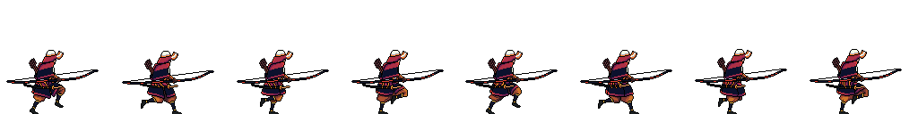

##### Jump.png

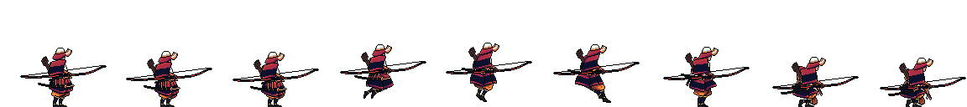

##### Light Attack.png

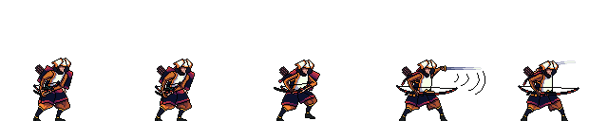

##### Heavy Attack.png



### Knight

#### Animations

These are the image files used for the knight’s animations

##### Idle.png



##### Run.png



##### Jump.png

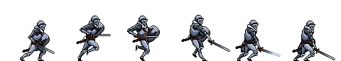

##### Light Attack.png

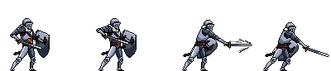

##### Heavy Attack.png

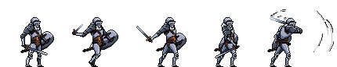

### Arrow

#### Arrow.png

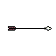

### Menu

#### Background.png

#### Level Editor Rect.png



#### Options Rect.png



#### Play Rect.png



#### Quit Rect.png



### Text Files

#### Player1Keybinds.txt

97

100

119

115

102

103

1073742049

#Each of the numbers is for a keybind and is a keycode for a key on the keyboard

#### Player2Keybinds.txt

1073741904

1073741903

1073741906

1073741905

47

46

1073742053

#Each of the numbers is for a keybind and is a keycode for a key on the keyboard

#### Level1.txt

Knight.300.200.57.60.0.0.255

Archer.800.200.57.60.0.0.0

Platform.300.600.700.25.0.255.0.False

Platform.792.406.200.15.0.255.0.True

Platform.306.399.200.15.0.255.0.True

#Each line is an object, they follow the format: ObjectType.xPosition.yPosition.width.height.colour(in r.g.b).CanBePassedThrough (if platform)

# Testing

Many different kinds of testing should be used to demonstrate the functionality of the project; from a direct analysis of the code, to allowing users to test the useability and practicality of the code, and stress testing the program to demonstrate its capabilities. This will allow the program to be fully tested and checked against original objectives to see where it hit them, where it surpassed them and if any were unable to be met.

During the programming of the project, lots of black box and white box testing was used to check functionality of aspects of the program. This allowed improvements to be made throughout so that the objectives could be met, and the program could be cohesive and functional. The tests on the final project, are shown below.

## Test table

The tests shown below are tests on my project against the initial objectives set out in the analysis section. These tests are shown on the testing video.

Link to the testing video on YouTube: <https://youtu.be/cpoSfSrNKtI>

Or alternatively on Google Drive: https://drive.google.com/file/d/1m61Cop9t_gt9lrzob5leTekAHOuHIPhg/view?usp=drive_link

* - this means that changes made to make this problem work will be discussed below

|  |  |  |  |  |  |  |
| --- | --- | --- | --- | --- | --- | --- |
| Test No | Objective Tested | Description | Input Data/ Event | Test Type | Expected Result | Actual Result |
| 1 | 2 | Test to show user can select a level and that the correct data is loaded and displayed. | Level data | Unit testing | File data is transferred to objects and displayed on screen. | Same as expected |
| 2 | 3 | Test to show player can stand on platforms | Player and platform hitboxes | Functional testing | Player stands on platform. | Same as expected |
| 3 | 4 | Show that the player moves when move keys are pressed. | User input of move key pressed | Functional testing | Player moves on screen. | Same as expected |
| 4 | 5 | Test to show all player attacks deal damage to other players. | User input of attack key pressed | Functional testing | Attack animation plays and other player is hit back. | Same as expected |
| 5 | 7 | Test to show player can jump and double jump. | User input of jump key pressed | Functional testing | Player moves upwards and plays jump animation. | Same as expected |
| 6 | 8 | Test to show number of jumps is reset when player lands on platform | Player landing on platform | Functional testing | Program outputs 2 jumps when player lands. | Same as expected |
| 7 | 9 | Test to show player can dash. | User input of dash key pressed | Functional testing | Player moves faster across screen. | * |
| 8 | 10 | Testing that user can never take damage when dashing. | User inputs | Boundary testing | Player doesn’t get knocked back. | Same as expected |
| 9 | 11 | Show player remaining on and passing through certain platforms using down keybind. | Down key pressed | Unit testing &  Edge case testing | Player passes through if down is pressed on correct platform. | Same as expected |
| 10 | 12 | Player jumping from underneath platforms. | Jump from underneath | Functional testing | Player hits head on big platform and passes through small ones. | Same as expected |
| 11 | 13 | Projectiles shot hitting players and going off screen. | Projectiles shot | Functional testing | Projectiles disappear upon collision. | Same as expected |
| 12 | 14 | Knock player off platform and have player fall off bottom of screen. | Player off bottom of screen | Functional testing | Score is added to player’s score and dead player is moved to spawn point. | Same as expected |
| 13 | 16 | Press undo button after performing an action in level editor. | Undo pressed | Functional testing | Last action removed | Same as expected |
| 14 | 17 & 18 | Test that saving data to a file saves it correctly and that it works in several circumstances. | Level data | Manual inspection &  Boundary testing | Level data saved to a file in expected format. | Same as expected |
| 15 | 19 | Test loading a created level loads it correctly. | Level data | Manual inspection | Level loaded as user created. | Same as expected |
| 16 | 20 | Allow for user to change keybinds in settings menu. | User input of keybind | Functional testing | Keybind changes on screen. | Same as expected |
| 17 | 21 | Test that saving keybind data to a file saves it correctly, is loaded correctly. | Keycode of new keybind | Manual inspection &  Boundary testing | Keybind data saved to a file in expected format. | Same as Expected |
| 18 | 23 | Show deceleration of a player with friction and gravity work. | Program applying friction and gravity | Unit testing &  Edge case testing | Player slows down at a steady rate and accelerates downwards. | Same as expected |
| 19 | 24 | Testing of the knockback formula to make sure it works as intended. | Damage taken values | Unit testing | Correct knockback values printed. | Same as expected |
| 20 | 25 | Testing several different attacks and outputting their damages. | Attack user inputs | Functional testing | Different damages taken from different attacks. | * |
| 21 | 27 | Getting client to send data over server as objects to check the server works. | Objects from clients to server | Functional testing & security testing | Scene is outputted on both screens. | Same as expected |
| 22 | 28 | Check several clients can connect simultaneously. | Two clients’ data to the server | Integration testing | Scene changes simultaneously on both screens. | * |
| 23 | 29 | Tests to check that the button’s function when pressed. | User input of left click | Functional testing | Program outputs when a button is pressed. | Same as expected |
| 24 | 30 | Tests quit button exits the program. | User input of left click | Functional testing | Program closes. | Same as expected |
| 25 | 32 | Compares start time with time when program has loaded to check that the program loads quickly. | Program opening | Load time testing | Program outputs time lower than target time in objectives. | Same as expected |
| 26 | 33 | Stress test program under several circumstances. | Arrows created until program slows | Stress testing | Program can handle at least 100 arrows per second. | Exceeded expectation |
| Questionnaire: | | | | | | |
| 27 | 1 | Questionnaire to ask if users think the game is easy to learn and accessible. | User feedback | Useability testing | Questionnaire |  |
| 28 | 6 | Questionnaire to ask if users opinions on the characters’ abilities. | User feedback | Useability testing | Questionnaire |  |
| 29 | 10 | Questionnaire to ask user opinions on dashing to dodge damage. | User feedback | Useability testing | Questionnaire |  |
| 30 | 15 | Questionnaire about users’ opinions on the level editor, after users have tested it and played on their levels. | User feedback | Useability testing | Questionnaire |  |
| 31 | 22 | Questionnaire to ask if users think the objects in the scene and player’s animations look good and cohesive. | User feedback | Useability testing | Questionnaire |  |
| 32 | 24 | Questionnaire to ask users if they think the amount the player moves backwards when hit is appropriate. | User feedback | Useability testing | Questionnaire |  |
| 33 | 25 | Questionnaire to ask users opinions on several keybinds for different attacks and the fairness of these attacks within the game. | User feedback | Useability testing | Questionnaire |  |
| 34 | 26 | Questionnaire to ask users opinions on experience playing against someone on the same device. | User feedback | Useability testing | Questionnaire |  |
| 35 | 27 | Questionnaire to ask users if online experience was good | User feedback | Useability testing | Questionnaire |  |
| 36 | 31 | Questionnaire to ask users’ opinions on buttons and menus. | User feedback | Useability testing | Questionnaire |  |

## Questionnaire Responses

### After playing the game, would you say you found it easy to learn and accessible and why?

Jacob: Every level was easily accessible, and it was easy to figure out the keybinds for each player by going into the keybinds menu. The game mechanics were relatively easy to pick up after a bit of playing.

Ozz: Yes, there's menu tooltips wherever something's non-standard and it gives the option to change control layouts.

Ian: Very easy to learn. Simple game. Consider adding a way you can win (eg best of 10?).

Clare: Menu was clear and easy to use. Key commands were chosen well and easy to learn. Use of escape made it easy to exit each screen.

### What did you think of the abilities, such as dashing, and the attacks of each character?

Jacob: They function well, I like the dashing feature! The double jump has saved me a couple of times.

Ozz: They're appropriately balanced and provides different play styles the users can engage in.

Ian: The attacks were good, easy and effective. I found the dash a little difficult as when I used it I usually fell off the platform.

Clare: I liked the short range and long range attacks. The dashing worked well as a defensive option.

### What did you think of the level editor, and when you selected to play your level, was it how you expected?

Jacob: Was fairly intuitive. Instructions on screen were useful in the level editor.

Ozz: The level editor was simple to use and very unrestricting as to what kind of levels you can make. It worked exactly as expected when in game.

Ian: This is very easy to use. However, I created a level where my character would fall to their death as they don't have a platform at the start. An improvement would be to make it a requirement to have a platform under the spawn point.

Clare: The ability to create your own levels made this game unique and it was great fun making your own levels and playing them. Very easy to use and worked well.

### Do you think the scene, player images and player animations looked good and fit well together?

Jacob: The animations were very smooth, textures on game objects! but it looks good.

Ozz: Yes. They're effective and aesthetically pleasing, and visually work well with each other.

Ian: Yes. I particularly liked how they have different sorts of attacks.

Clare: The player images worked very well and the images moved as the character moved to make it appear realistic movement.

### Knockback increases as damage increases - what were your thoughts on this?

Jacob: That makes sense as long as it’s not a ridiculous amount of knockback.

Ozz: It's an intuitive addition to the player's experience, while it also helps balance the game by bringing the opponent taking damage further out of range. I think it's a very good addition.

Ian: This is a great feature as it makes it easier to kill the opponent, the more you hit them. However, some sort of meter to understand how much damage you have taken or inflicted on the opponent would be useful.

Clare: Knockback increasing with damage was a great feature to add a competitive edge to the game and avoid stalemates in points.

### What did you think of the fact that there were several different attacks with different keybinds, and did you think these attacks were fair?

Jacob: Adds some nice variation to the game.

Ozz: I think it helped to make the game more complex and interesting; and they were fairly balanced.

Ian: Yes. The archer has two completely different attacks. The knights are similar. Consider if the Knight could have two different attacks.

Clare: Having 2 different attacks per character was fair and added interest to the game.

### What do you think of the player being able to dodge damage when dashing?

Jacob: I am undecided because, on the one hand, I believe that dashing avoiding damage is a good thing, but it could be useful to have a second dash that does not dodge damage.

Ozz: It's a good design for a defensive move; it further expands the potential for gameplay styles.

Ian: It's good, but the dash needs a little refining to make it easier to control.

Clare: I liked being able to defend myself but had to be careful not to fall off the platform and losing points when dashing!

### What did you think about playing on the same computer/laptop as another person?

Jacob: Multiplayer functionality is better but having both is very useful and cool.

Ozz: It was very responsive and it's useful to be able to play when your opponent doesn't have access to their own device.

Ian: You get instant feedback so it's good fun. Being able to change the keybinds is also useful to ensure you both have enough room on a keyboard.

Clare: Sharing the laptop worked well so we could both see the screen and the controls for each character were on opposing sides of the keyboard so easy for each player to use separately.

### What did you think about the playing experience across the server?

Jacob: It was smooth for the most part.

Ozz: It's dependent on the players' internet connection, but it worked well when I tried it.

Ian: A good feature and the feedback on the character was very swift, making the game playable.

Clare: This was an amazing feature which worked well and enabled us to play against each other in different locations of the house.

### What did you think of the aesthetics of the menu, and buttons as well as their functions?

Jacob: The background picture fits the theme very well; I have no problems with the aesthetic.

Ozz: They're very effective, I think they work well.

Ian: Good. Consider calling "options" "controls" as that's what it is and it would make it easier to find thr game controls (keybinds).

Clare: The menu was clear and easy to read. They were well spaced out and well thought through. Colour choices were good to make it easy to read.

### Comments on user feedback

The improvements will be discussed in evaluation section. The comments were overall very positive and concluded that original objectives were met and exceeded in places. Many users were very happy with the aesthetics and useability of the program and would like more gamemodes in the future.

The main, specific, positive points mentioned by users in the questionnaire were: the overall positive feedback on the dashing to avoid damage because this is a feature which is not included in every game but has worked well for this project, the player having two different attacks was commented on positively by everyone and they enjoyed finding out when the best time to use each attack was, and finally the positive feedback on the knockback, because this is a core aspect to winning the game and many users said it worked very well and was exactly how they would like it.

## Improvements

|  |  |  |
| --- | --- | --- |
| Test number | Error/problem | Improvement |
| 7 | Dash did not last very long so had to be used at a very exact time to dodge damage. | Dash time was increased from 500ms to 1100ms after some testing to make sure it was possible to dodge attacks but not too easy or hard. |
| 20 | Attacks all dealt correct damage; however, the archer’s heavy attack didn’t do enough damage for how difficult it was to hit. | Archer’s heavy attack adjusted to do more damage, from 20 to 30 damage after testing with different damages. |
| 22 | Players cannot rejoin after leaving the game because server client limit is 2. | If client tries to join after 2 player limit is reached (either by a player trying to rejoin or a third player trying to join) the player trying to join is sent to the main menu. |

# Evaluation

## My overall evaluation

Overall, I think my project completes the beginning aim. From presenting it to other students, teachers and family members, I have received lots of positive feedback from the clients interviewed at the start, showing that I have satisfied the aims for my project. The clients especially commented positively about how the program looks and how responsive it is to key presses. This highlights how it completes the beginning aim because the program efficiency, along with aesthetics and fun of the game, were some of the main aims from the beginning.

The game has a simple, yet visually appealing and effective colour theme which allows the user to easily see players and understand how to control them. This was of high priority to users at the beginning and when they were interviewed again, they were very positive about these features. The gameplay also assists with this, allowing users to easily understand which player they are and get straight into playing the game and having fun. This is further aided by allowing users to change their keybinds, so that they can play in any way they wish and keep these changes whilst they are offline. However, it may also be good for more customisation and interesting fights, to add moving platforms. This would add a new dimension of a dynamic level as well as players and give the users an option to have more to think about during fights.

The level editor has everything the project specification required it to have. However, I think adding more features to allow the user to fully customise their level, such as changing the background and platform colours or even designing their own players. I found in test 26 that my program could hand a lot of extra data on top of what was already output onto the screen, so more complex platform designs such as those shown below could be used to make the game look more realistic and interesting.

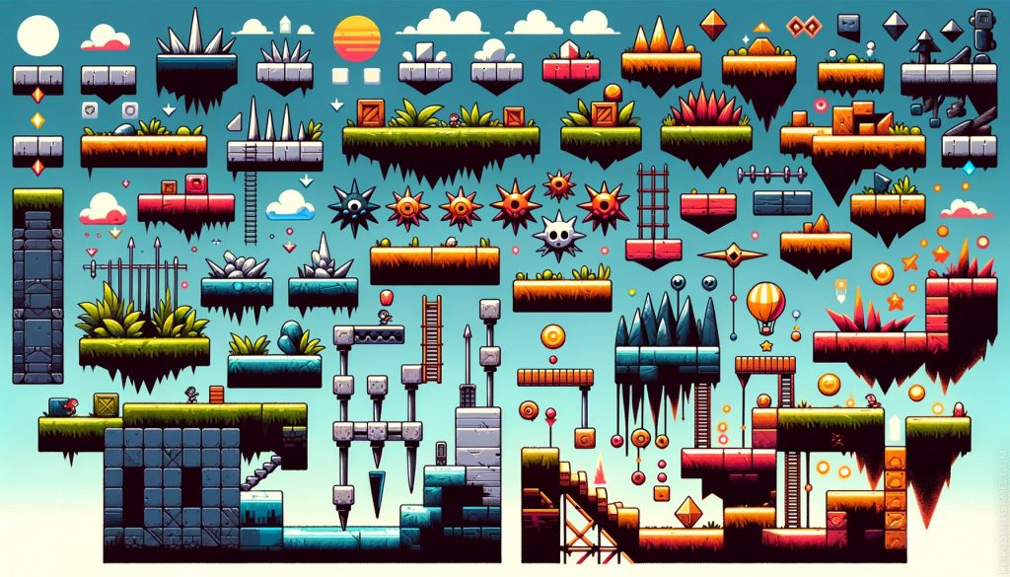

The online aspect of the game could be improved by allowing another player to join if a player leaves. At the moment, the server has a client cap of two which causes any more users trying to join to be rejected even if only one player is currently in the server. This would improve the ease of playing online for users and save them time.

The final way I think the game could be further improved is by having different game modes, such as setting a number of lives each player has so that when one player loses all of these, the other player wins. The current way of scoring could be a separate mode or saved in a file so players can continue their matches. This would cause users to play the game for longer because there would be more unique game modes to spend time on.

## Evaluation by objective

|  |  |  |  |
| --- | --- | --- | --- |
| Objective number | Objective overview | My/users’ evaluation | Potential improvement |
| 1 | Game should be 2D. | The game has an easy to understand colour scheme with easily identifiable objects even for new players. This is a very important part of making an accessible 2D game. | More realistic textures could have been used for the platforms to make them seem more realistic or more detail such as clouds added to the background. |
| 2 | Allow user to select which level to play. | Any level that the user has created or was already in the folder can be loaded by selection from the user. | Allowing the user to choose a name for their level to be called. |
| 3 | Colourful, working platforms. | The player stays on platforms and does not vibrate or float above them. The platforms are colourful and stand out from the background. |  |
| 4 | Moveable players by user inputs. | The player can move left, right, jump, dash and go down all by player inputs. | Could add a new attack that moves the player forward to add more aspects to fighting. |
| 5 | Player attacks deal damage to other players. | The player attacks created hitboxes which successfully added damage taken to the other player if a collision was detected. |  |
| 6 | Two or more characters with unique weapons or abilities. | Two different characters, knight and archer were fairly balanced and had several attacks of varying strength and difficulty to use. | More characters that the user can select from the play menu. |
| 7 | Play can jump and double jump. | Both players are able to jump and double jump depending how many times the user presses their jump keybind. | Options for users to change the maximum number of jumps both players can have. |
| 8 | Players’ number of jumps reset to two when they are on a platform. | Both players’ number of jumps attribute was set to two when colliding with a platform. |  |
| 9 | Player should be able to dash. | Player can dash by pressing their chosen keybind and this works on the ground or in the air, adding velocity to the player in the direction they are facing. |  |
| 10 | Dashing should make the user immune to taking damage. | If the user presses dash at the right time, then the user will dodge damage from the attacking player. | An increased cooldown on dash could make it more difficult for players to dodge. |
| 11 | Passing through small platforms by pressing down key. | The big platform cannot be passed through and passing through the small platforms always works and is smooth. |  |
| 12 | Players can jump through small platforms from underneath. | This always works and players cannot pass through the big platform from underneath. Due to how collisions are managed, if the player collides with the platform with a low, non-zero velocity, the players y coordinate may be changed to that of the platform. This causes the player to appear to be attracted to the platform in some places. | The players’ velocity could be checked if it is positive or negative, because if the player is moving down and a collision is detected, the y value can be set to that of the platform but if it is moving up its y value should not be changed. |
| 13 | Arrows should be removed from the screen after colliding with player or exiting screen. | Arrows are removed from the list of current arrows in the scene as soon as they collide with a player, or their x/y values mean they are off the screen so that they are not drawn on the screen or checked for further collisions. |  |
| 14 | Point added to other player’s score when a player falls off bottom of screen. | This feature works well and is a good way of scoring the game. This is because it requires no set up for the user so they can just press play and play straight away. |  |
| 15 | A way of users making their own maps to play. | Level editor allows users to place any small platforms and both users’ spawn points wherever they would like. | More customisation such as colour changing of aspects of the scene. |
| 16 | An undo button for level editor. | This works using a stack and removes the top item on the stack if undo is pressed. | Allow the undo to also undo the user selecting an item. |
| 17 | Option for user to select which level to save data into. | User can select up to 20 level numbers to save level data into or replace existing levels. | Allow user to name their own levels and more than a 20 level limit. |
| 18 | Storage of map data in files. | Data is correctly stored from saved levels into the format used for processing level data as it is loaded in the program. |  |
| 19 | Functions to load map data from files. | Data is correctly loaded from files and then each object is iterated through to be processed. |  |
| 20 | Ability to change keybinds. | User can change keybinds to any key recognised by Pygame. | Stop users from being able to change 2 actions to the same keybind. |
| 21 | Store keybind keycodes in file | Keybind data is stored as unique numbers, each corresponding to a key on the keyboard or button on mouse in Pygame, in a file with each row as its own action which the player can perform. |  |
| 22 | Fully animated and aesthetic characters. | Feedback on the character’s animations and appearance have been very positive. They have a unique animation for every action. | Different animation cooldowns for each different animation for even better animations. |
| 23 | Physics based calculations. | I used equations to make acceleration, friction, normal contact force and gravity close to real life (ignoring forces such as air resistance. |  |
| 24 | Fast, realistic and responsive fighting. | Due to the low time taken for the program to run, taking damage and detecting key presses happen almost instantly, allowing for players to feel responsive and fights to be fair. | Threading or other programming languages could have been used to make these processes even faster. |
| 25 | Several attacks with different keybinds. | Each player has two attacks which are unique to them and have different ranges, cooldowns and damages. |  |
| 26 | Offline mode. | Players can play against each other on the same device. |  |
| 27 | Online mode using sockets and servers. | Sockets work and host servers. There is very little delay between data being sent to the server and that data being displayed on the other client’s screen. | Allow more players to join if the user would like them to. |
| 28 | Several clients simultaneously using threading. | Two clients can send and receive data at the same time using threading and still run these processes very quickly. |  |
| 29 | Working buttons that can be pressed. | Throughout the game there are many buttons that perform different actions, including some that are text, some that are images and some that are text with image backgrounds. |  |
| 30 | Quit button. | Closes the program when pressed. |  |
| 31 | An interactive menu that takes the user to all parts of the game. | The menu has 5 buttons which take the user to the offline play mode, online play mode, level editor, settings and quit. All these menus have buttons that take them back to the main menu or can do this with the escape key. |  |
| 32 | A fast and efficient program. | The program can perform a game loop in 4ms even with the player jumping, moving and attacking. The program also loads very quickly, easily below the 20 seconds in the objectives. | The program could be made even faster so that if more is added, it can still run very quickly. |
| 33 | A program that can handle data. | The program can handle lots of data as shown in testing with the creation of massive amounts of arrows. | Could be made faster and more capable in other programs or languages. |

## Improvements

Below shows all the improvements that the users I interviewed in testing have suggested to further improve my project, these could not be completed in the time allocated for the project but given more time they could make the game even better.

* Put all the keybinds on screen in the play and edit level modes, this will help brand new players know what to do and get started quickly and easily. Would be useful to show that there is an undo button in the level editor.
* Add some modes, such as being able to select a certain number of lives for each player.
* Stop users from being able to set a spawn point where there is no platform or below the map or automatically add a platform below a spawn point.
* Add different coloured bars at the top of the screen to show how much damage the user has taken.
* The knight’s attacks are very similar, possibly make them more different.
* Stop the player dashing if they move sideways after the dash so that they can control it more easily.
* Call the settings menu controls instead unless more settings are added to better inform new users.

# References

## Analysis

Image: Baamboozle. Gravity Game. <https://www.baamboozle.com/game/238262> (Accessed: 11 December 2024).

Image: OpenGameArt. Keyboard Keys 1. <https://opengameart.org/content/keyboard-keys-1> (Accessed: 11 December 2024).

Image: Sonic News Network. Boost. <https://sonic.fandom.com/wiki/Boost> (Accessed: 11 December 2024).

Image: Adobe Stock. Loading Screen with Lime Green Progress Bar Vector. [https://stock.adobe.com/uk/images/Loading-Screen-with-Lime-Green-Progress-Bar-Vector/524340504](https://stock.adobe.com/uk/images/Loading-Screen-with-Lime-Green-Progress-Bar-Vector/524340504?as_content=tineye_match&clickref=1101lA2yjBoC&mv=affiliate&mv2=pz&as_camptype=domain&as_channel=affiliate&as_source=partnerize&as_campaign=tineye) (Accessed: 11 December 2024).

Image: Reddit. (2013) Can someone please explain why I got hit by Nix's Side Signature?.<https://www.reddit.com/r/Brawlhalla/comments/1c4086l/can_someone_please_explain_why_i_got_hit_by_nix/?rdt=64685> (Accessed: 11 December 2024).

Image: Brawlhalla Wiki. Attacks. <https://brawlhalla.fandom.com/wiki/Attacks> (Accessed: 11 December 2024).

Image: Nintendo. Nintendo Switch. <https://www.nintendo.com/my/switch/aaab/index.html> (Accessed: 11 December 2024).

Images and Information: Chadha, Bone and Suanders, (2016). A Level Physics for OCR A: Year 1 and AS. Oxford University Press – Children.

Image: Nintendo. Super Smash Bros. Ultimate for the Nintendo Switch system. https://www.nintendo.com/switch/ (Accessed: 11 December 2024).

## Design

Image: MrWallpaper. Gradient Blue and White Portrait*.* <https://mrwallpaper.com/wallpapers/gradient-blue-and-white-portrait-rcpqbavx5bayfimf.html> (Accessed: 11 December 2024).

Image: iStock. Smooth Dark Blue Sky. <https://www.istockphoto.com/photos/smooth-dark-blue-sky?page=2> (Accessed: 11 December 2024).

Image: LinkedIn. Measurement for Business Activity. <https://www.linkedin.com/posts/andrew-brown-0279288a_measurement-for-business-activity-7209844134155599872-bz3p> (Accessed: 11 December 2024).

Image: Rawpixel. Gray Rectangle PNG Blank Geometric Shape Transparent Background. <https://www.rawpixel.com/image/11915019/gray-rectangle-png-blank-geometric-shape-transparent-background> (Accessed: 11 December 2024).

Image: LDTK. Download. <https://ldtk.io/download/> (Accessed: 11 December 2024).

Image: Reddit. (2013) How do I get those soundtrack lines?. <https://www.reddit.com/r/geometrydash/comments/1dyboyg/how_do_i_get_those_soundtrack_lines/> (Accessed: 11 December 2024).

Image: Game UI Database. *User Interface Reference*. <https://www.gameuidatabase.com/index.php?set=1&scrn=21&sort=2&series=2&tag=156> (Accessed: 11 December 2024).

Image: Desmos. Desmos Graphing Calculator. <https://www.desmos.com/> (Accessed: 11 December 2024).

Image: Reddit. (2017) Hitboxes. <https://www.reddit.com/r/Brawlhalla/comments/6kp99h/hitboxes/> (Accessed: 11 December 2024).

Image: GameDev Stack Exchange. (2018) What are the benefits or drawbacks of splitting the player animation system from the player logic system?. <https://gamedev.stackexchange.com/questions/159975/what-are-the-benefits-or-drawbacks-of-splitting-the-player-animation-system-from> (Accessed: 11 December 2024).

Image: Stack Overflow. (2015) spl_stack: How it works and why.<https://stackoverflow.com/questions/33236575/splstack-how-its-works-and-why> (Accessed: 11 December 2024).

## Technical solution

Image: CraftPix. Free Samurai Pixel Art Sprite Sheets. <https://craftpix.net/freebies/free-samurai-pixel-art-sprite-sheets/> (Accessed: 11 December 2024).

Image: CraftPix. Free Knight Character Sprites Pixel Art. <https://craftpix.net/freebies/free-knight-character-sprites-pixel-art/> (Accessed: 11 December 2024).

Information: OpenAI. (2024) Conversation about how to use UDP servers for broadcasting in Python. ChatGPT (Accessed: 11 December 2024).

## Evaluation

Image: Thoviah. Platform Jumper. <https://soundcloud.com/thoviah/platform-jumper> (Accessed: 11 December 2024).